1. MYSQL TABLE: (menu table)

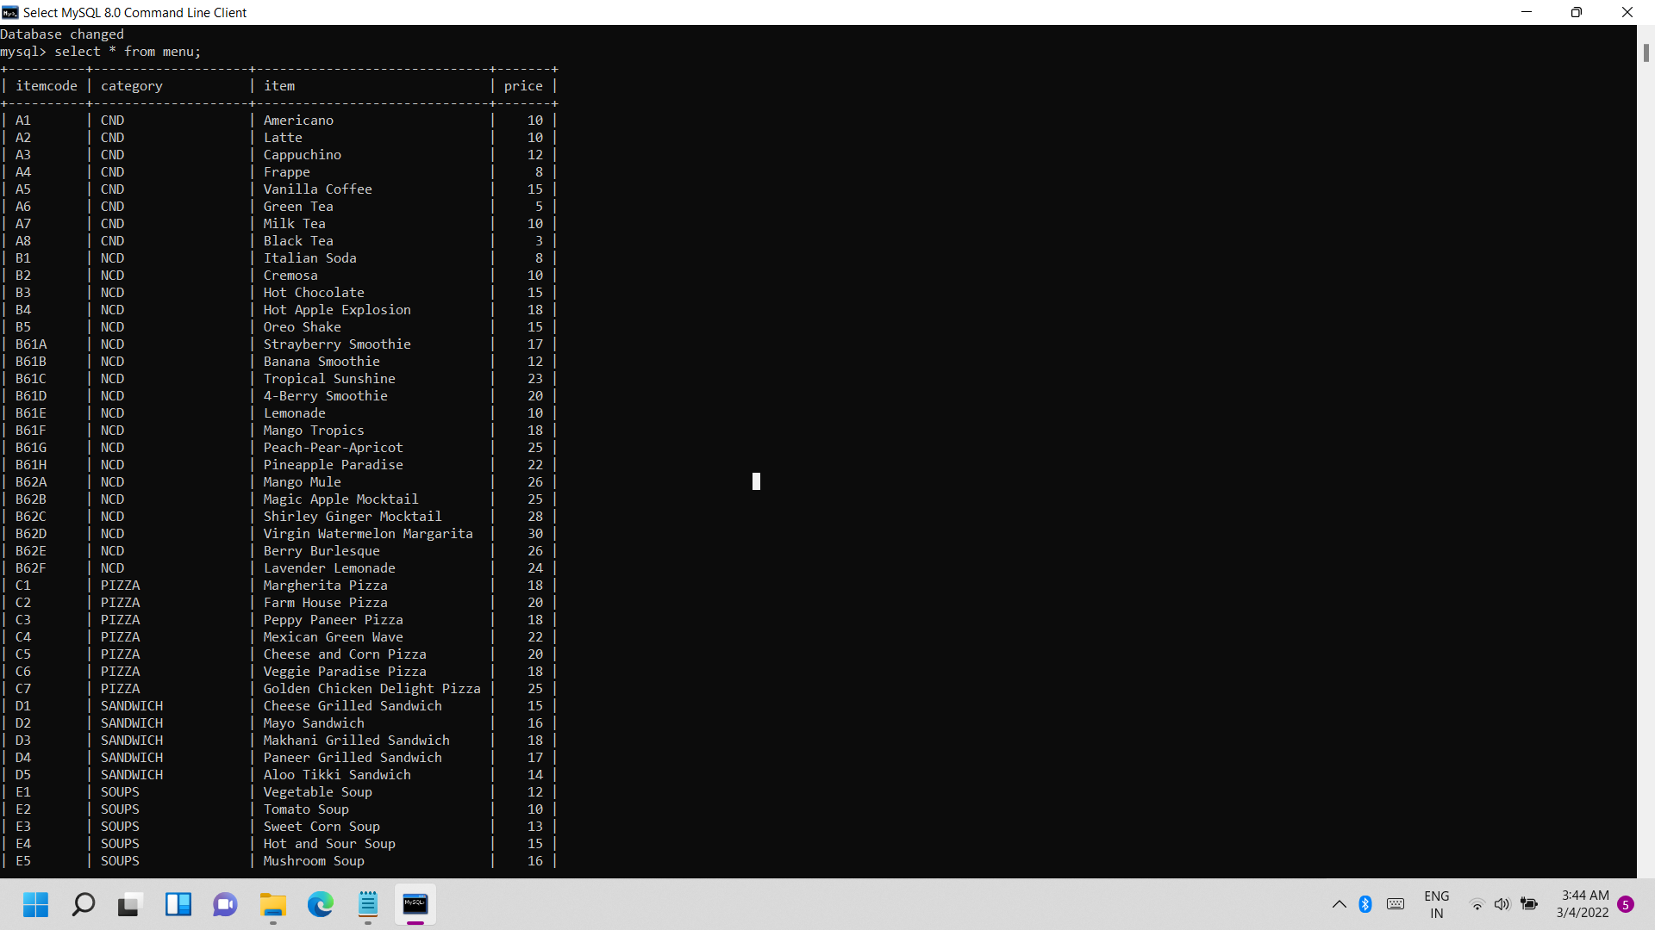

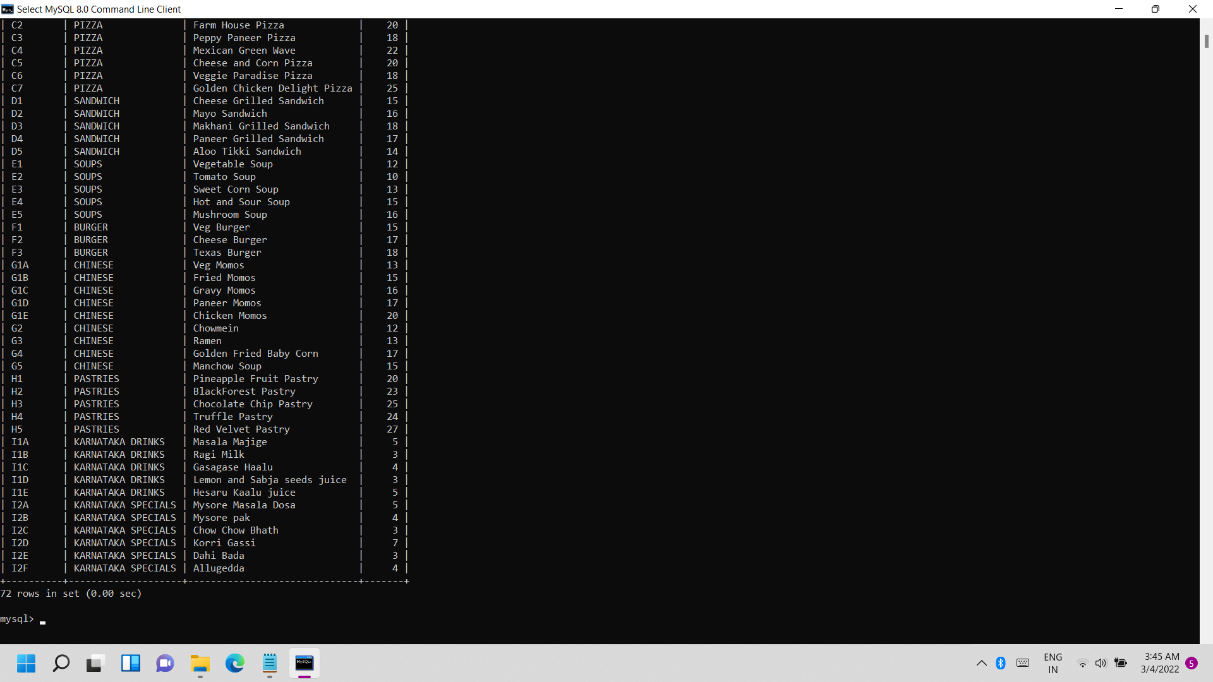

Crecord table:

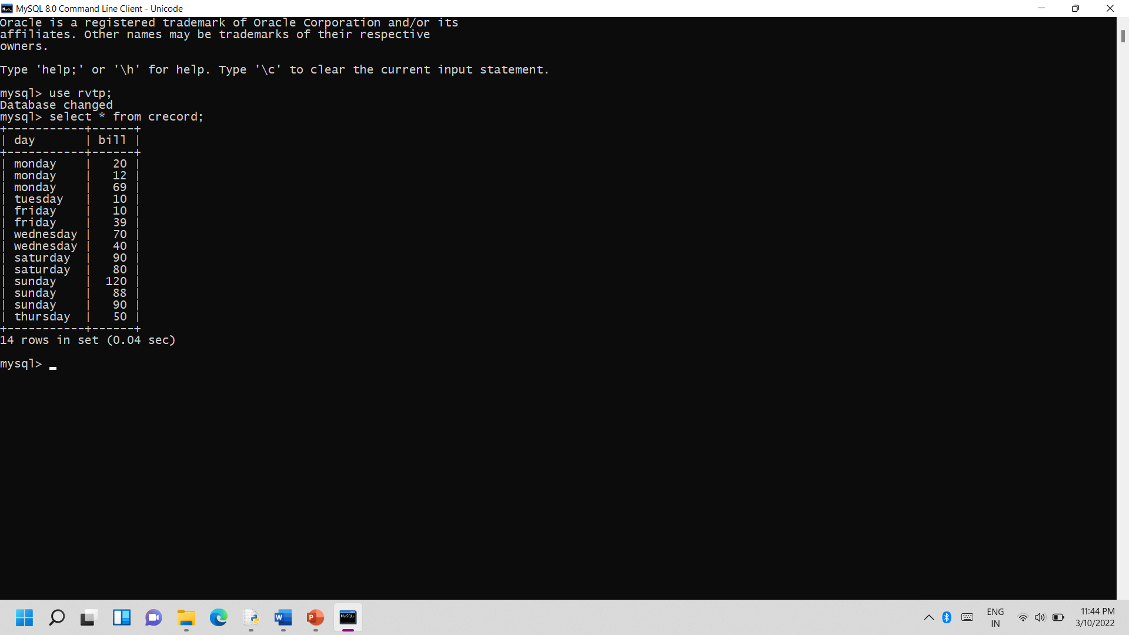

1. PYTHON CODE:

Displaying the password box:

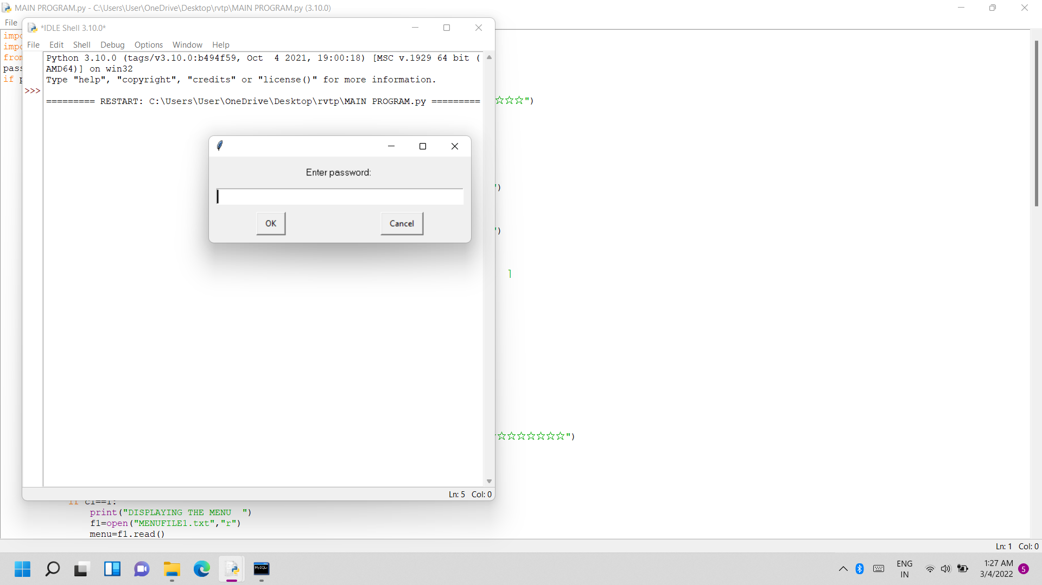

1. Entering password:

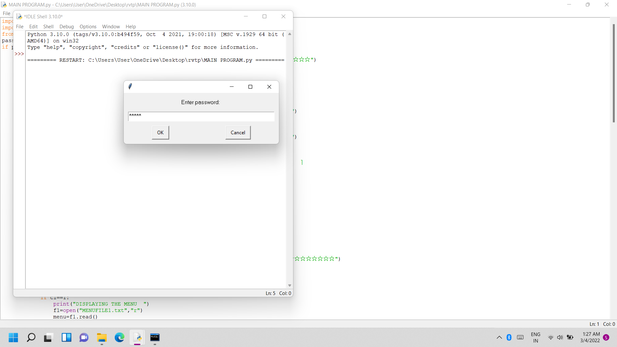

1. Entering wrong password:

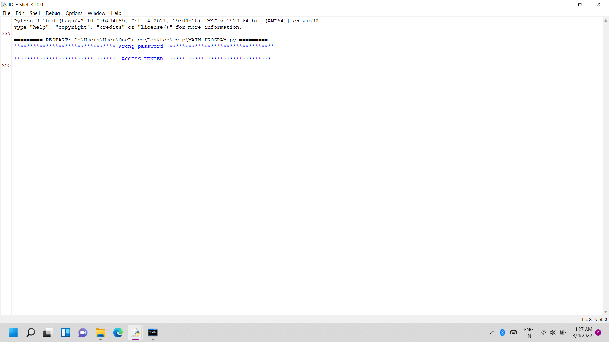

1. Entering correct password:

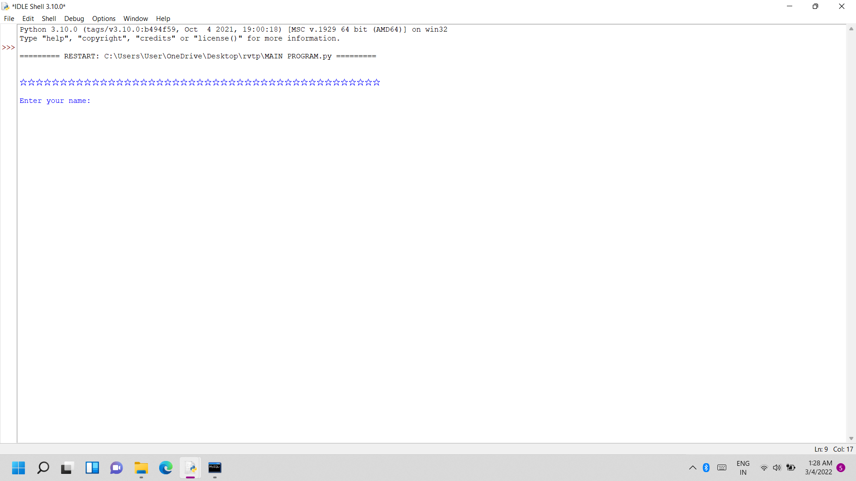

1. Customer services:

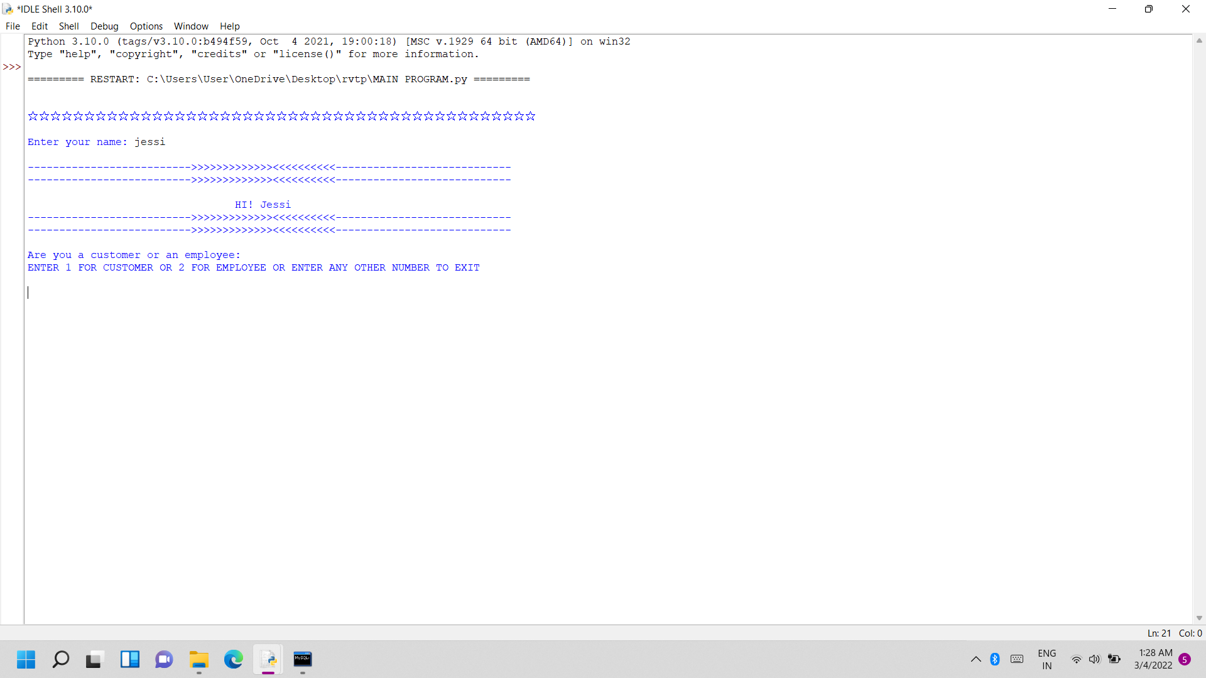

1. Displaying main menu:

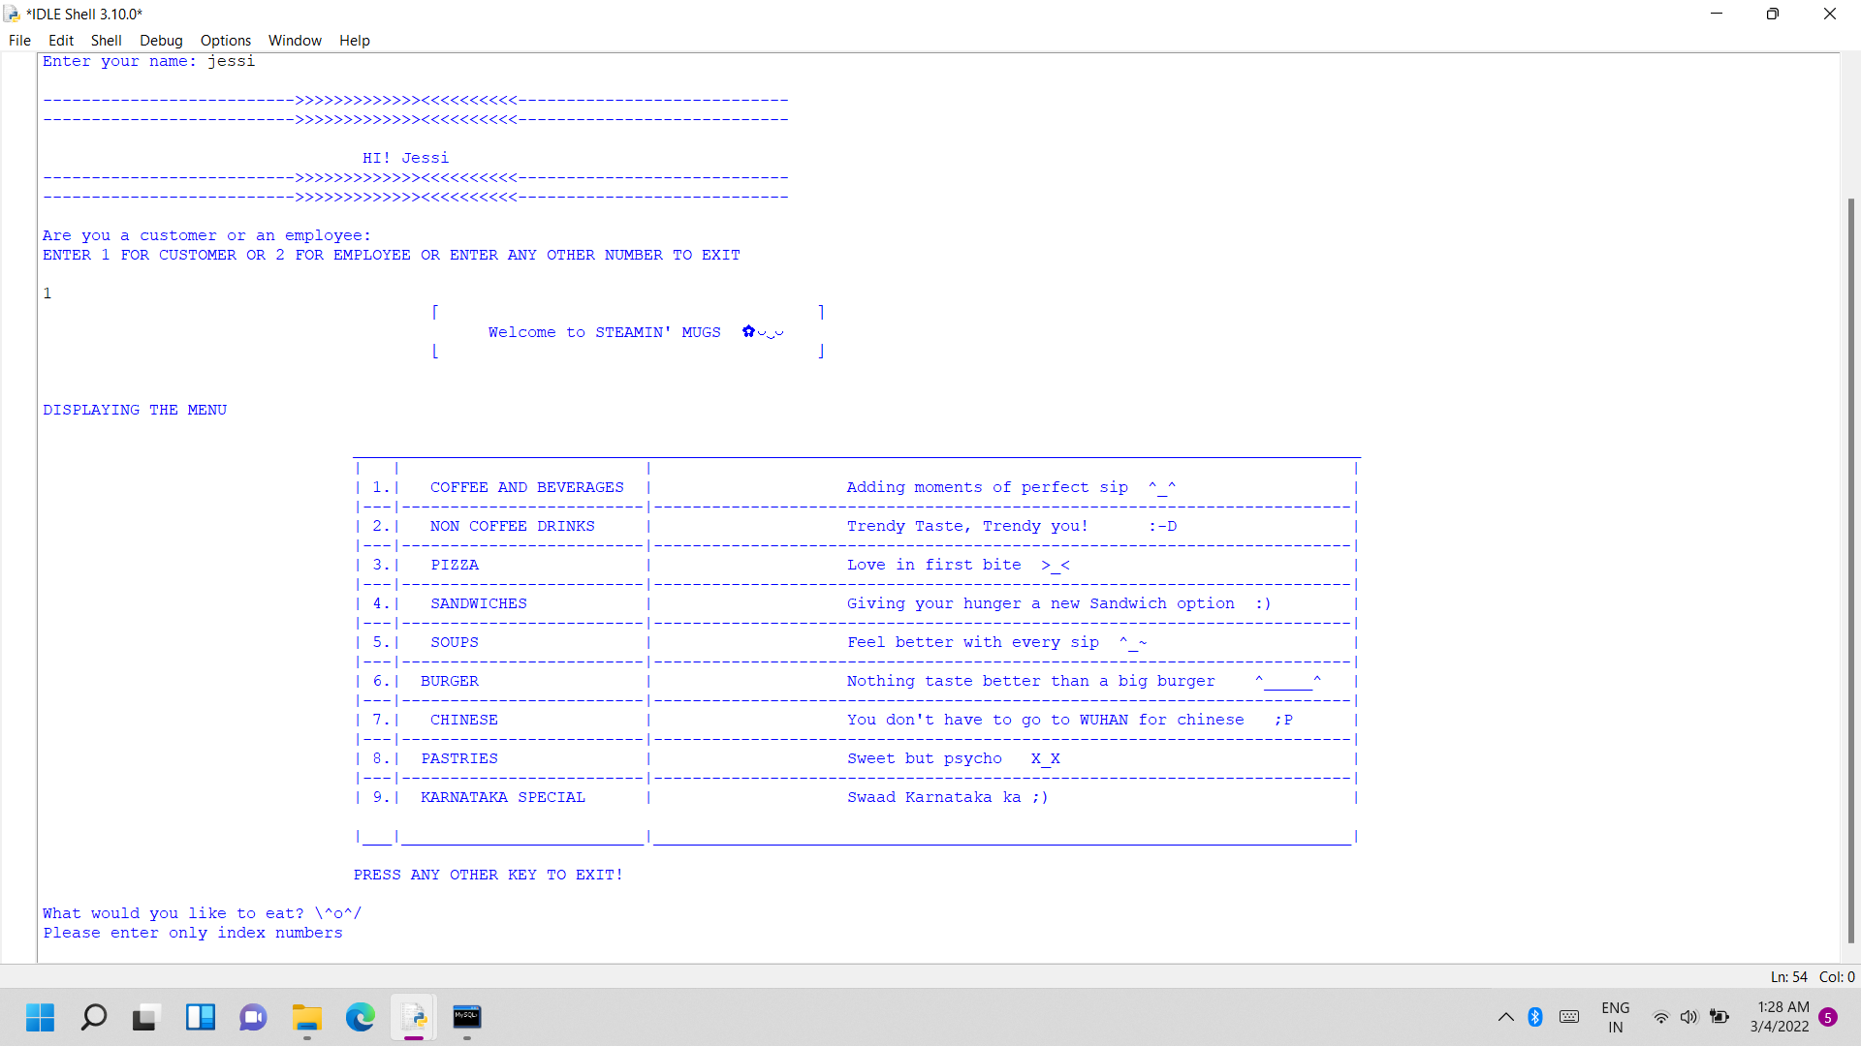

1. Displaying sub menu on request:

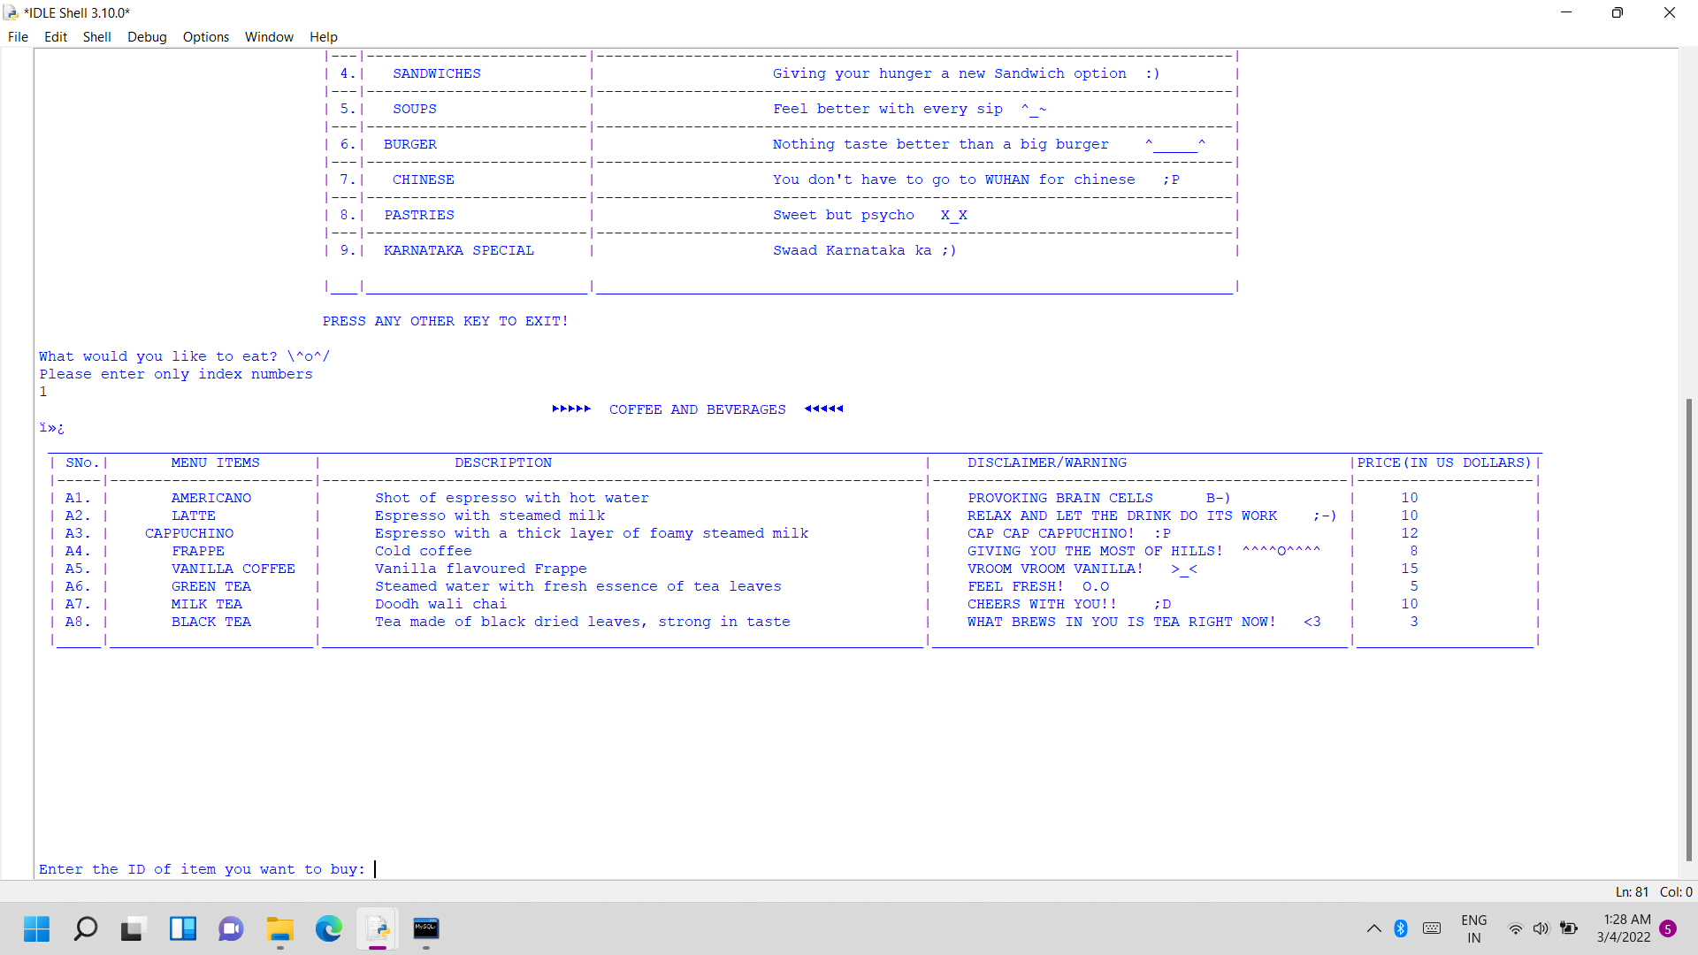

1. Customer choosing from the menu and entering the quantity:

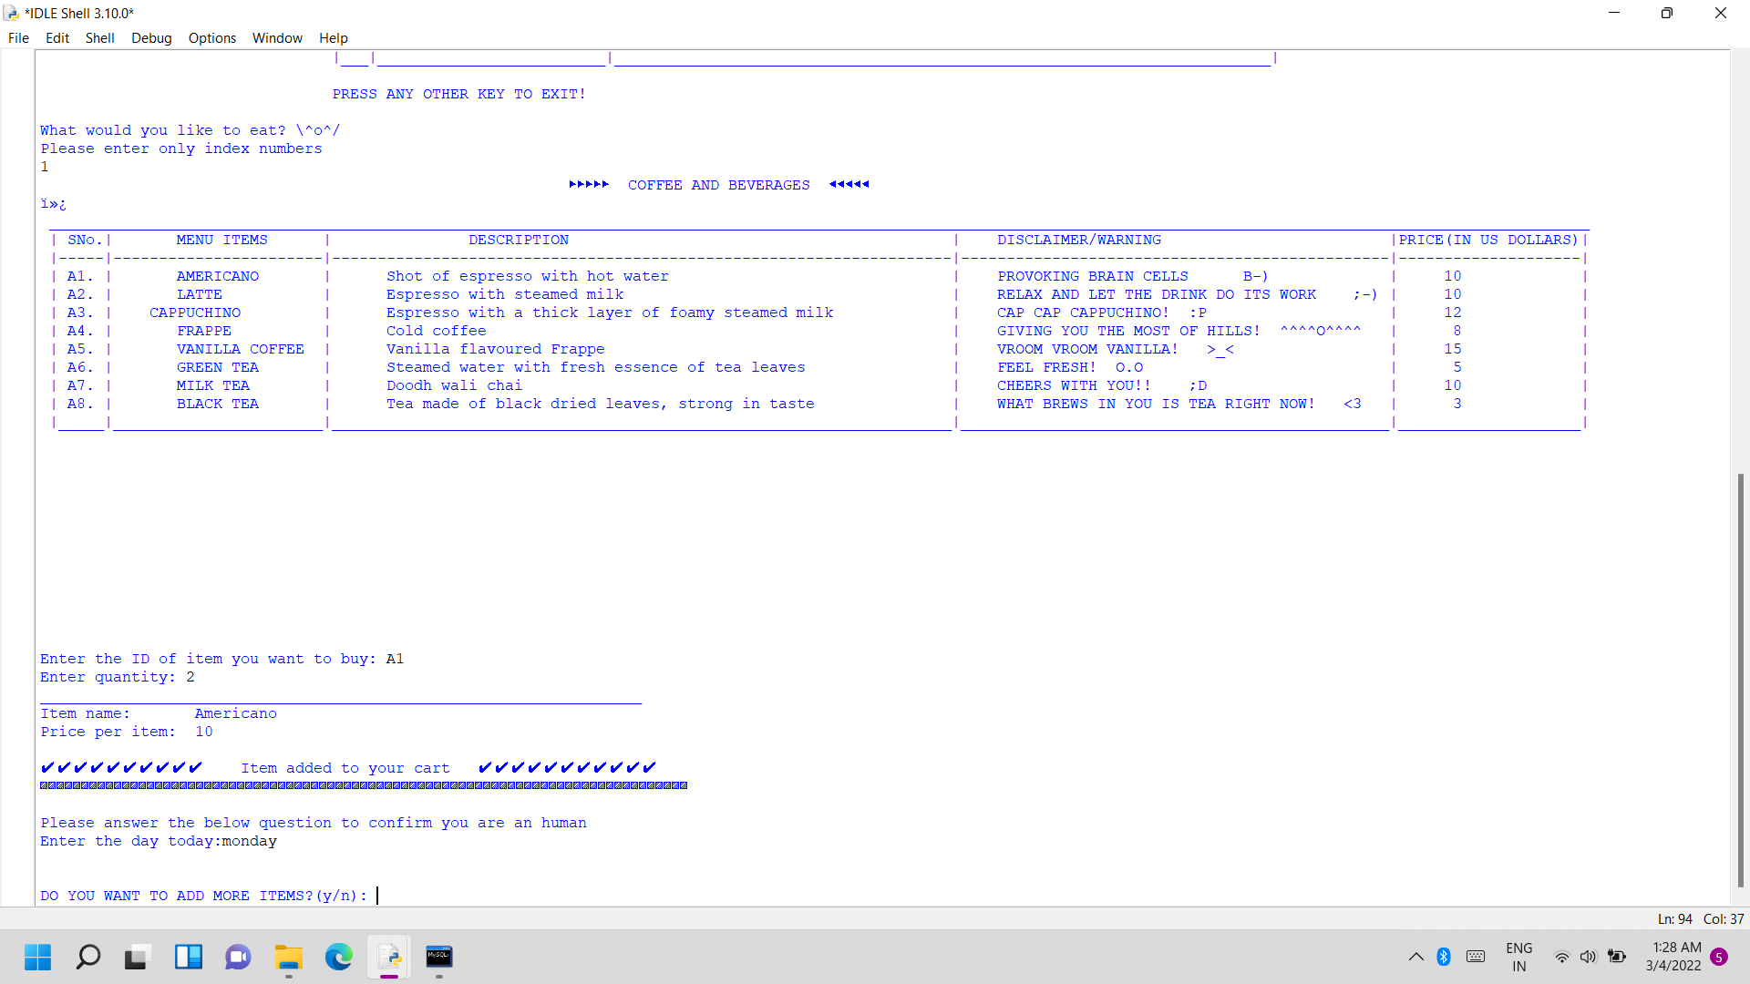

1. Customer opting to choose more items from the
2. From the same category
3. From different category

and entering the quantity:

i.)

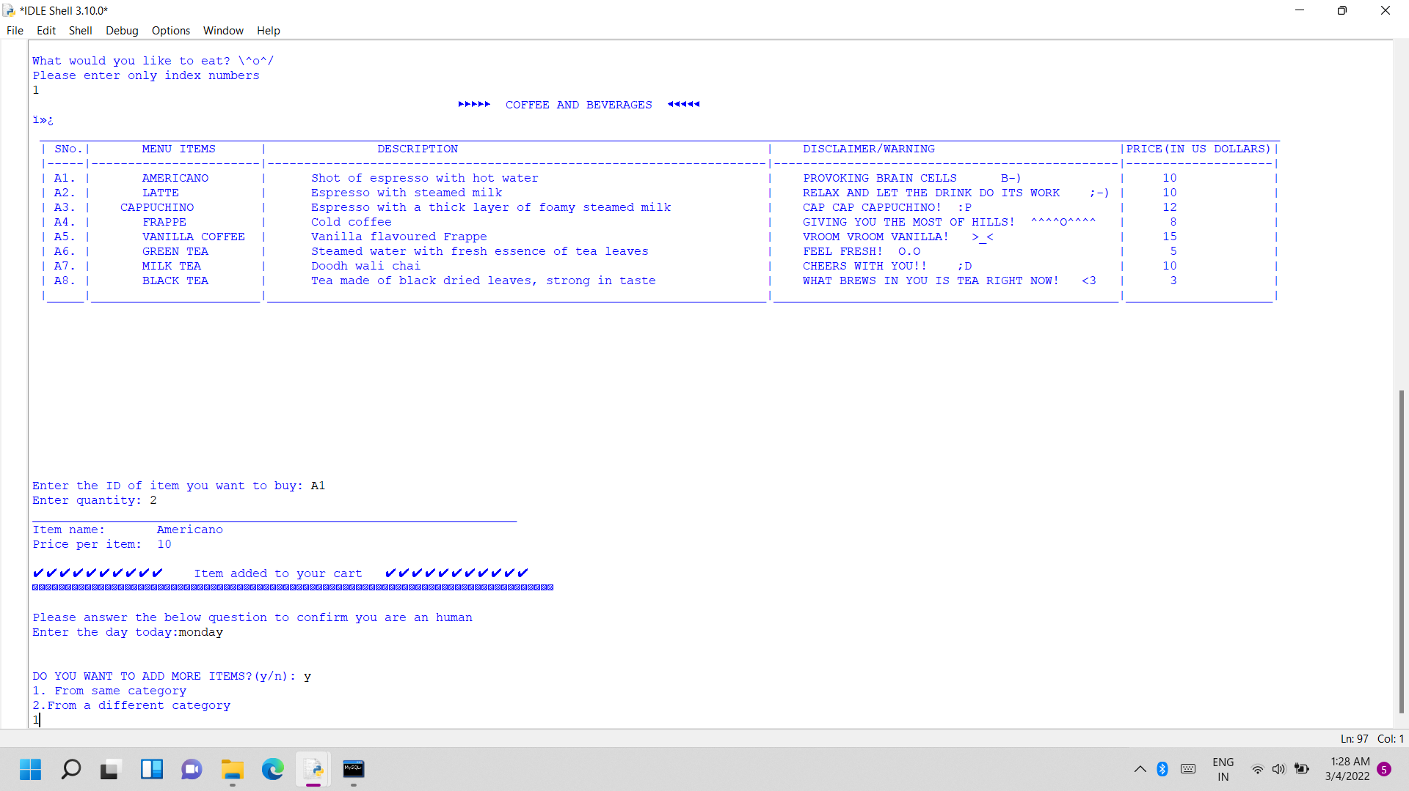

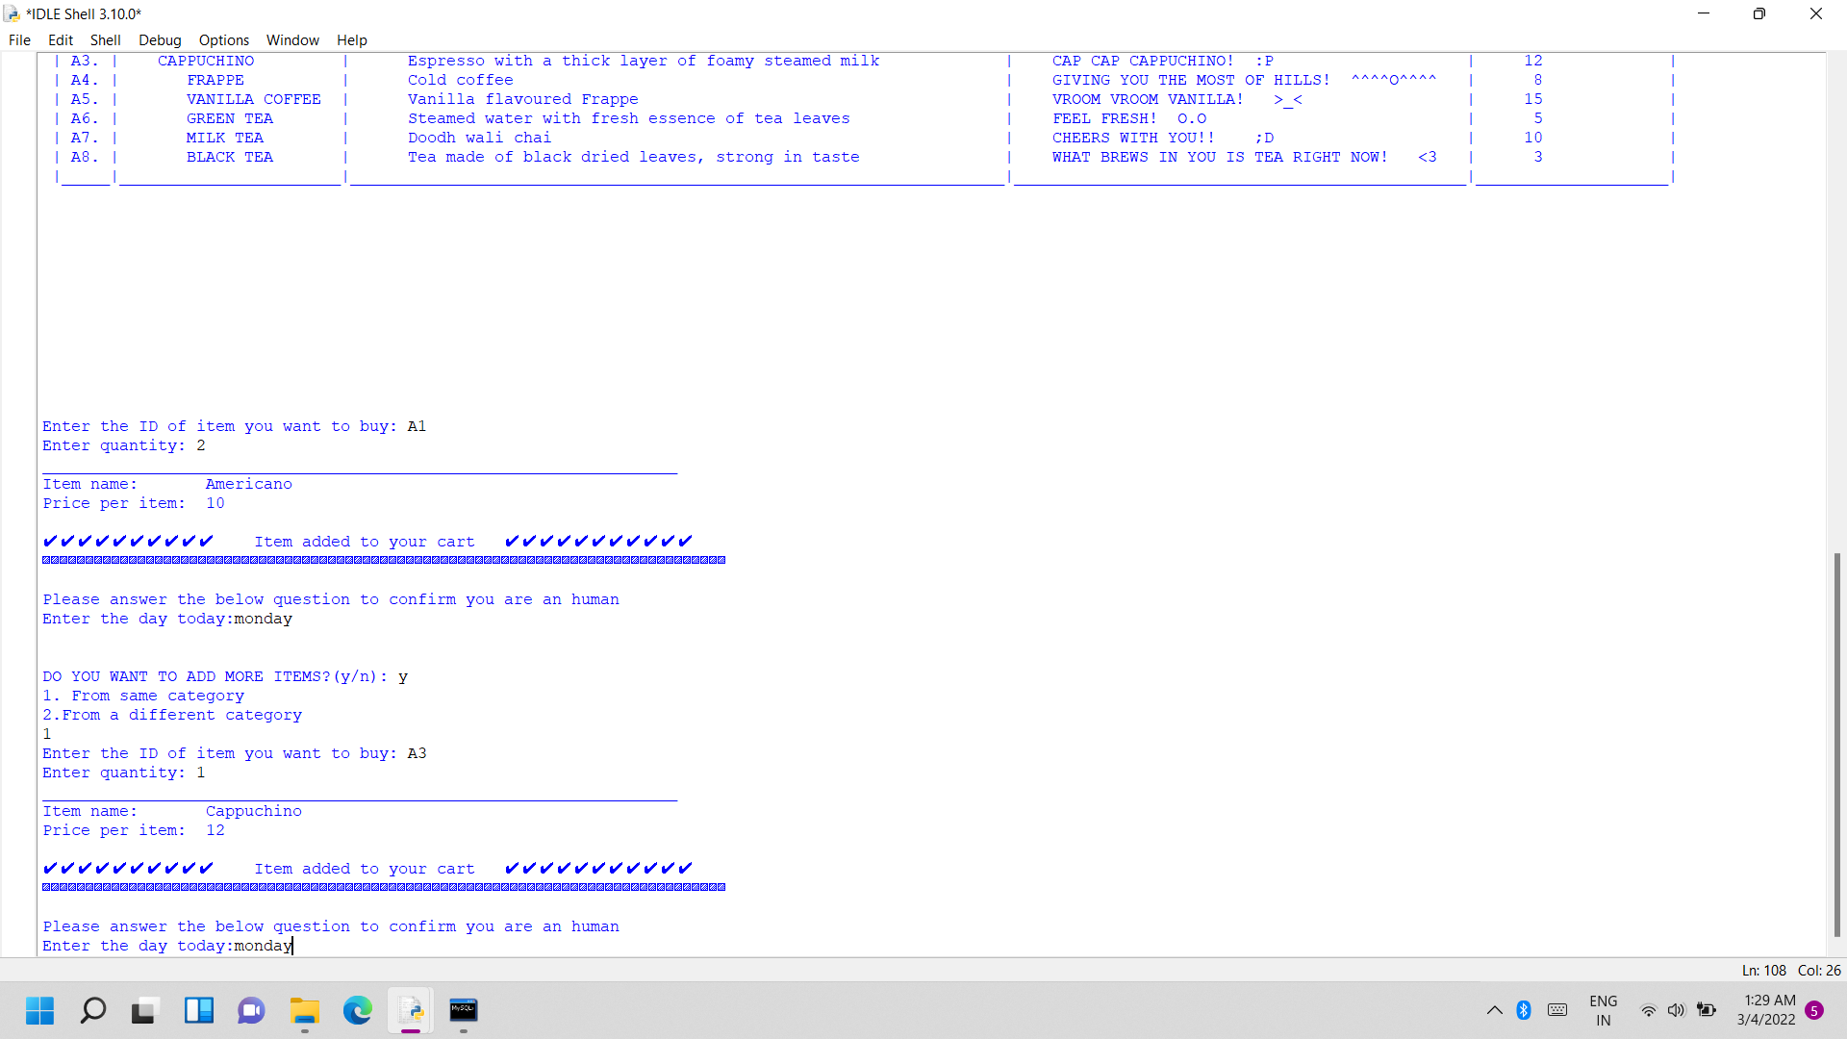

ii.)

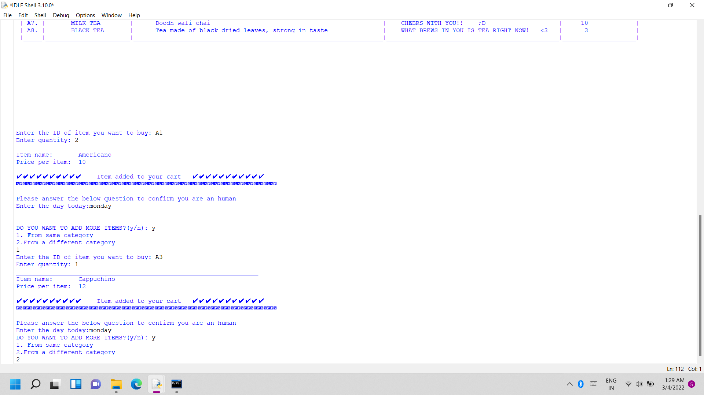

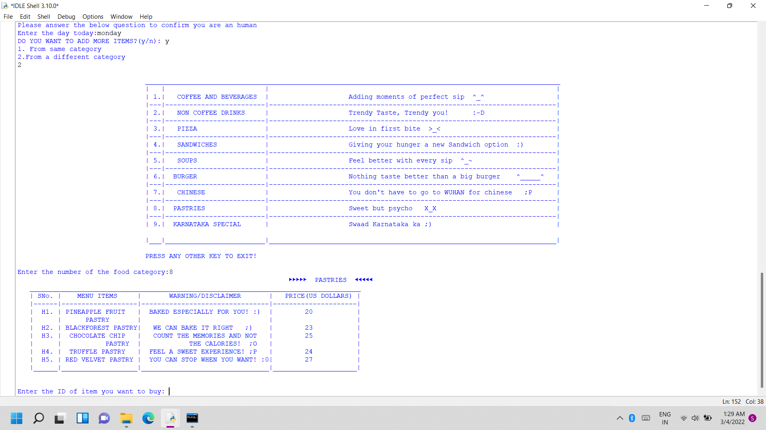

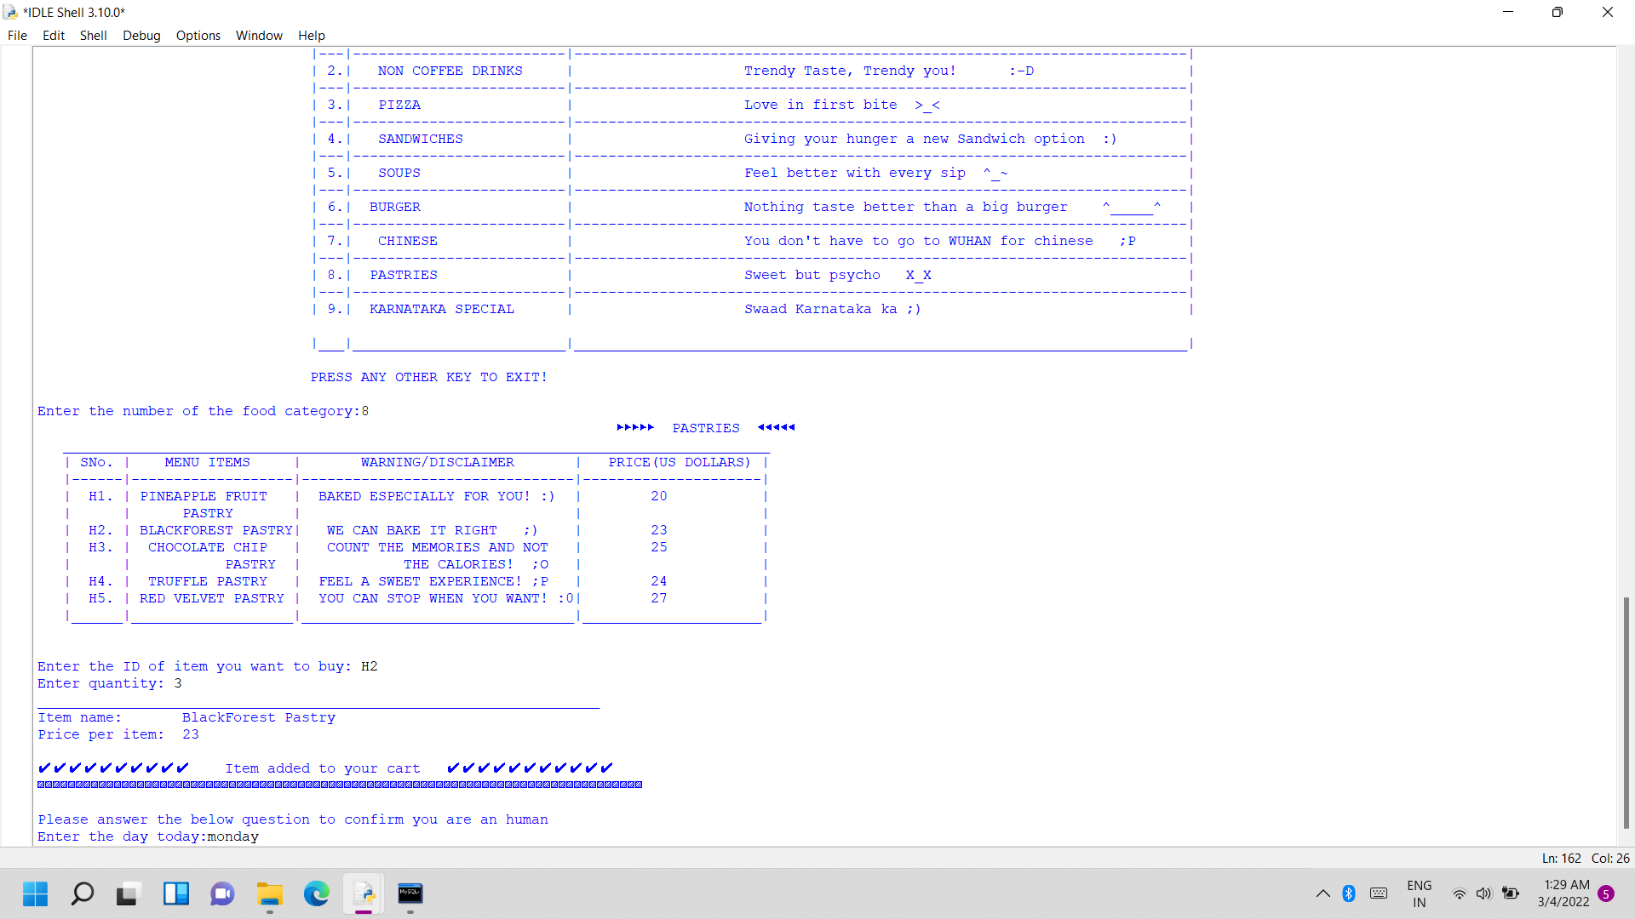

1. Customer choosing to buy no more items:

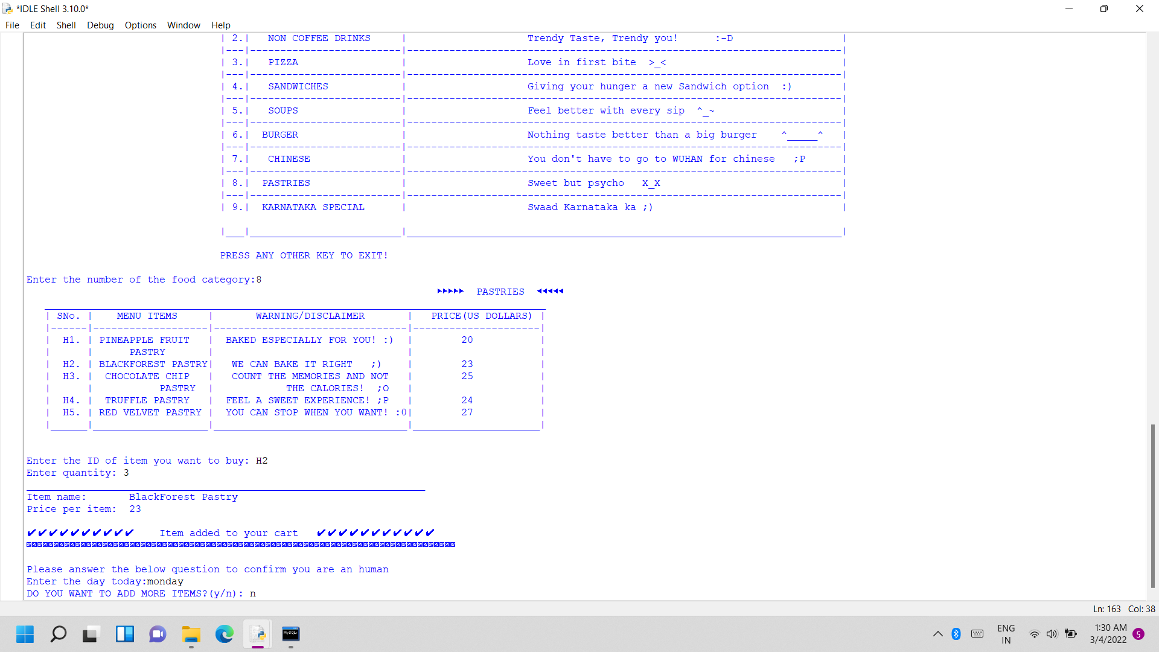

1. Generating the bill for the customer:

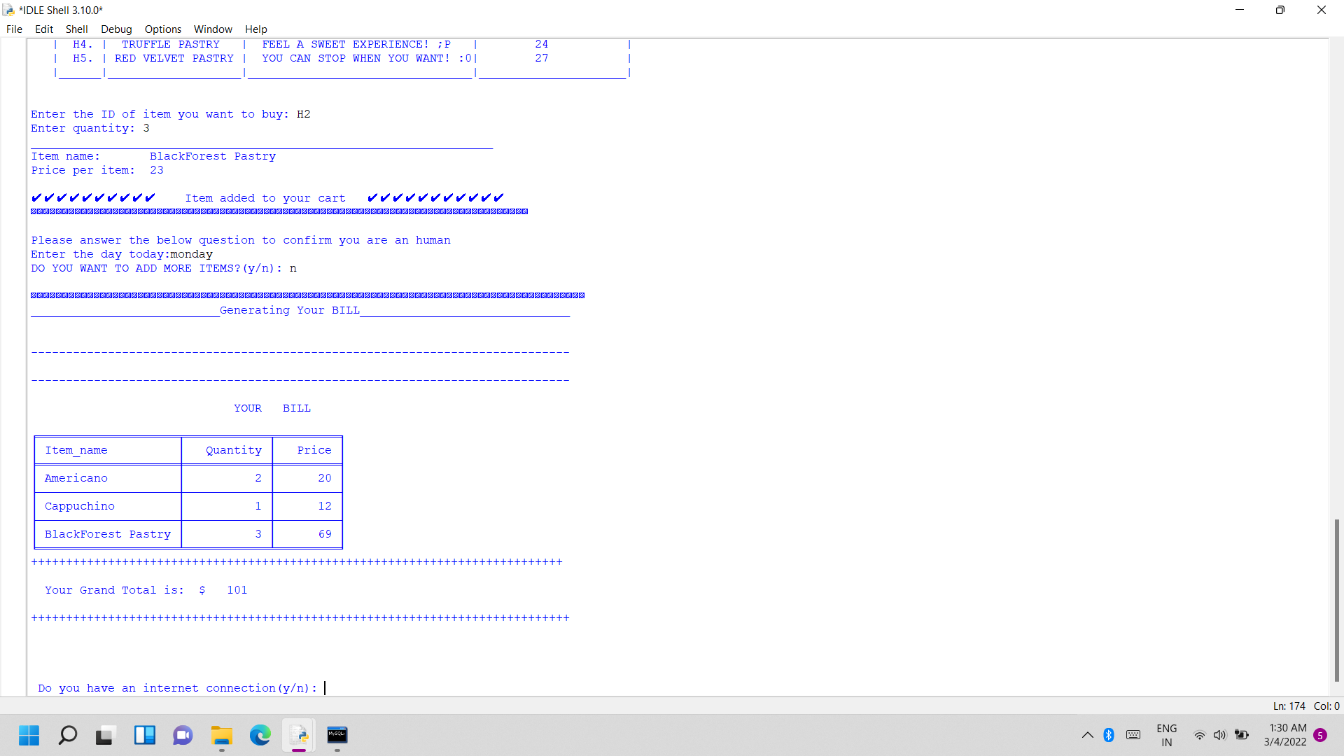

1. Making the customer enter his details and asking for the confirmation code to finalise the purchase:
2. Customer has an internet connection:

Customer entering yes(y) for internet connection:

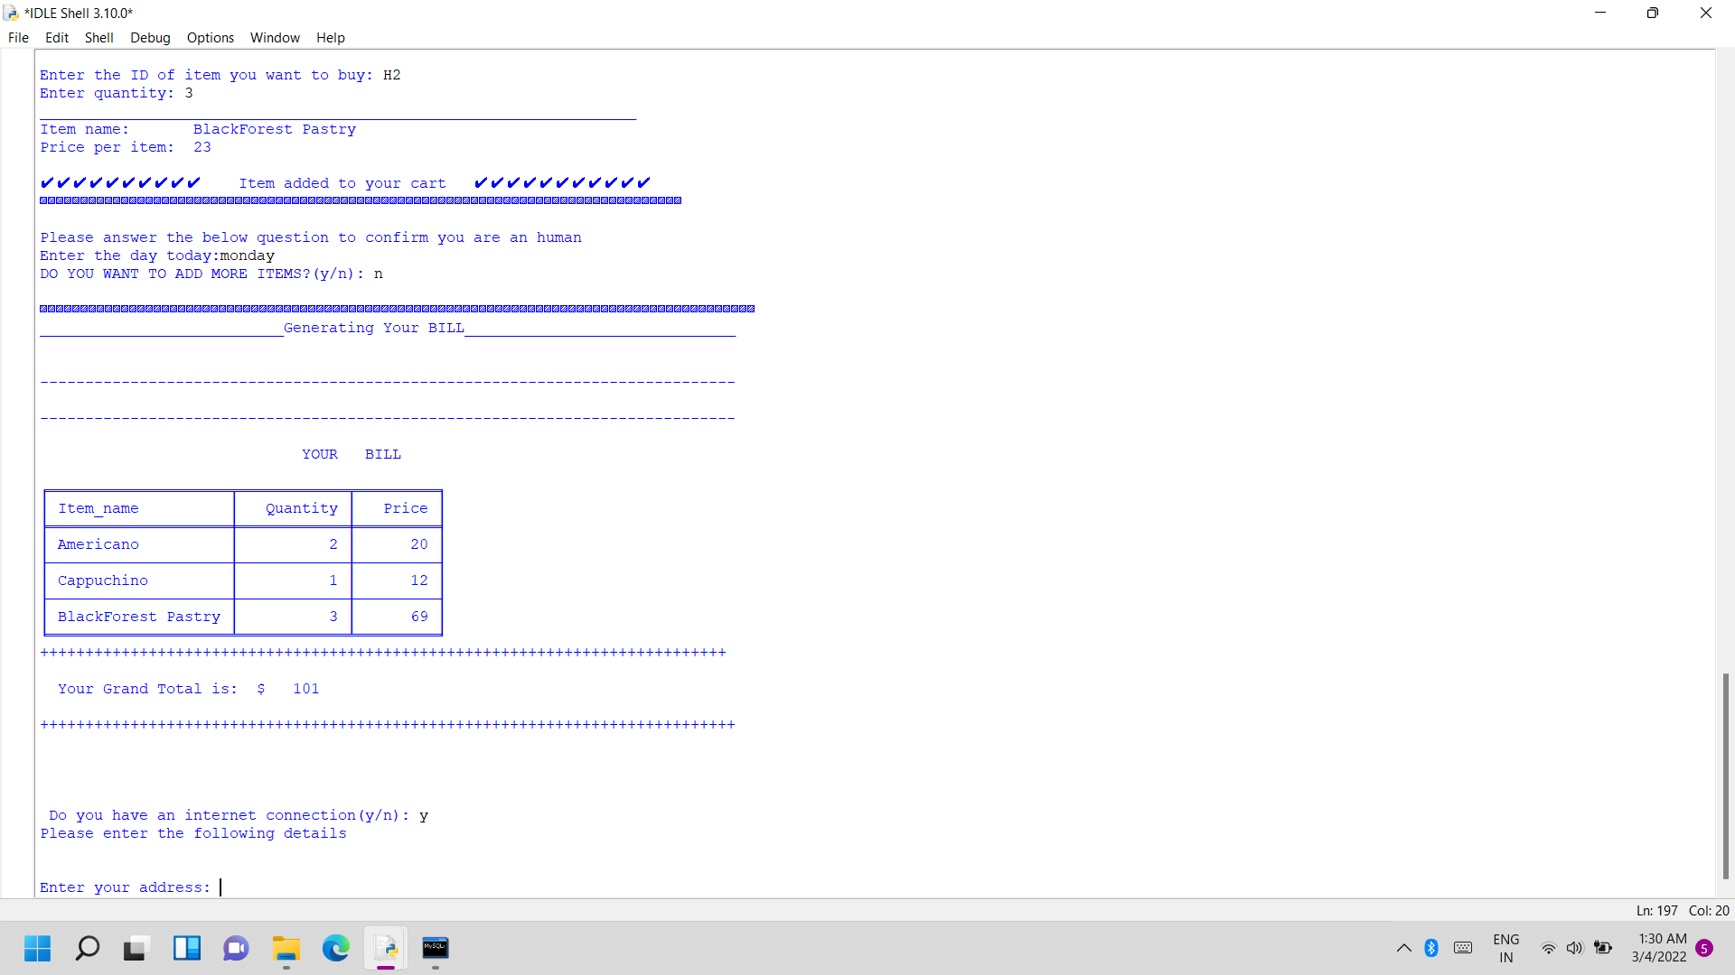

Customer entering details:

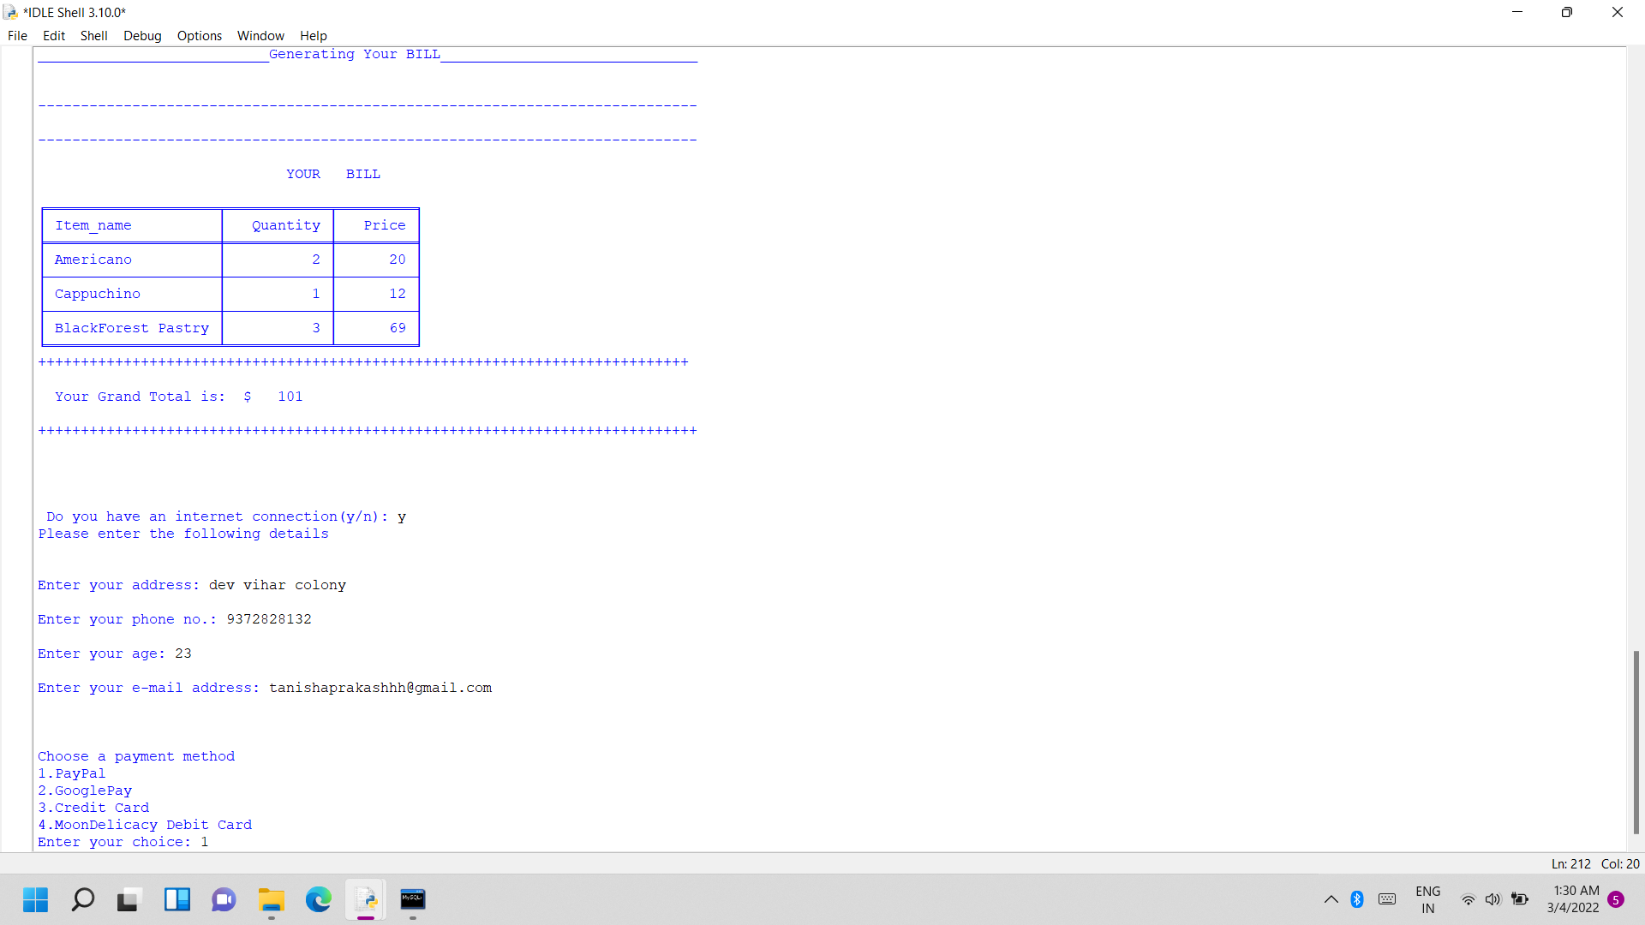

Confirmation code sent to email:

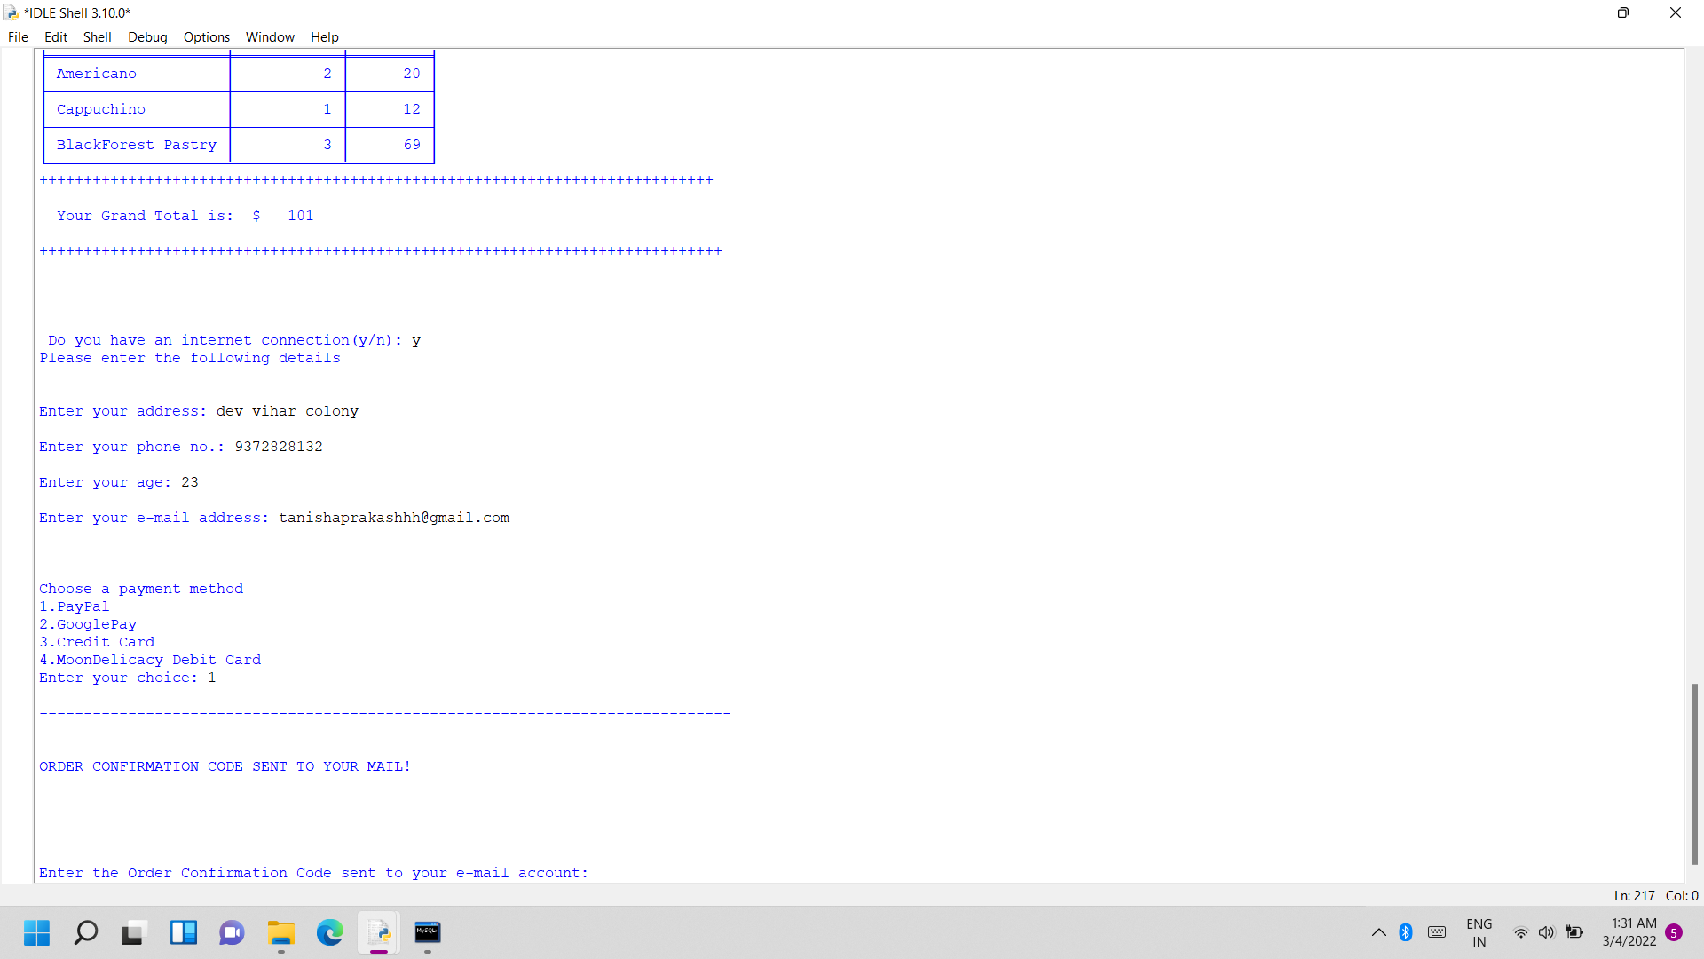

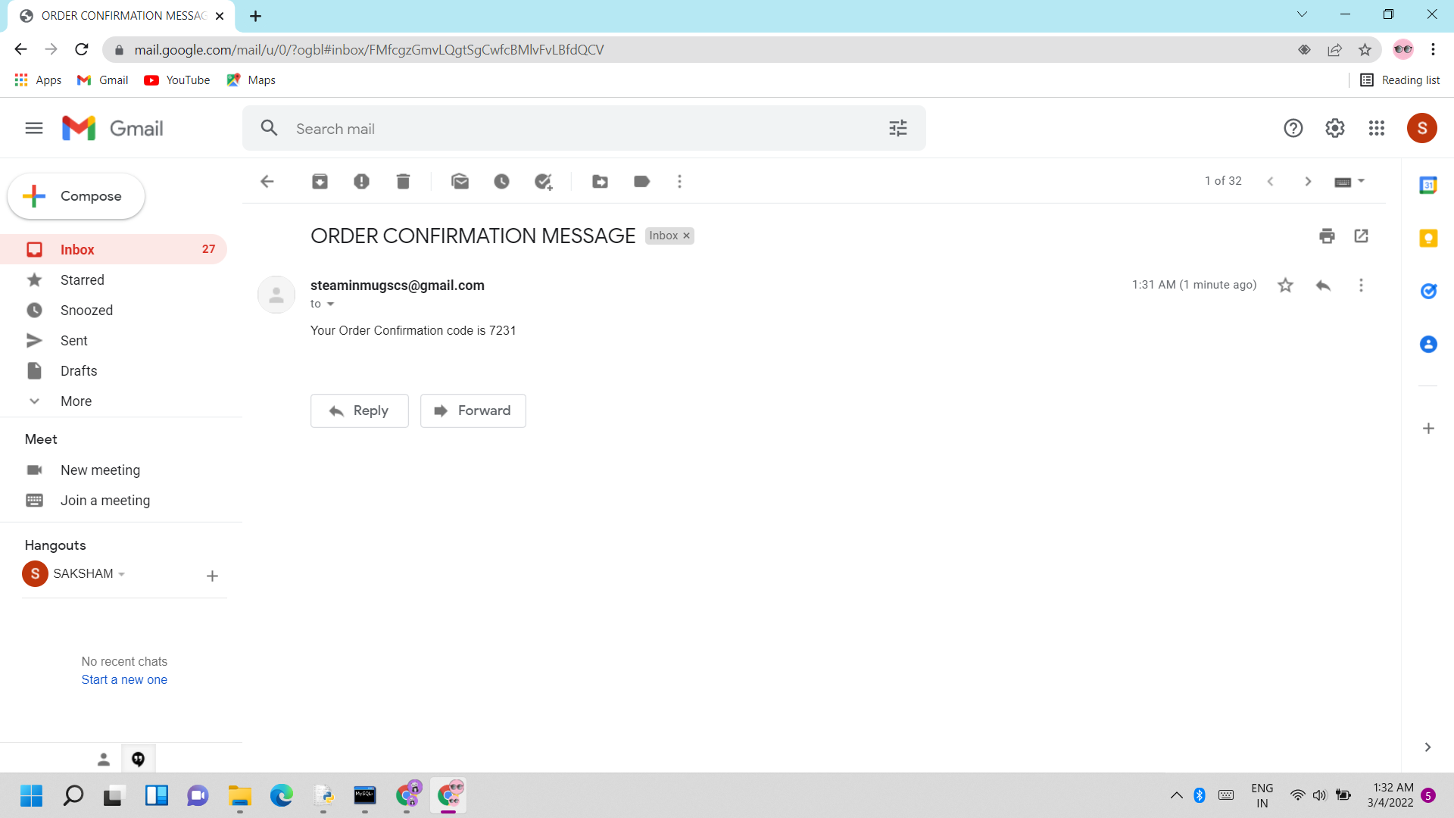

Customer entering the confirmation code in python:

If matches with the sent code:

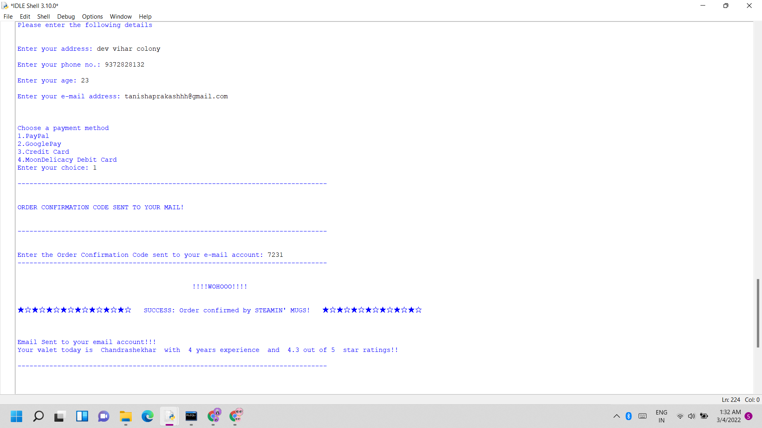

Success message displayed!

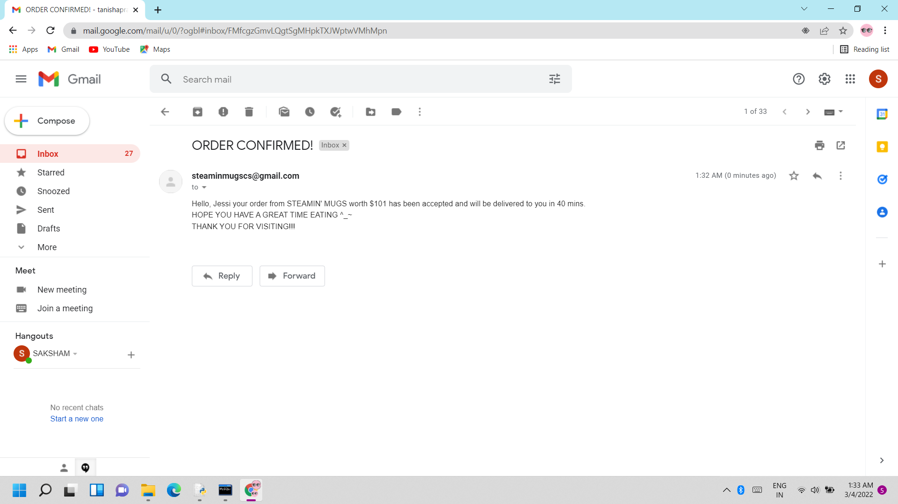

Order successful message sent to the entered email

If doesn’t match with the sent code:

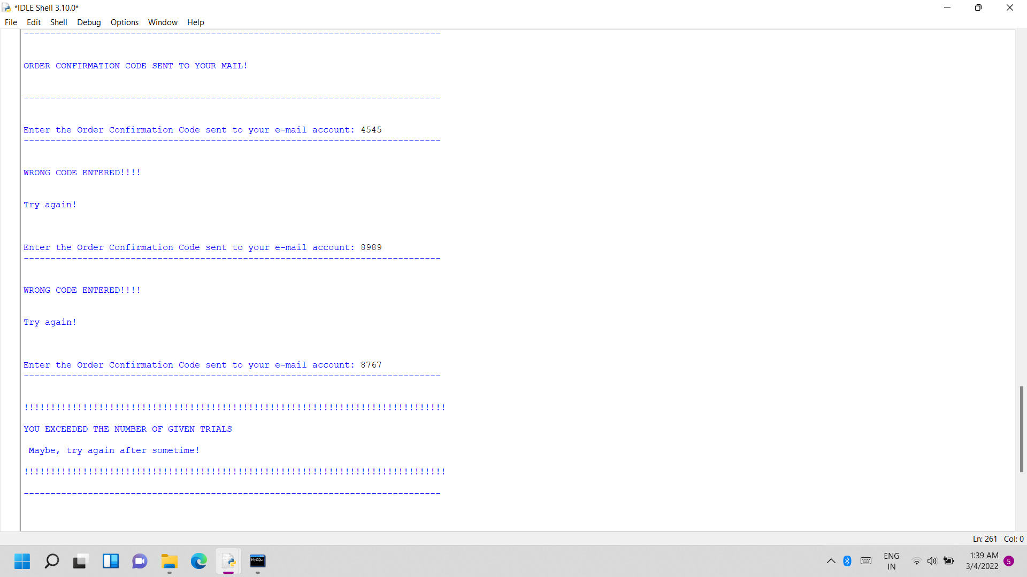

Exceeded given number of trials!

1. Customer doesn’t have an internet connection:

Customer enters no(n) for internet connection and enters details and the confirmation code displayed on screen itself.

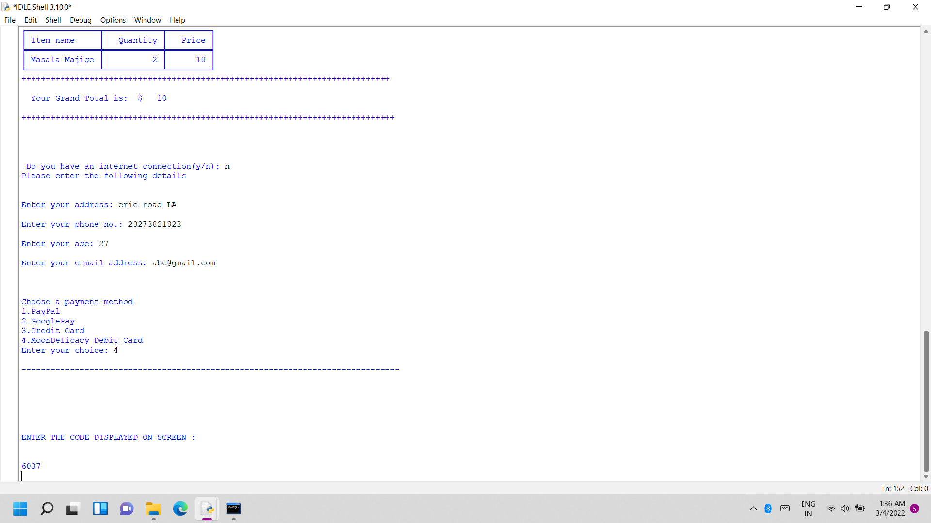

Confirmation code displayed on screen!

If matches with the displayed code:

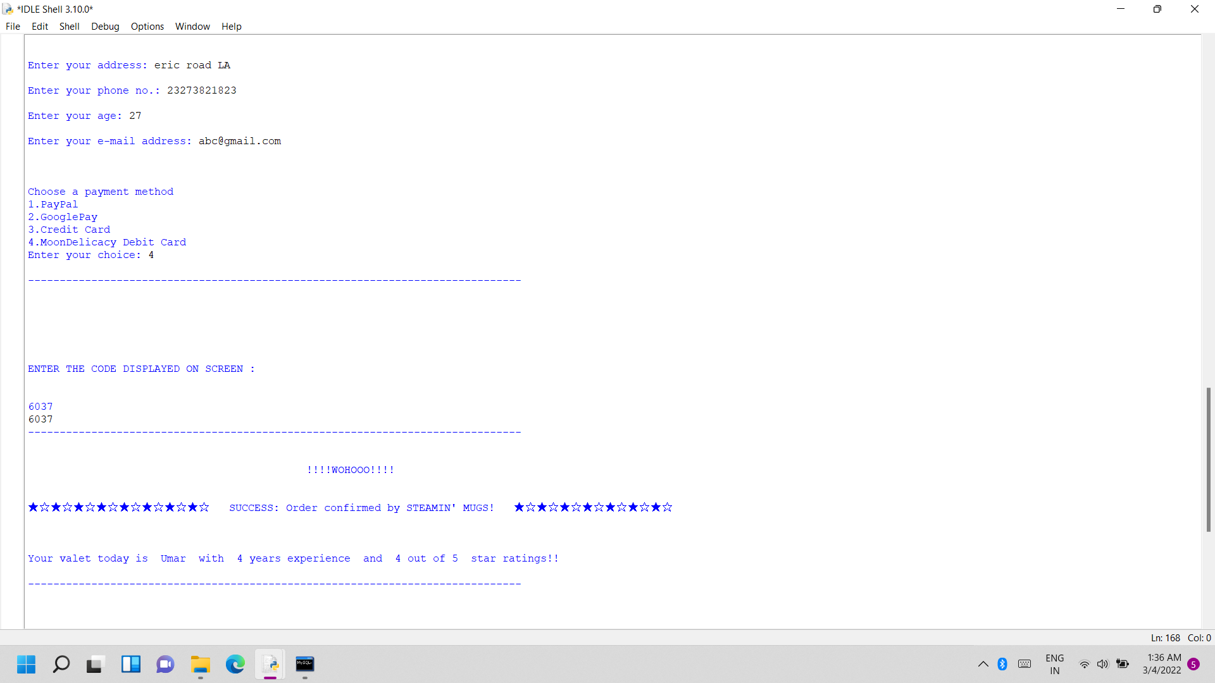

Success message displayed!

1. Making the customer rate our service and ending the customer program:

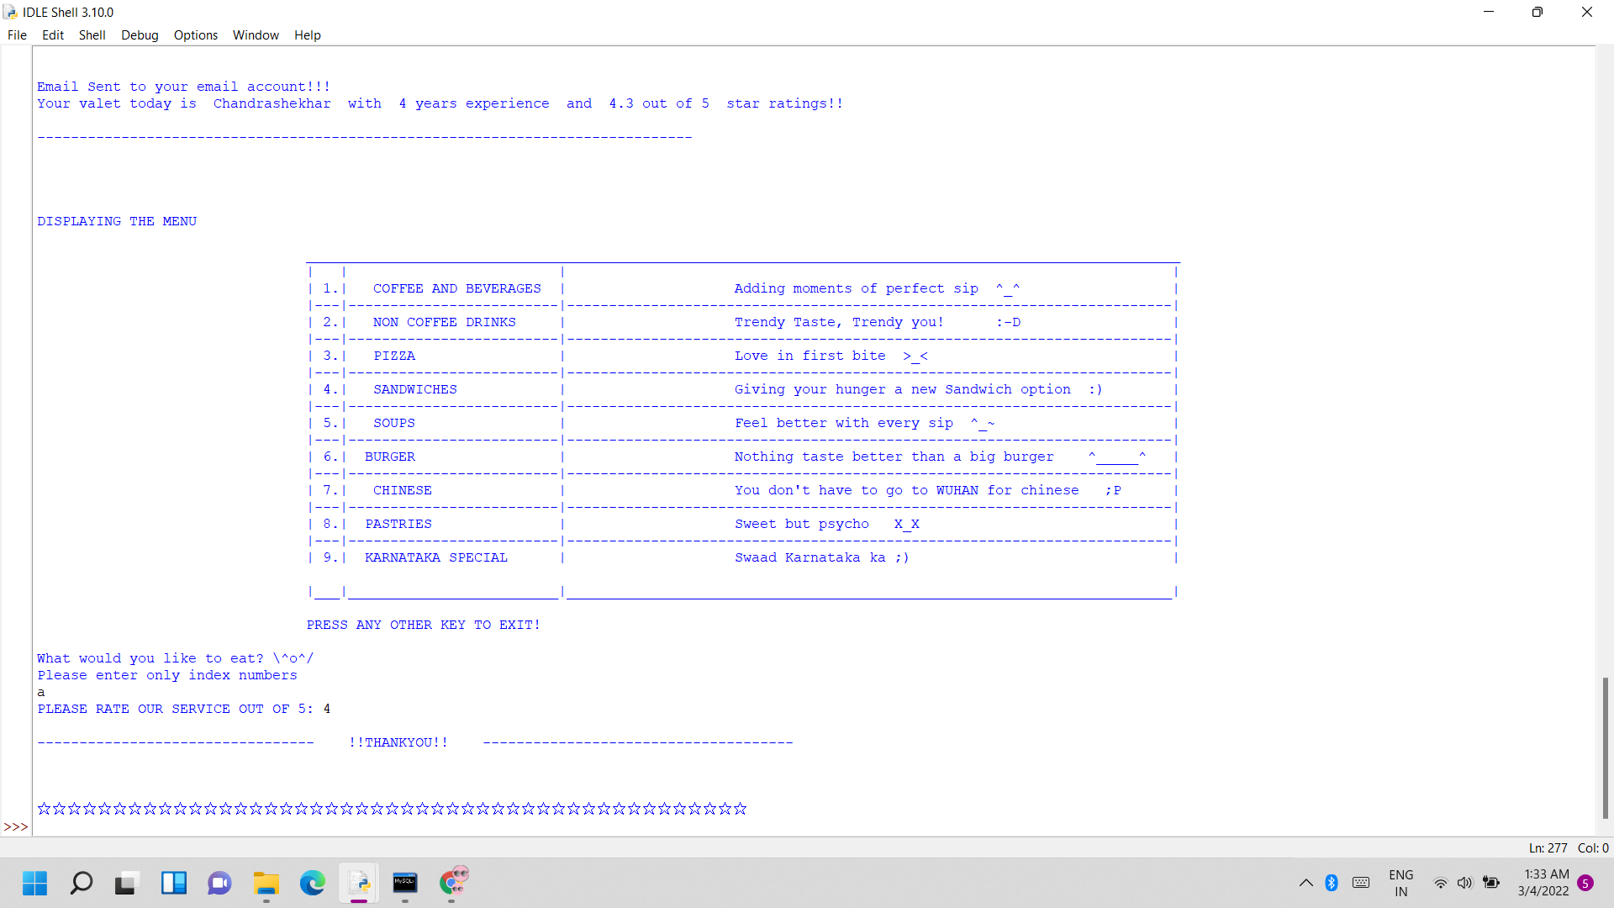

1. Customer record getting saved in csv file:

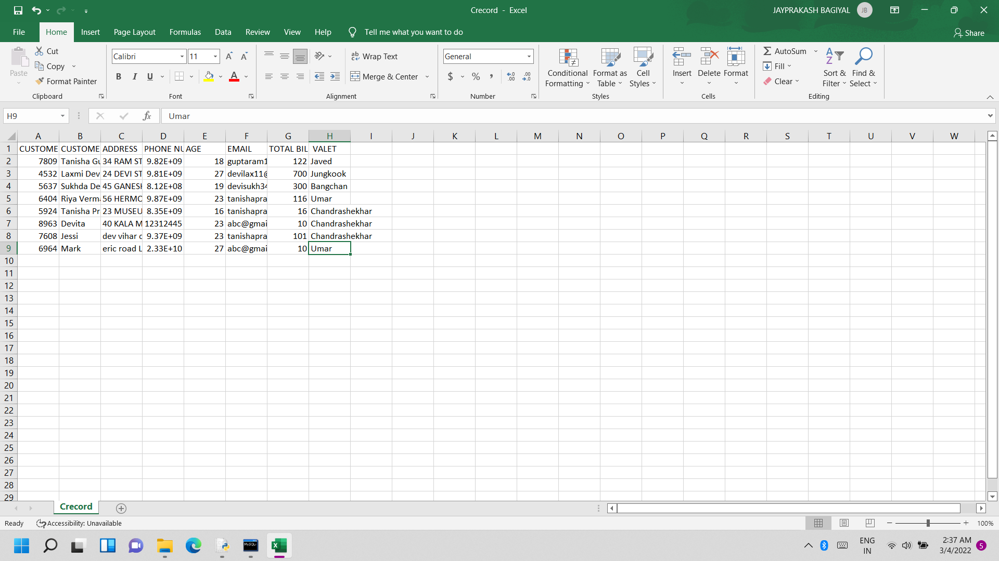

1. Retailer services:

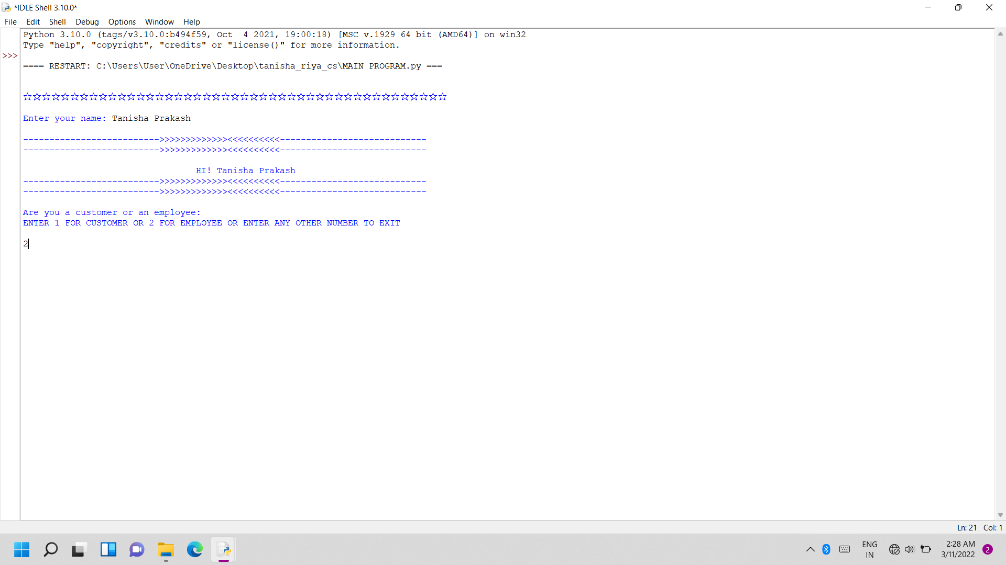

1. Asking verification password for retailer. If correct, then retailer tasks displayed otherwise the program ends for the user.

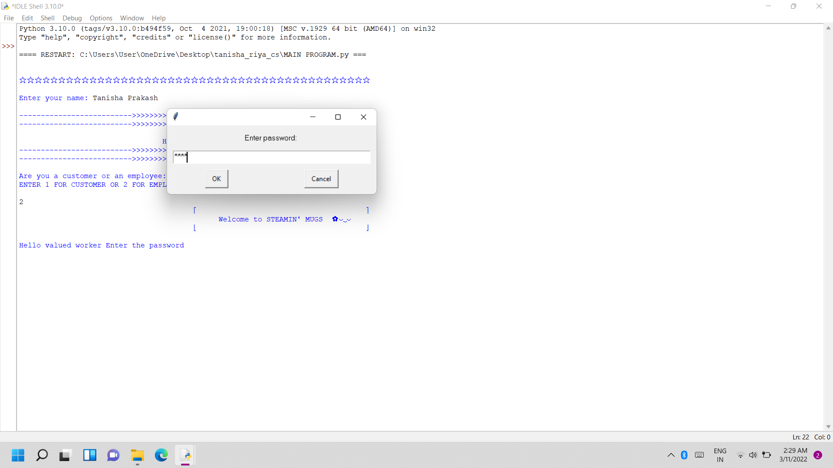

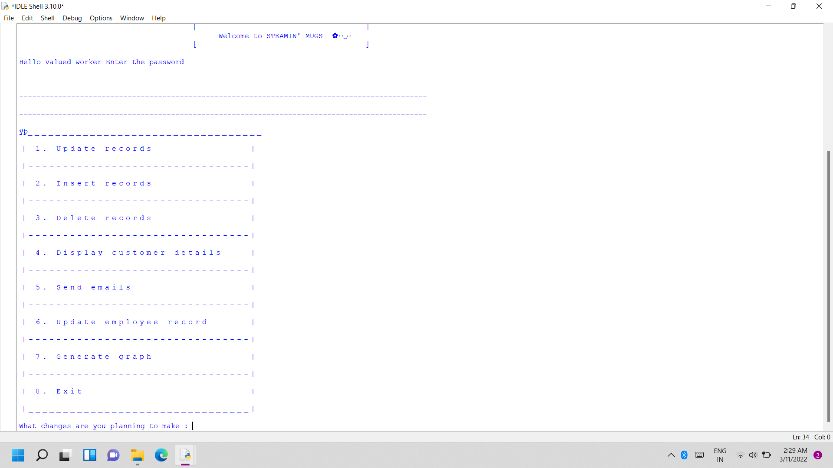

CORRECT PASSWORD!

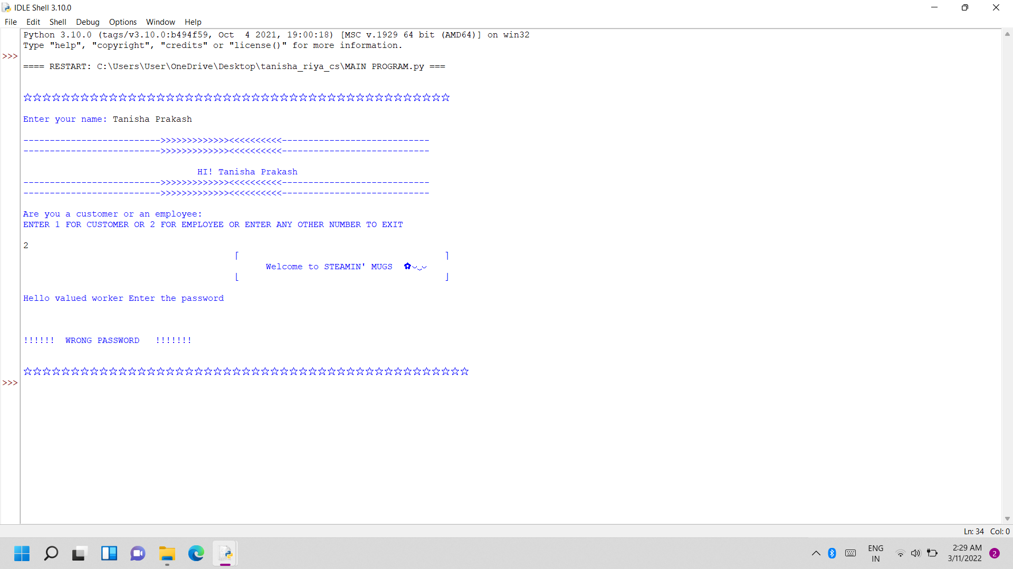

INCORRECT PASSWORD!

1. Updating item records
2. Updating price

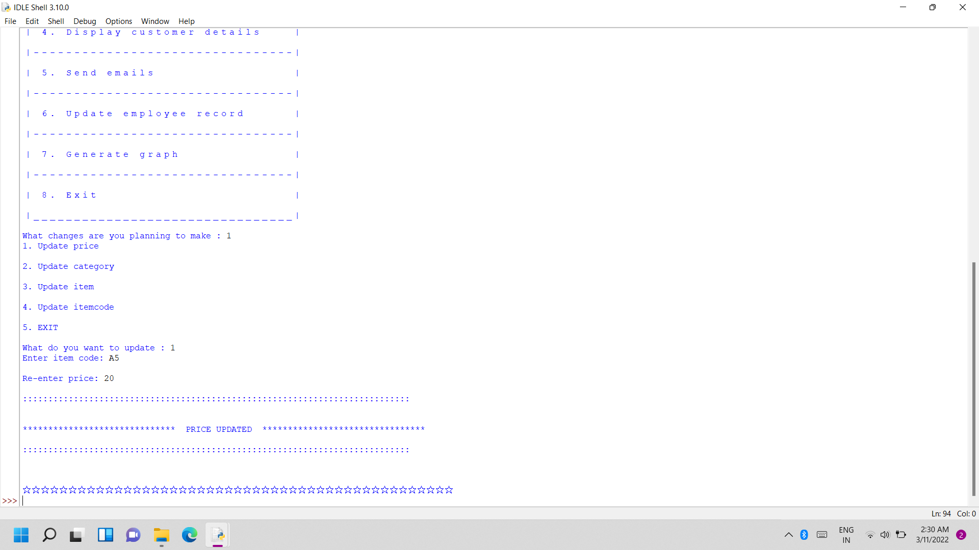

1. Updating category

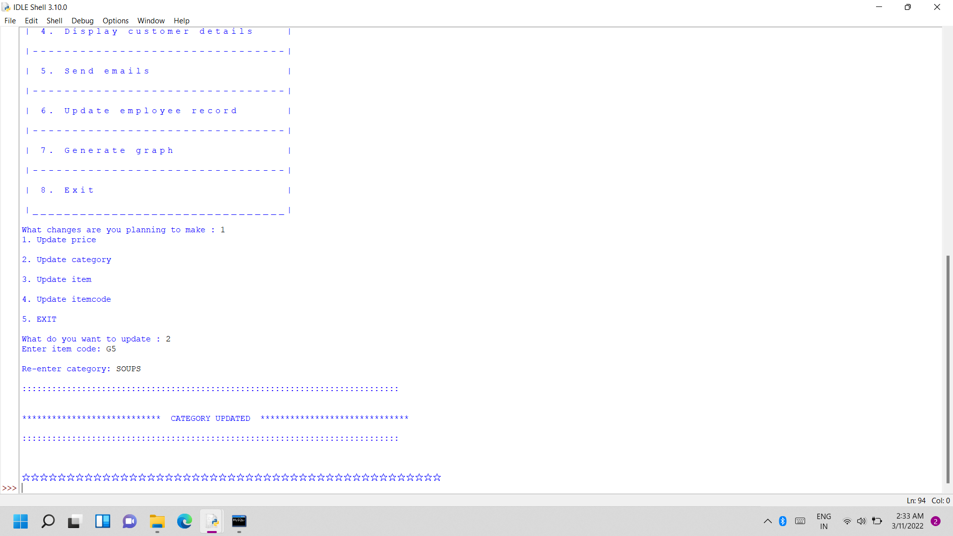

1. Updating item

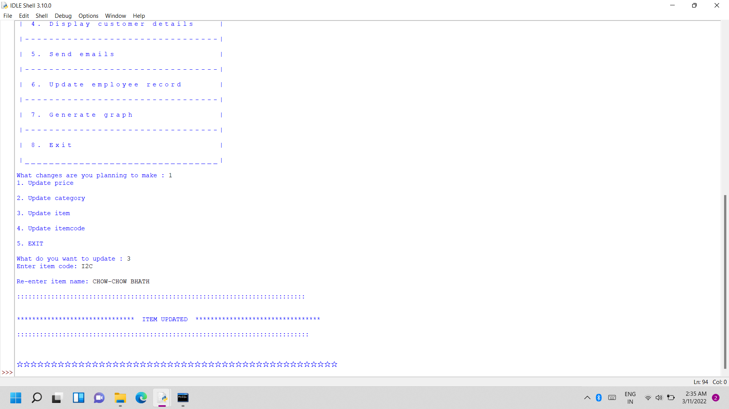

1. Updating itemcode

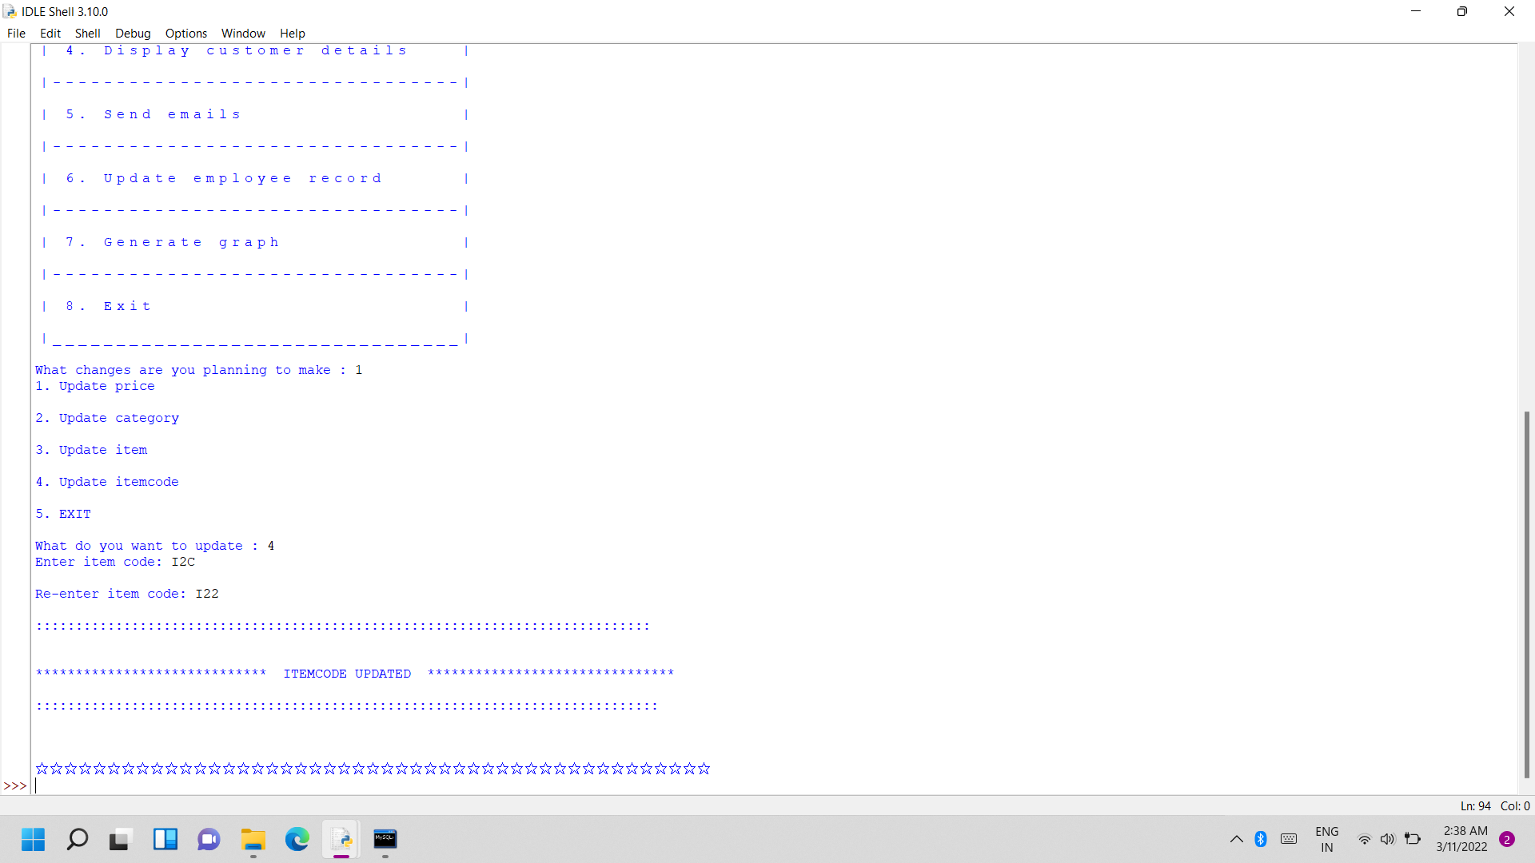

1. Exit

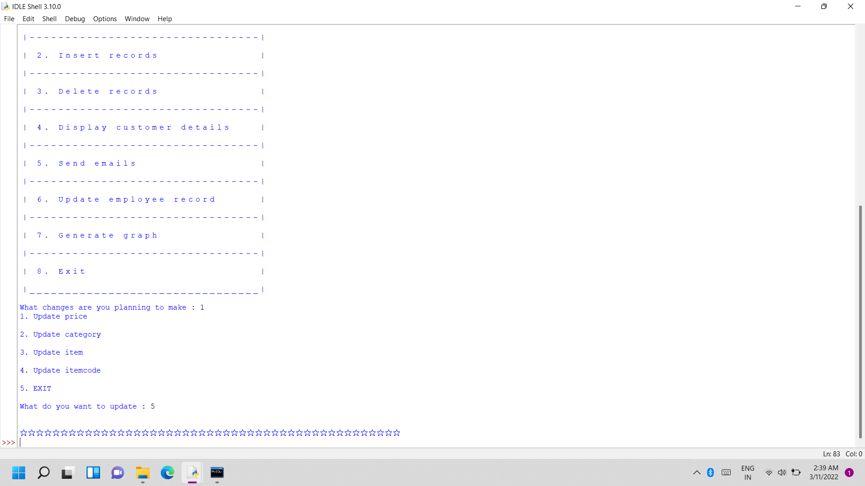

1. Inserting item to the menu table

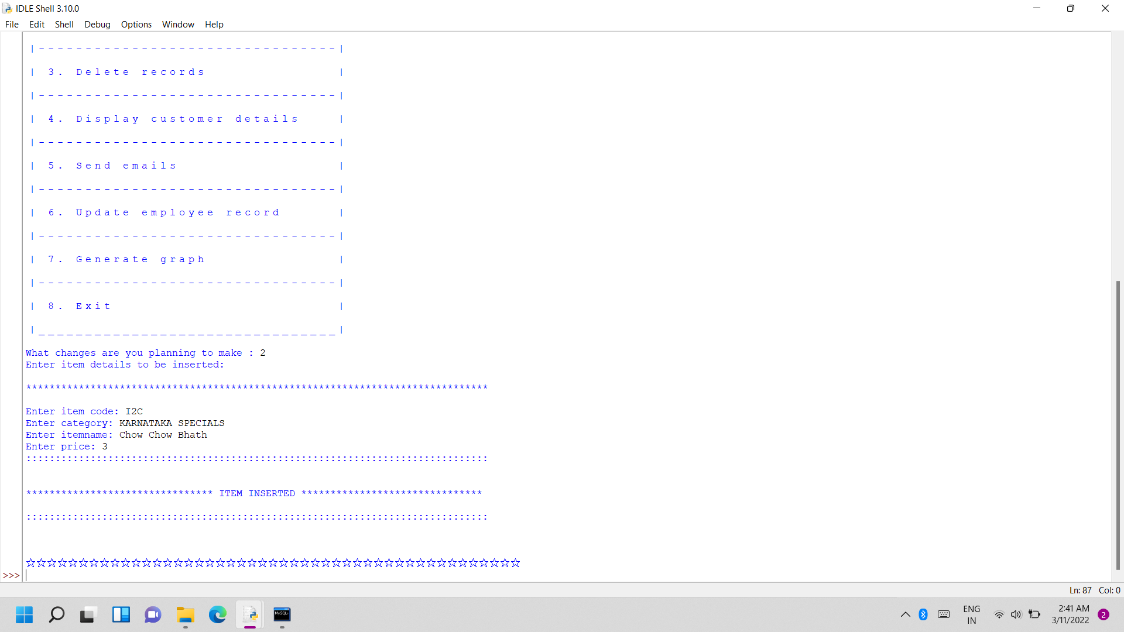

ITEM INSERTED!

1. Deleting records from menu file

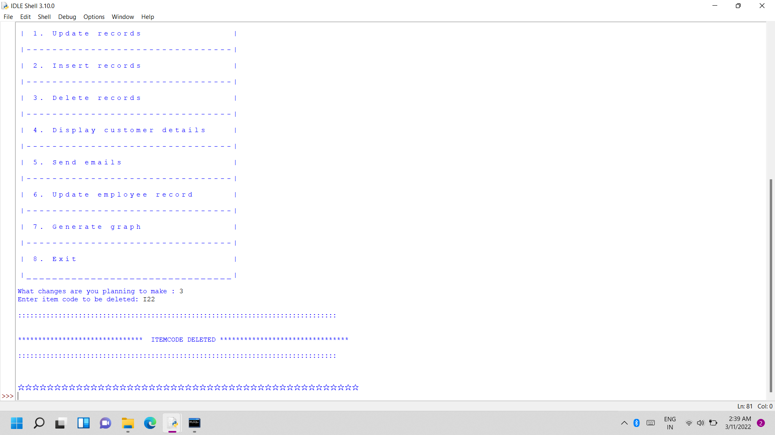

ITEM DELETED!

1. Displaying customer details:

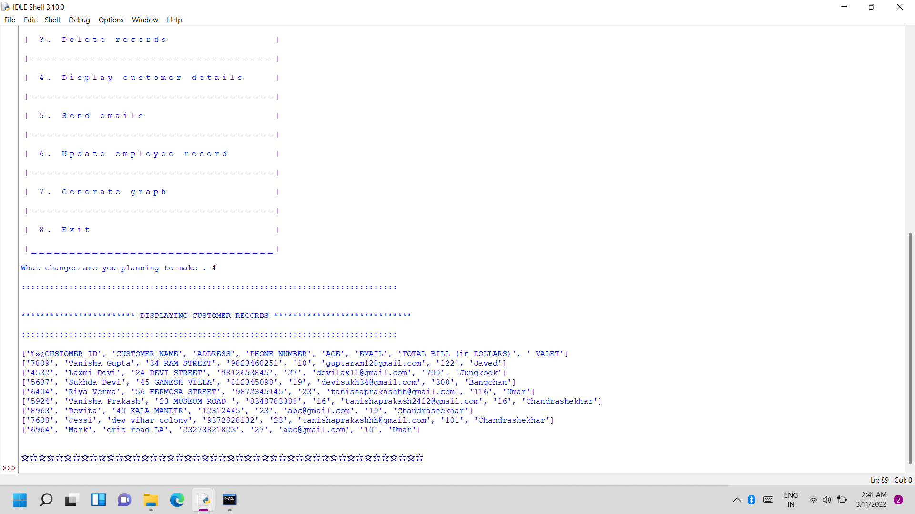

DISPLAYING CUSTOMER RECORDS

1. Sending emails:
2. To all the customers

Forming the message to be sent

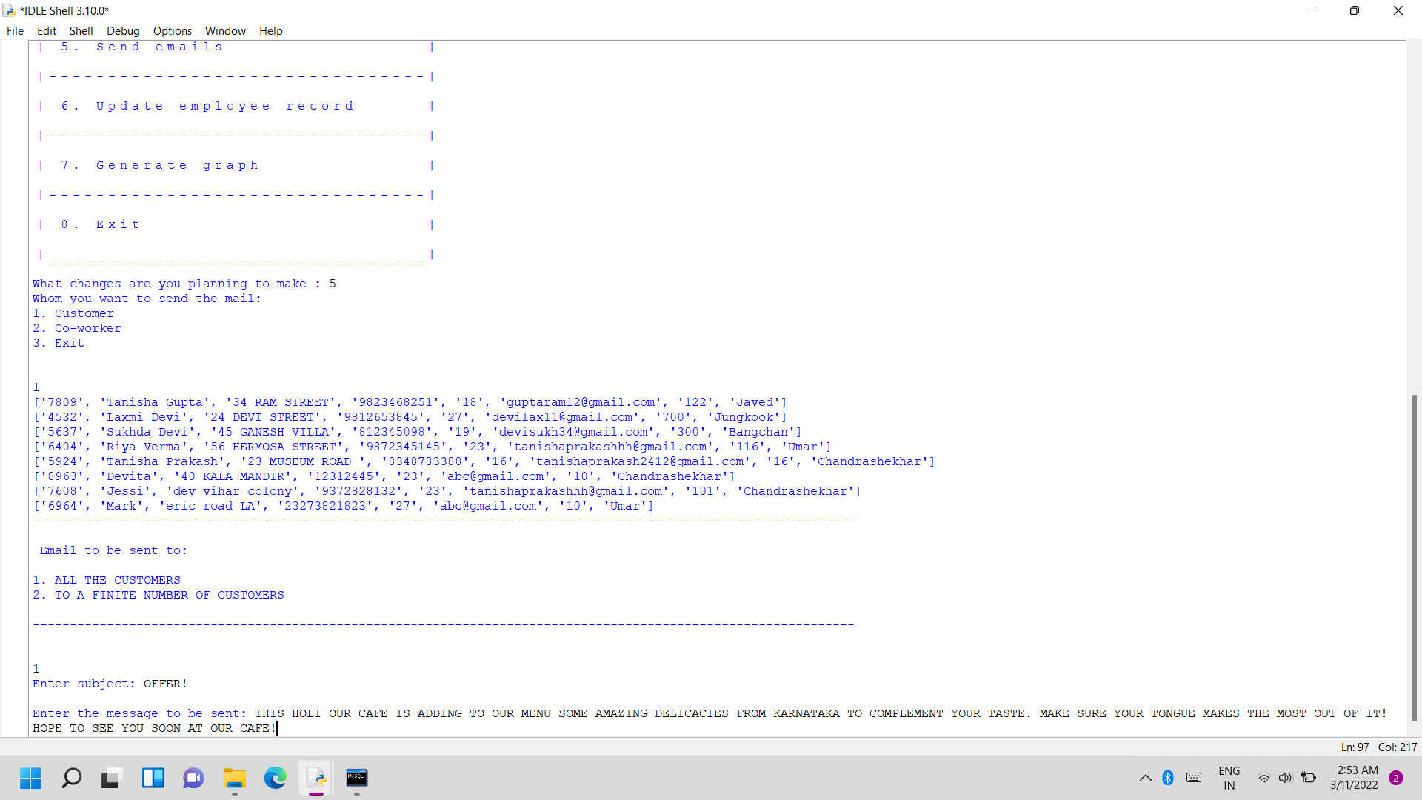

FRAMING THE MESSAGE TO BE SENT TO ALL CUSTOMERS

Email sent to all customers:

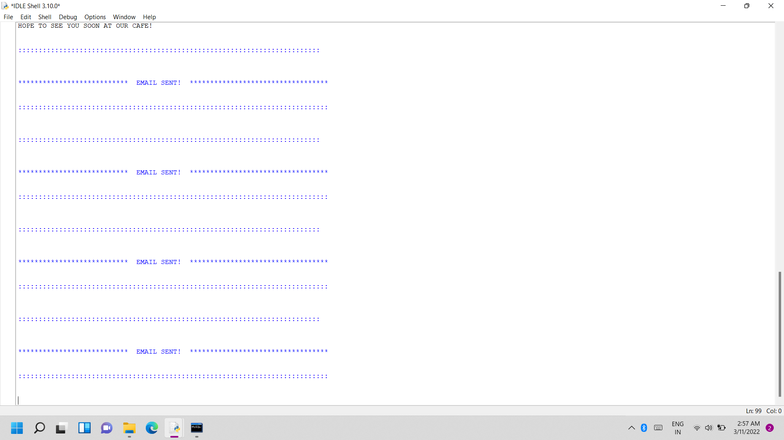

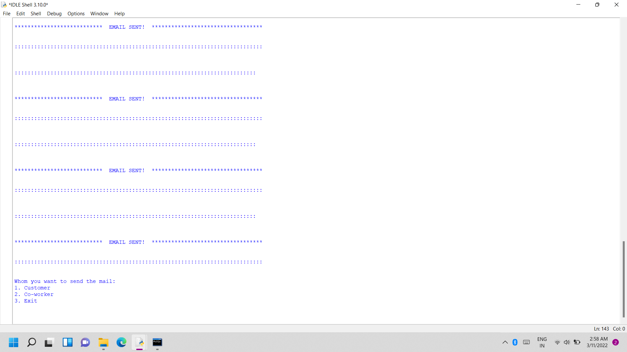

EMAIL SENT TO ALL CUSTOMERS

1. To only a specific customer:

Framing the message to be sent:

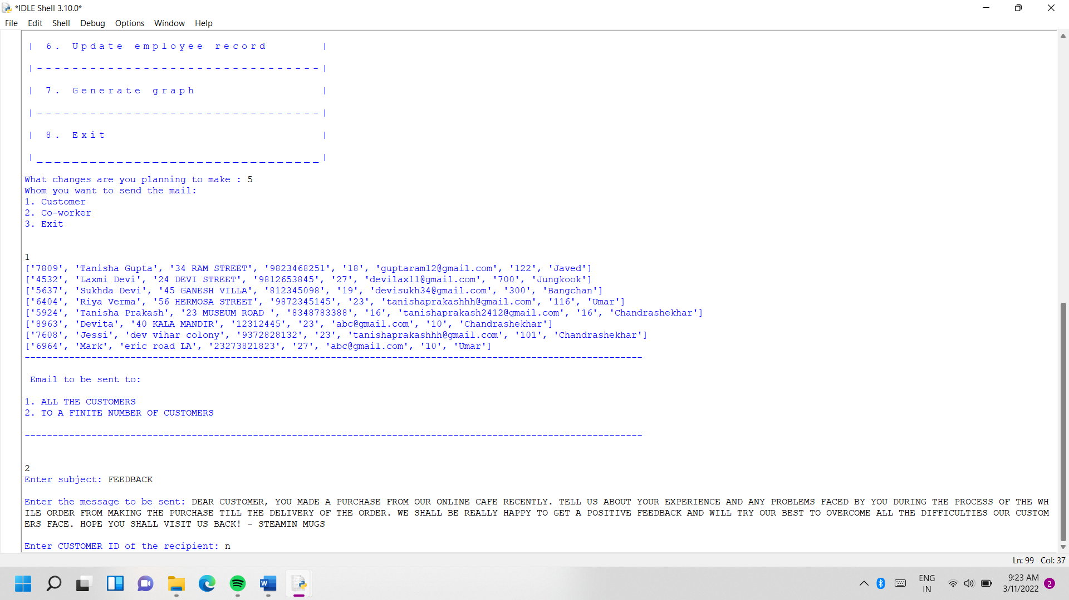

FRAMING THE MESSAGE TO BE SENT TO THE CUSTOMER

Email sent to a particular customer:

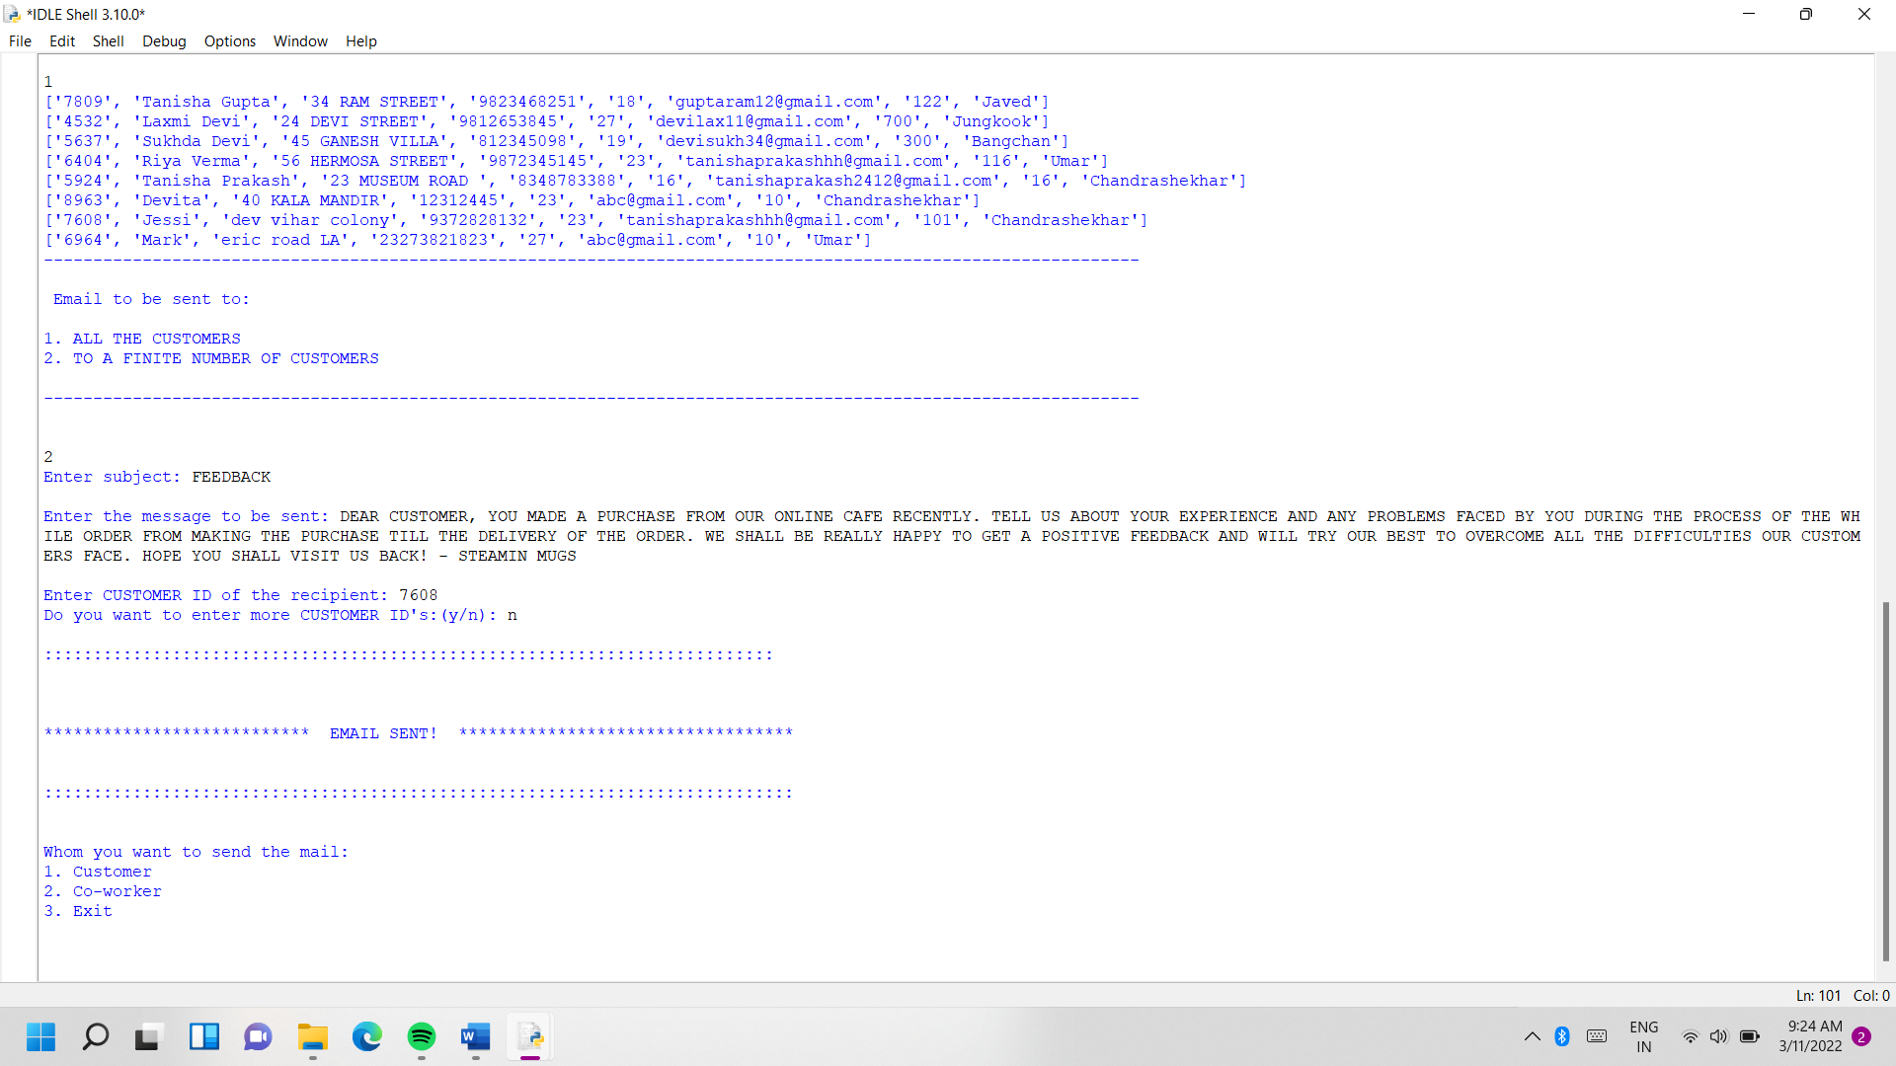

EMAIL SENT TO THE CUSTOMER

1. To all the employees:

Framing the message to be sent:

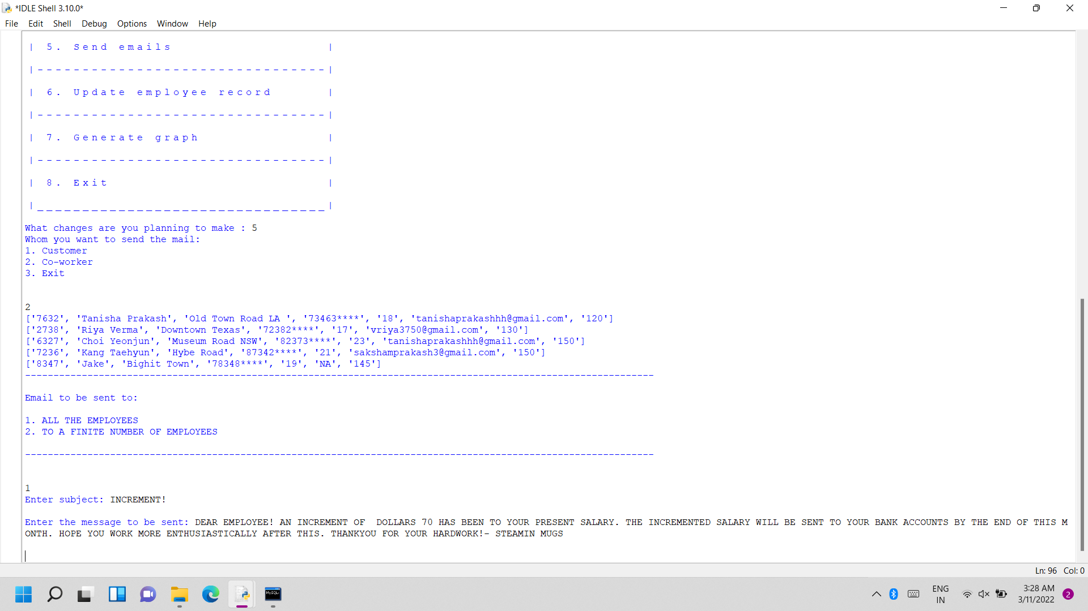

FRAMING THE MESSAGE TO BE SENT TO ALL EMPLOYEES

Email sent to all the employees:

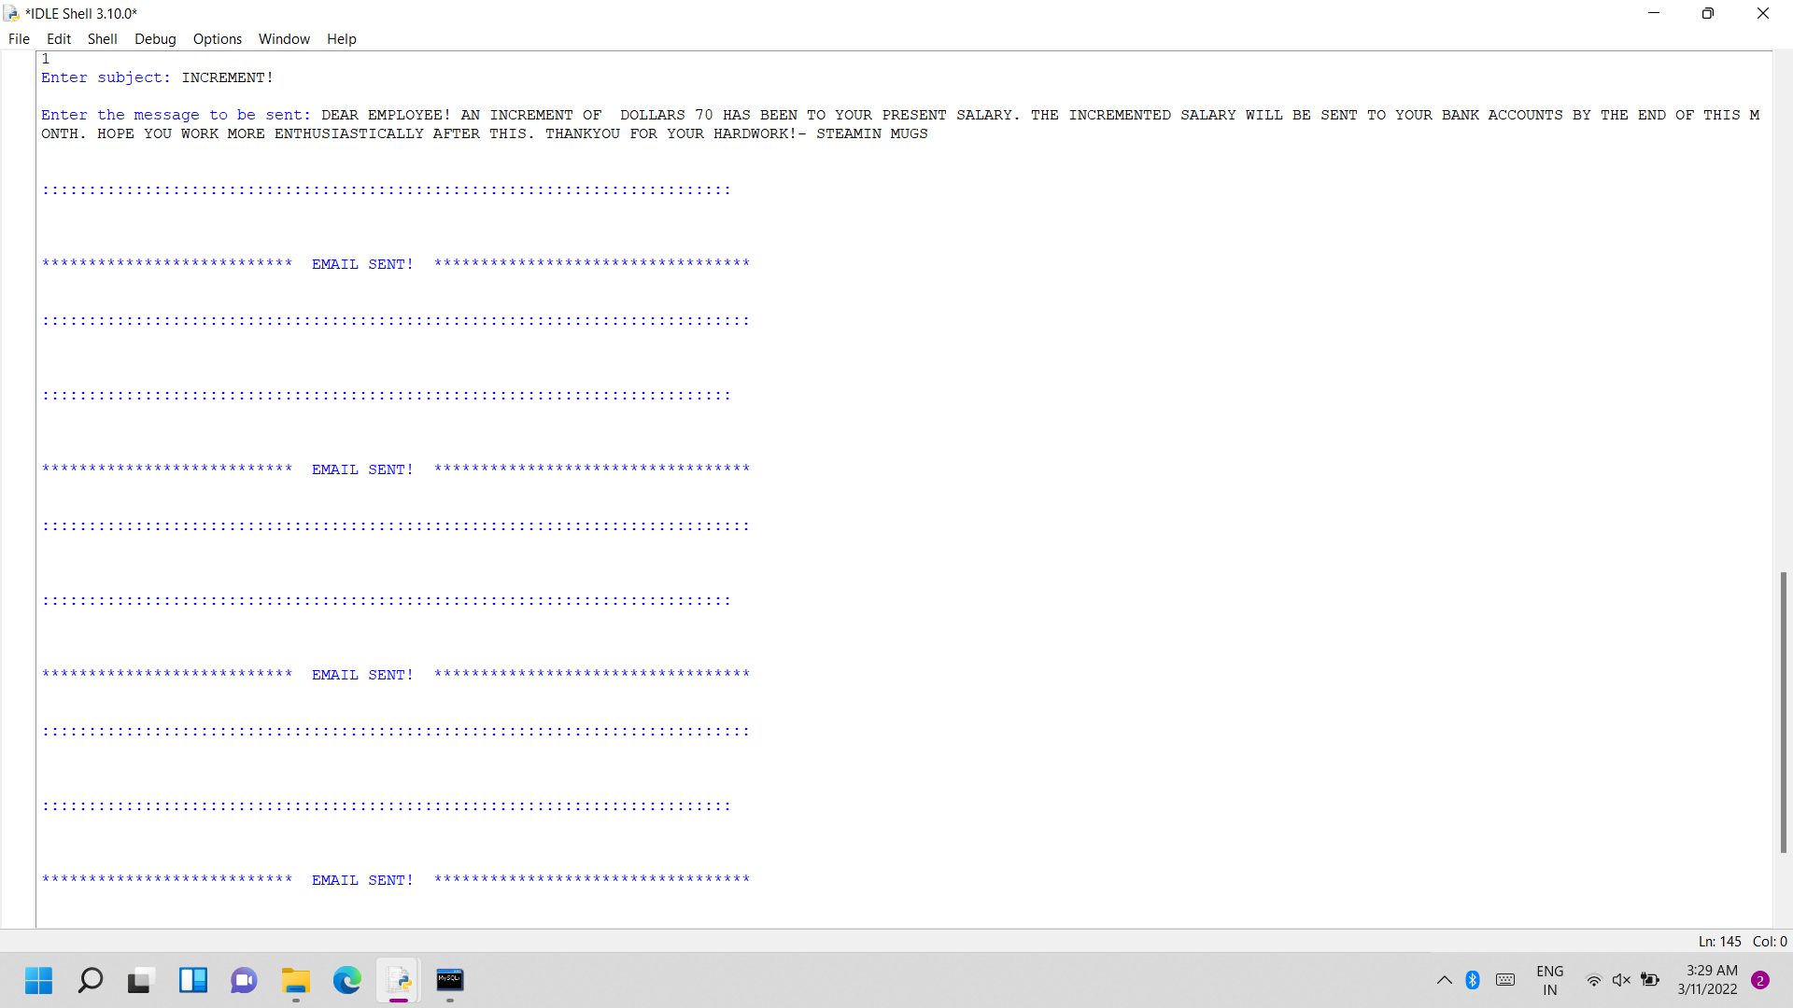

EMAIL SENT TO ALL EMPLOYEES

1. To a particular employee:

Framing the message to be sent:

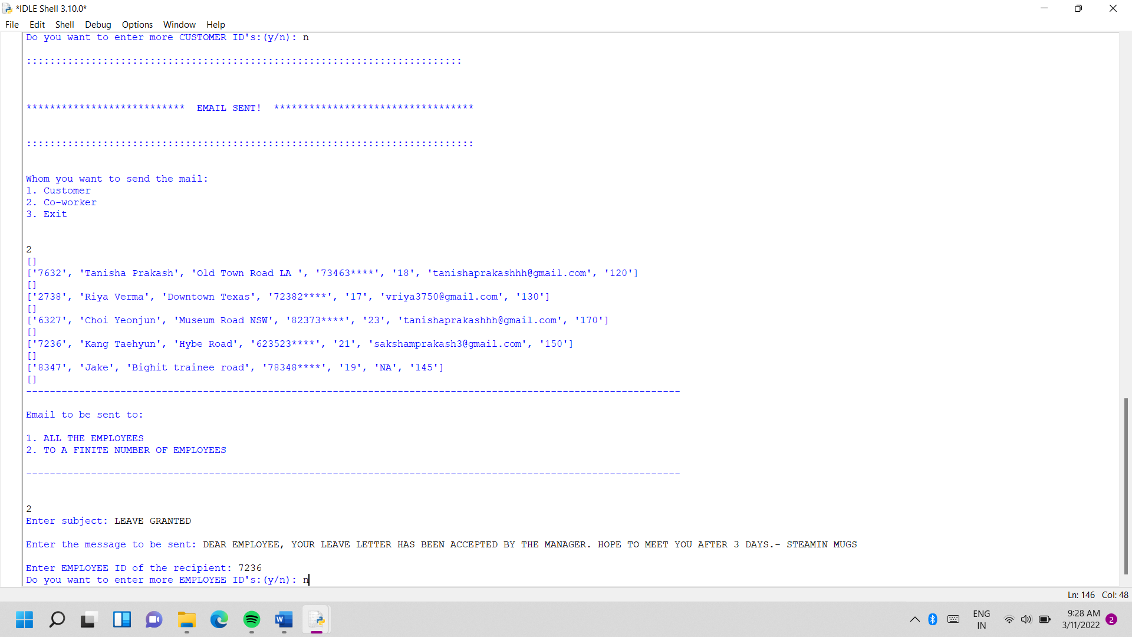

FRAMING MESSGE TO BE SENT TO THE EMPLOYEE

Email sent to the particular employee:

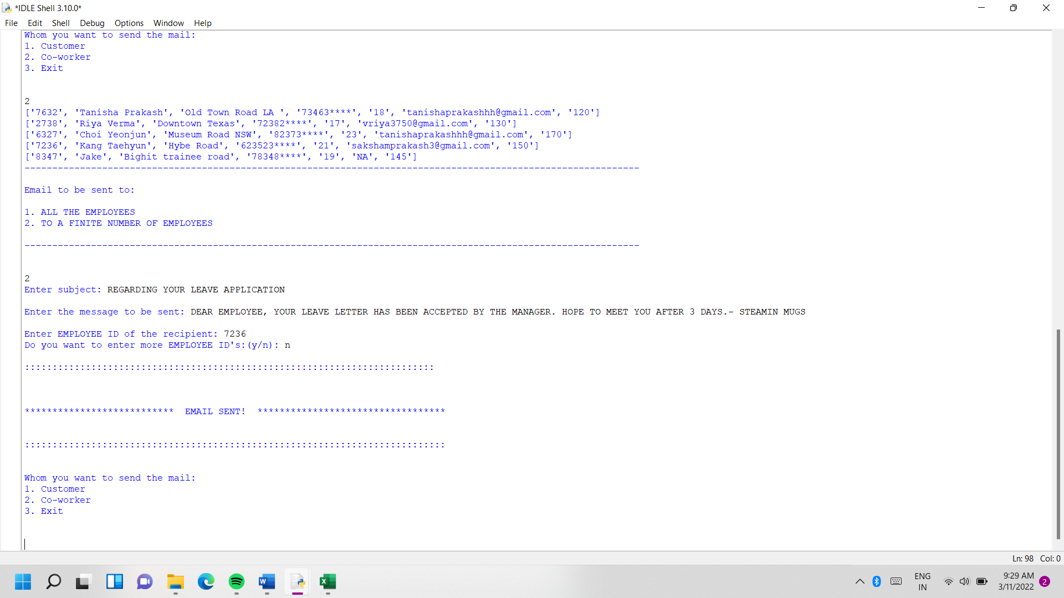

EMAIL SENT TO THE EMPLOYEE

1. Updating employee records (service only available for the head employee):
2. entering password as a head employee, if correct allowed to make changes, otherwise forbidden to make the changes:

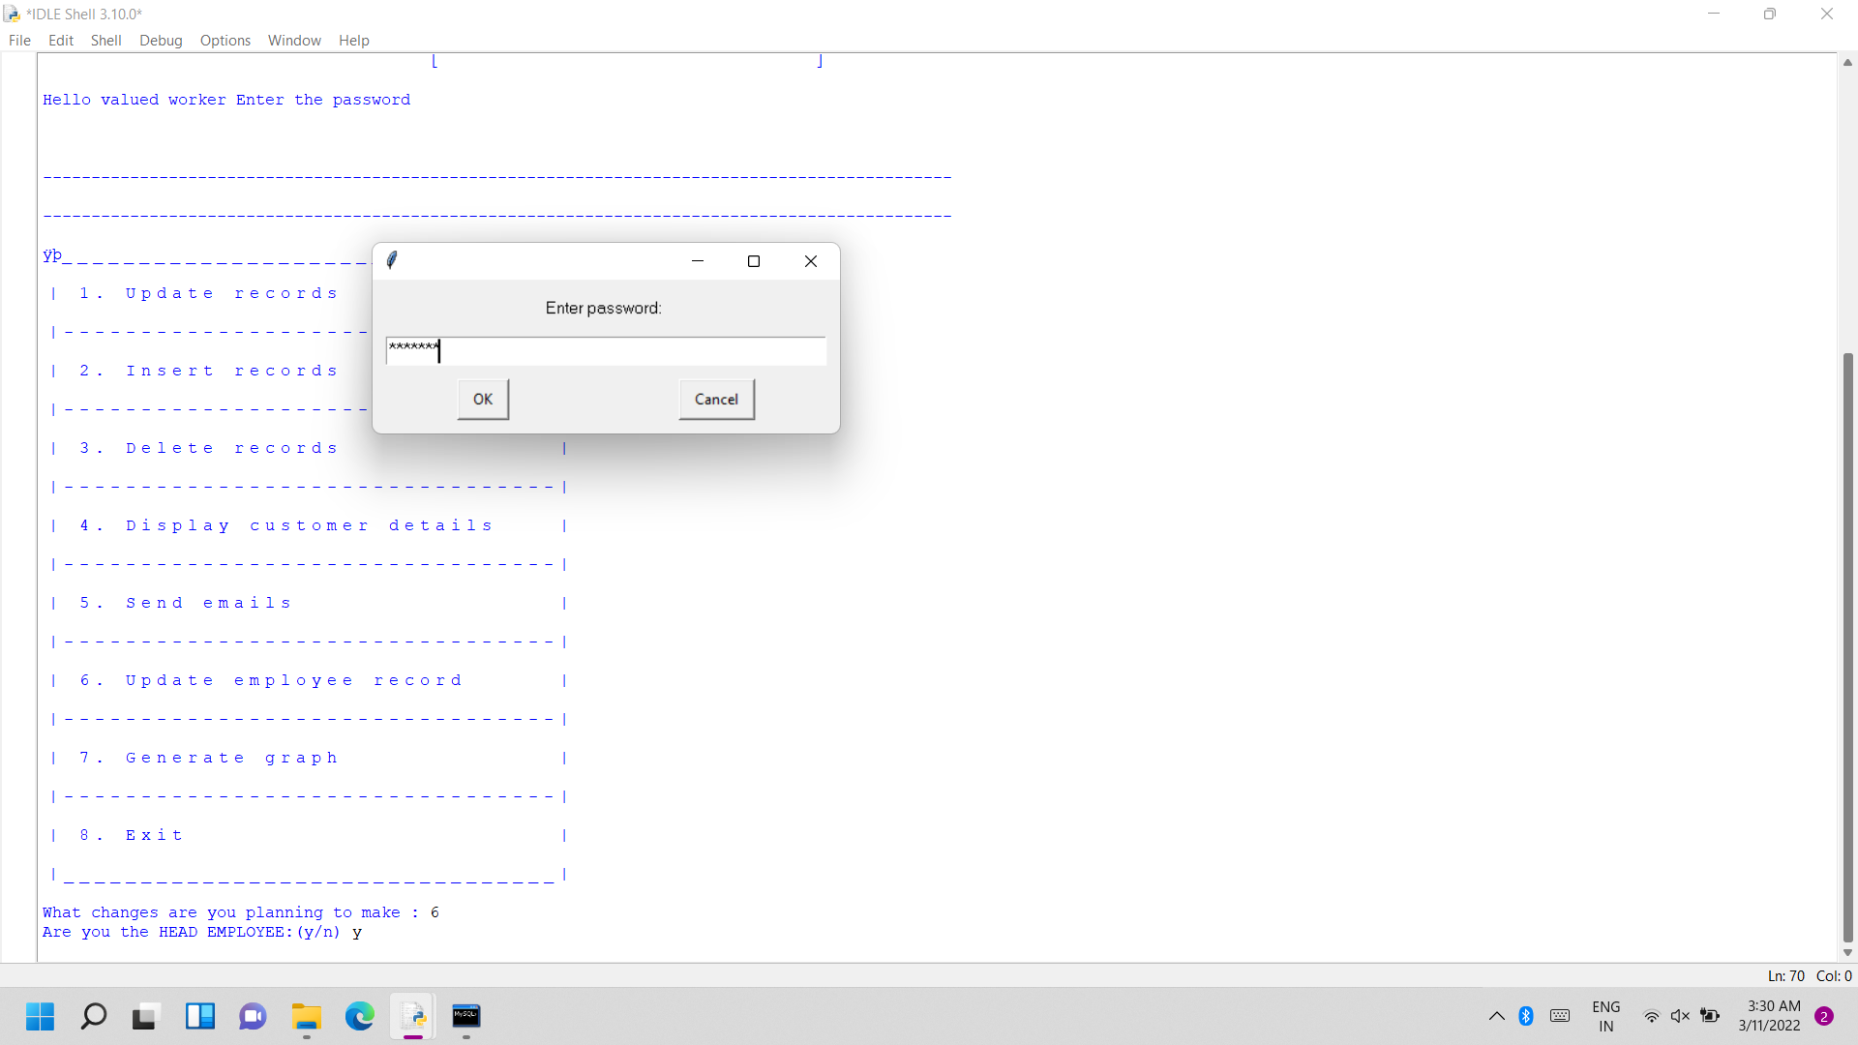

If password incorrect:

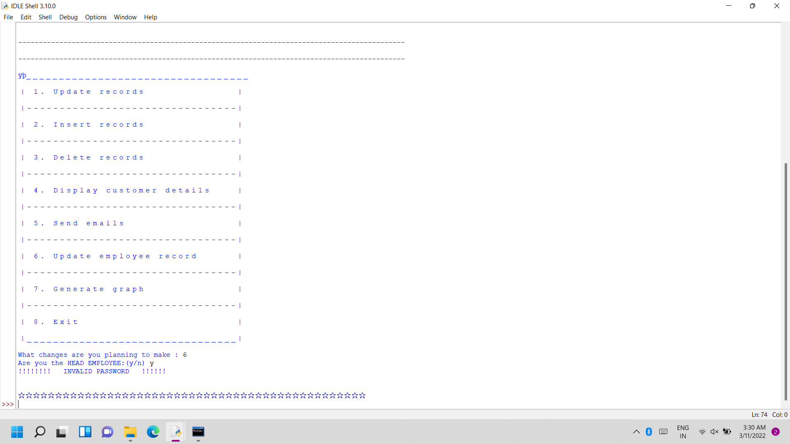

PASSWORD INCORRED, SO NOT ALLOWED TO MAKE CHANGES IN THE EMPLOYEE FILE

If password correct:

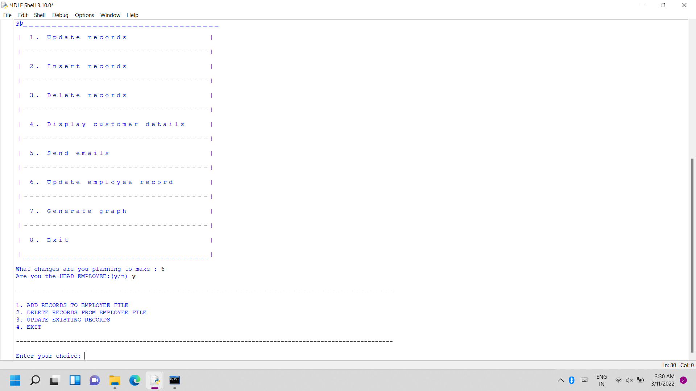

PASSWORD CORRECT, SO CHOICES DISPLAYED

1. adding records to the employee file:

Entering the new employee details:

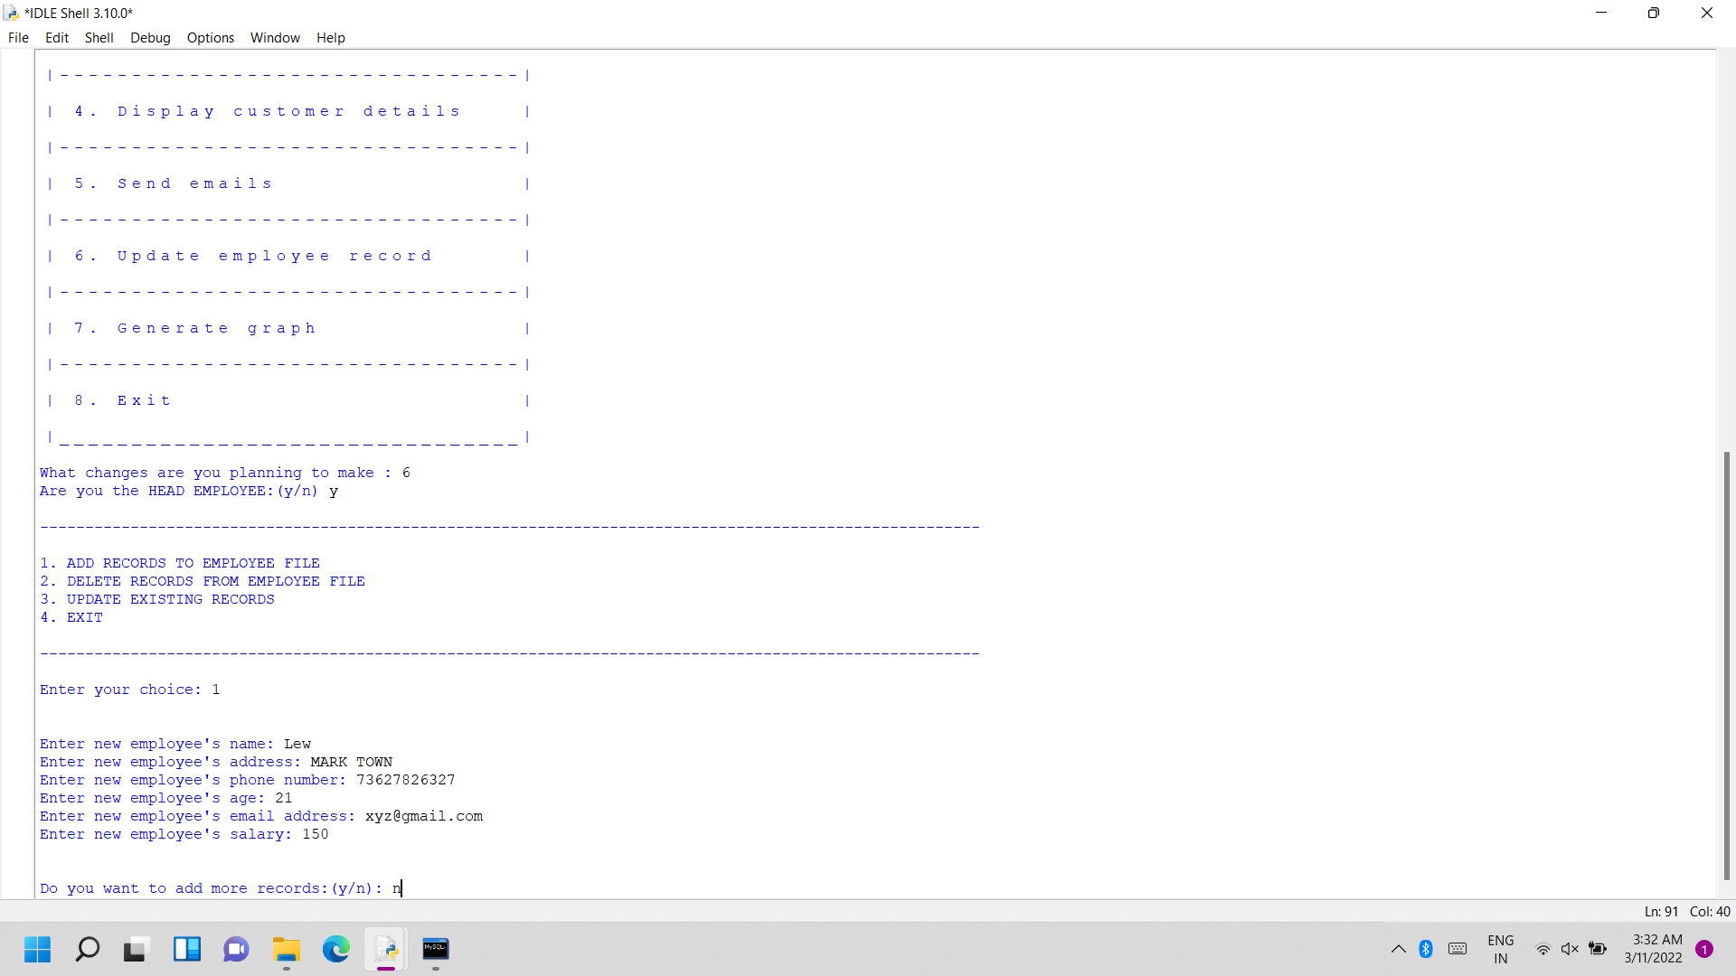

Details added to the customer file:

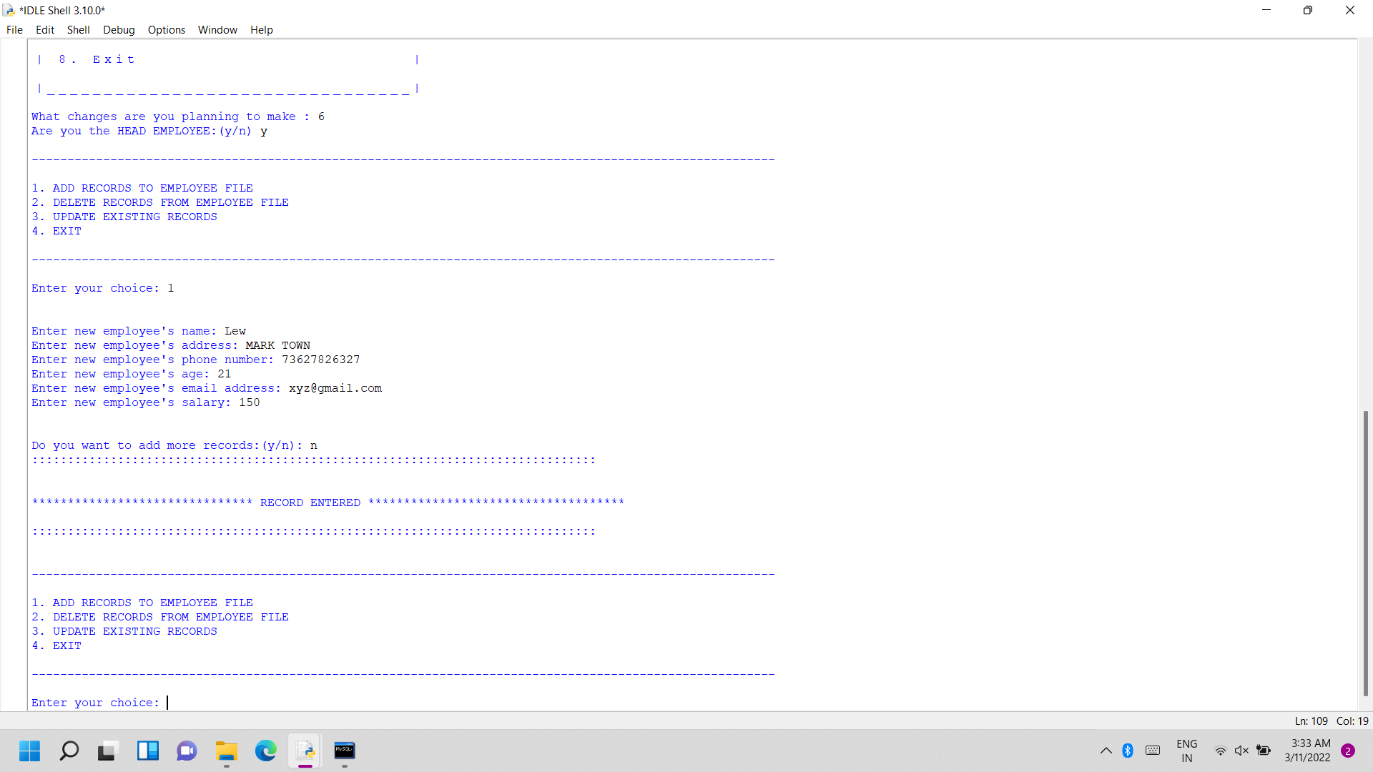

RECORD ENTERED

1. deleting record from the employee file:

entering the employee id of the employee whose details has to be deleted:

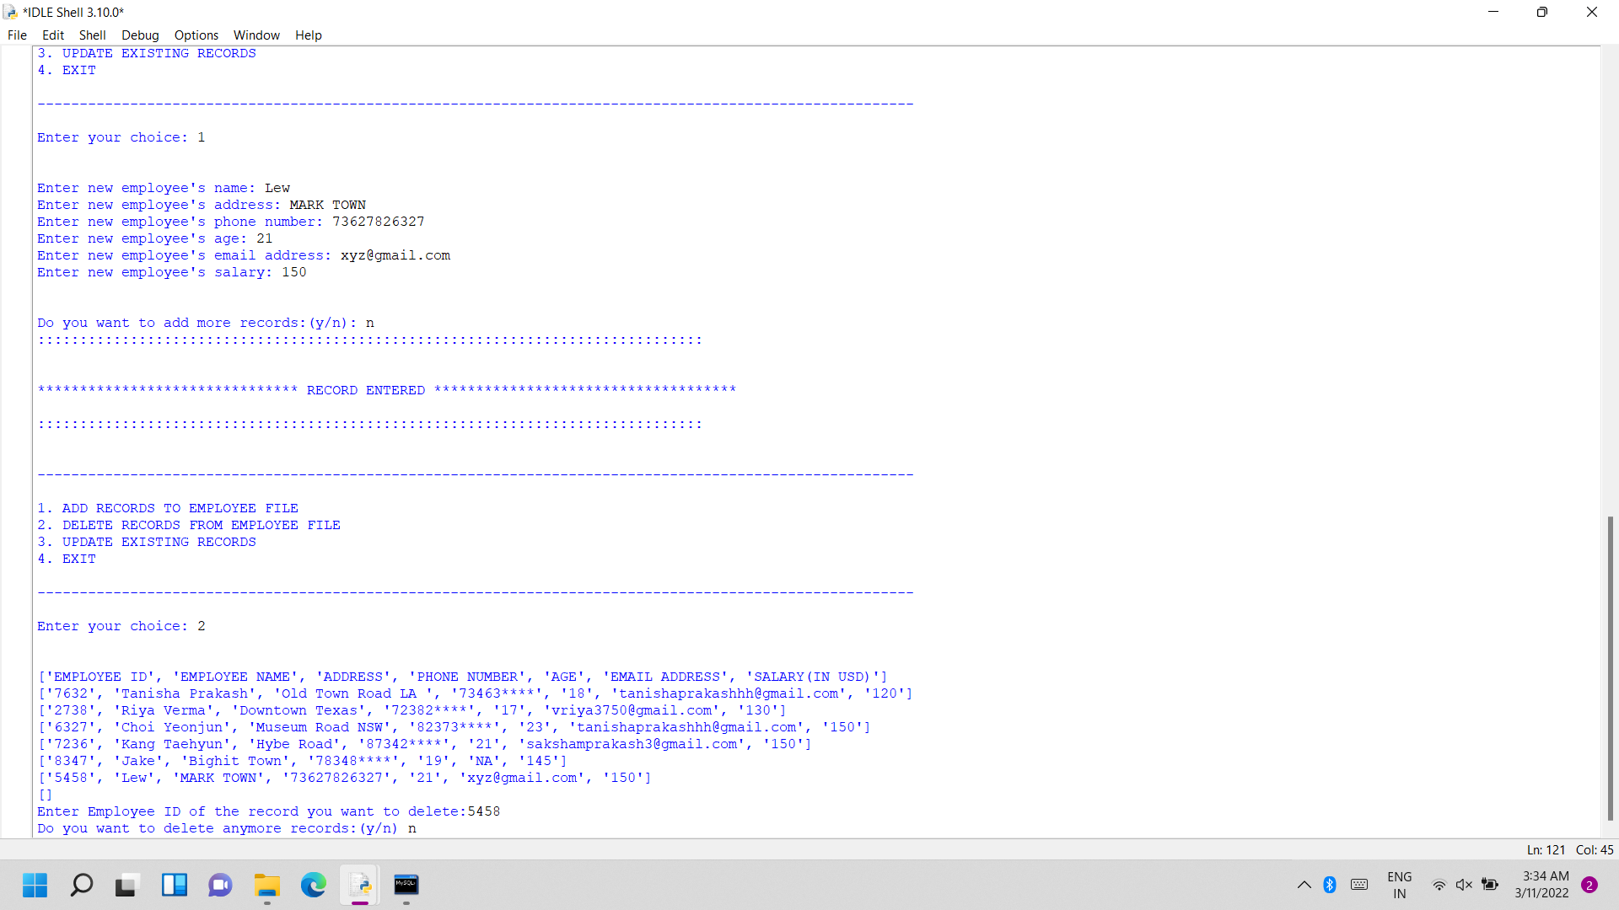

Record deleted from the employee file:

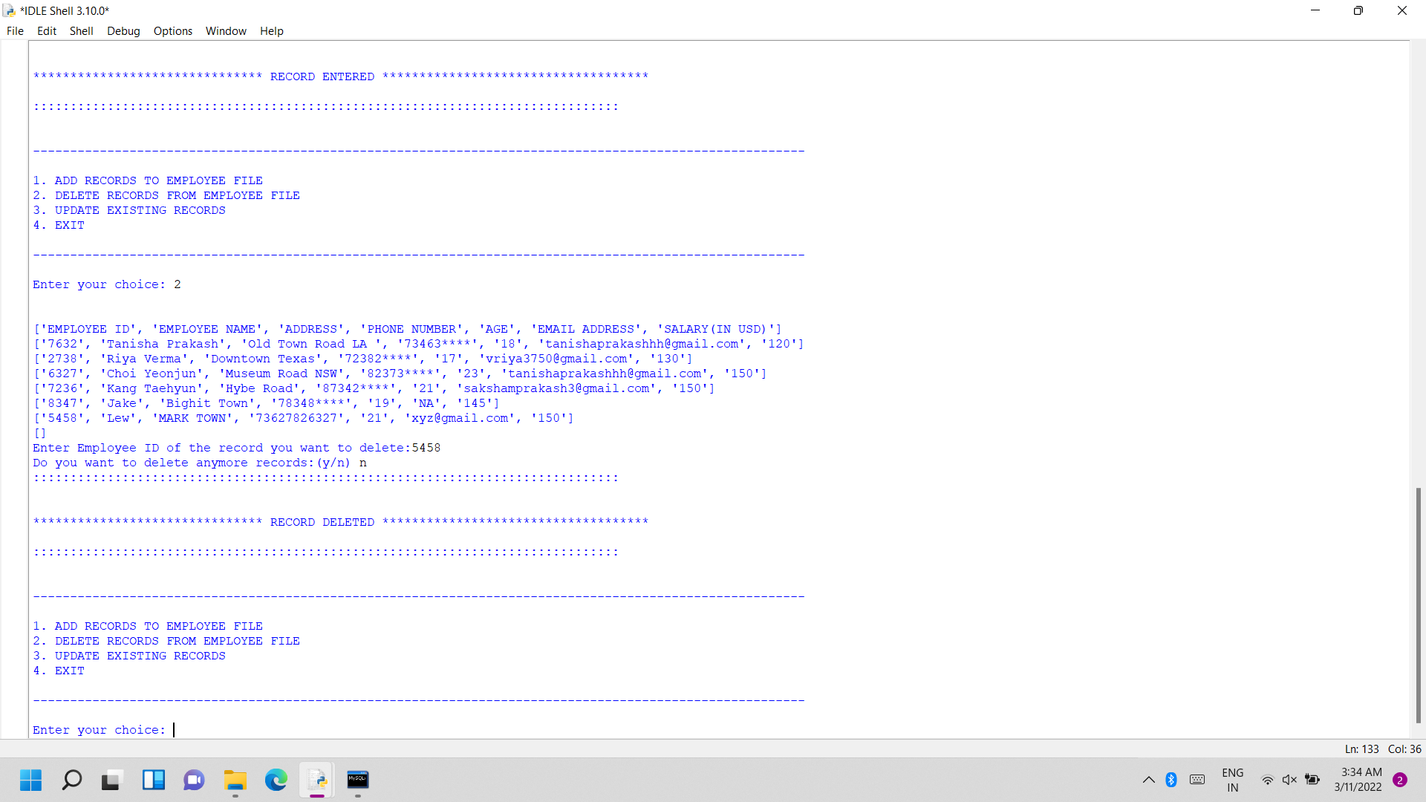

RECORD DELETED

1. updating existing records of the employee:
2. UPDATING ADDRESS:

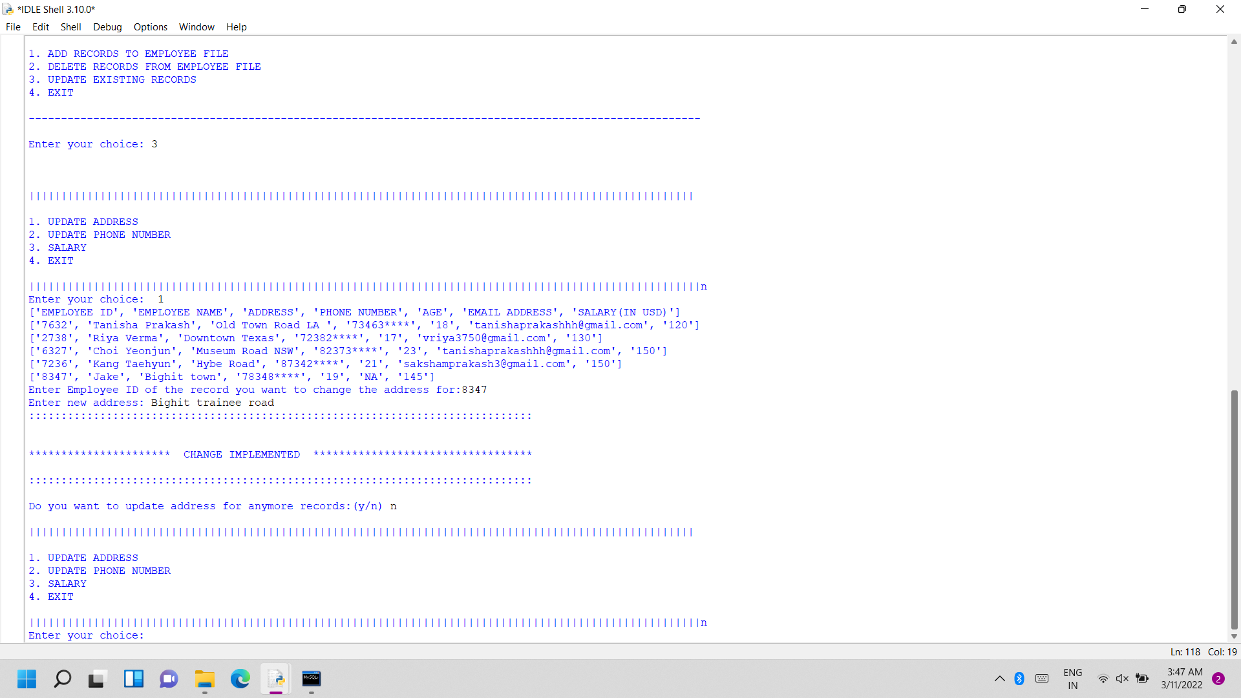

ADDRESS UPDATED

1. UPDATING PHONE NUMBER:

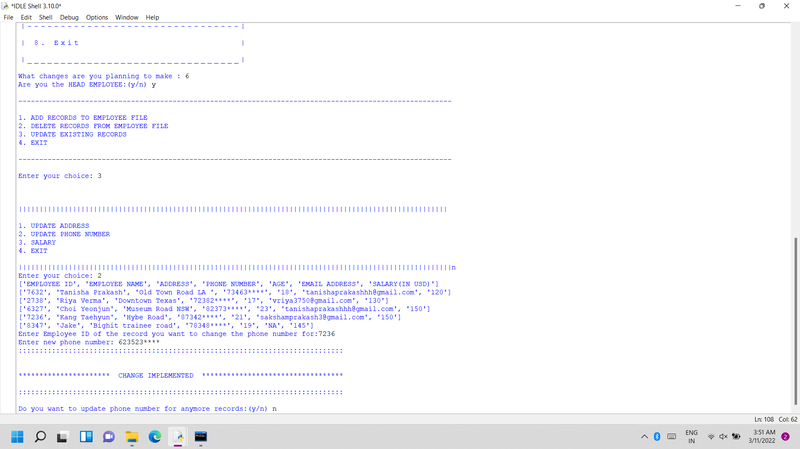

PHONE NUMBER UPDATED

1. UPDATING SALARY BY ADDING AN INCREMENT:

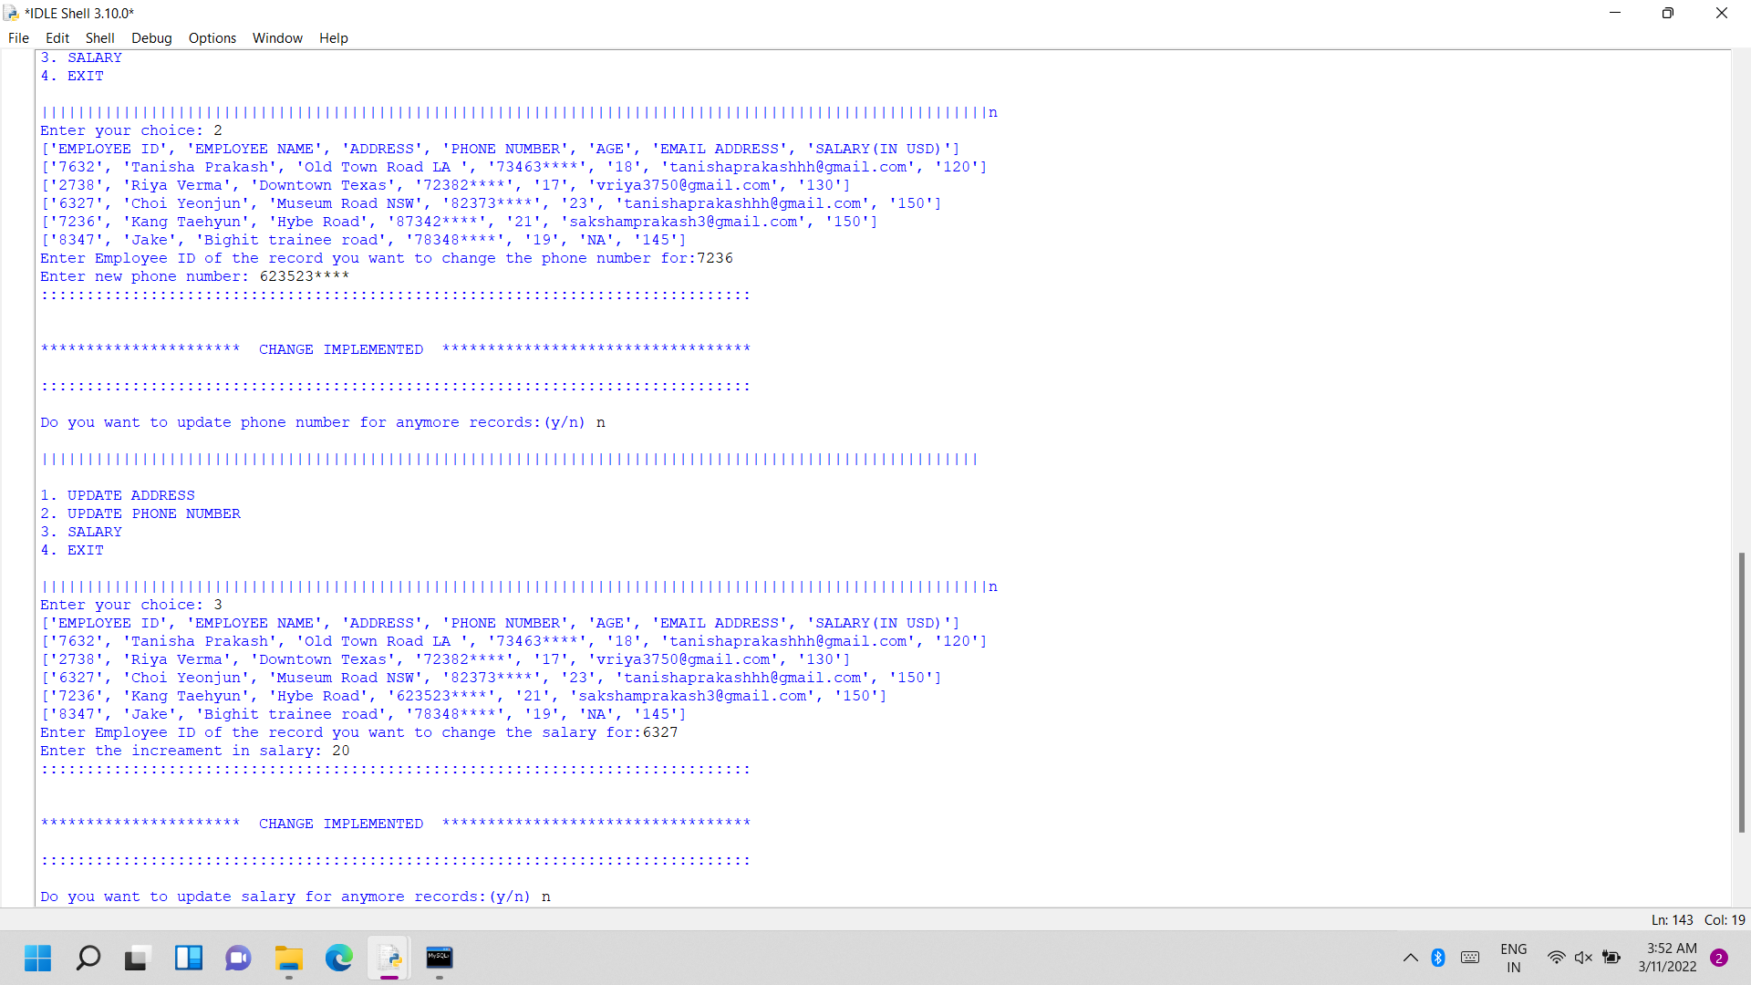

SALARY UPDATED

1. NOT WANTING TO UPDATE ANYTHING:

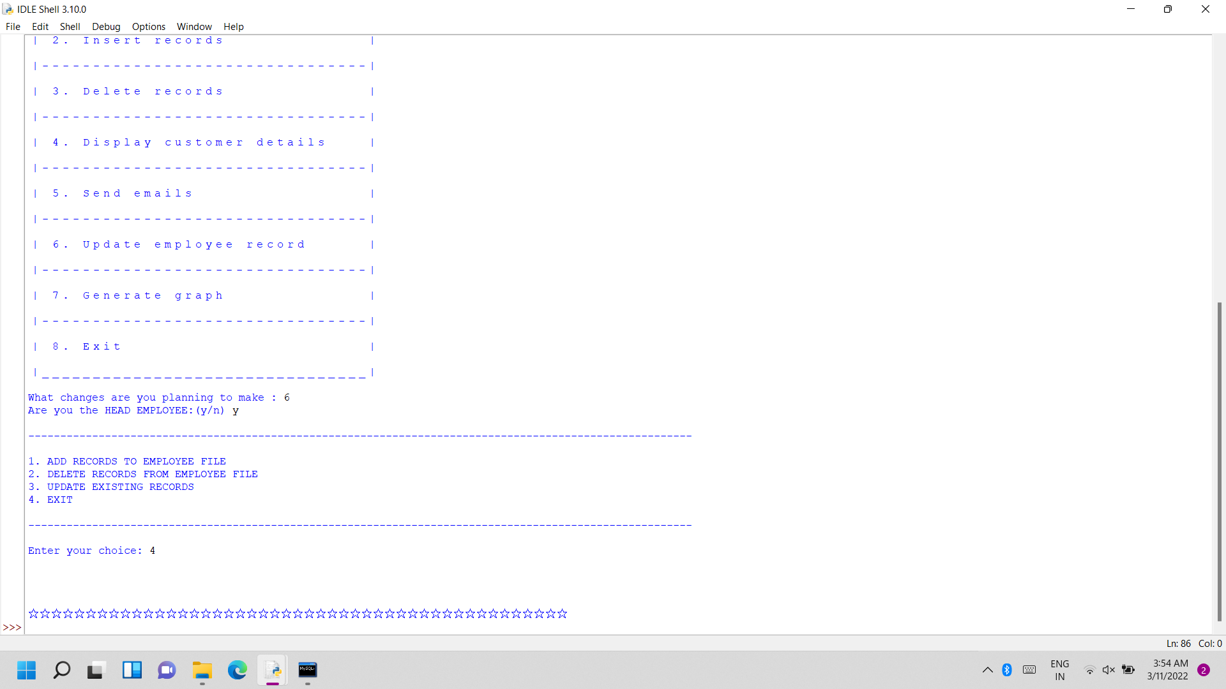

1. DISPLAYING SALES GRAPH FOR DIFFERENT MONTHS:

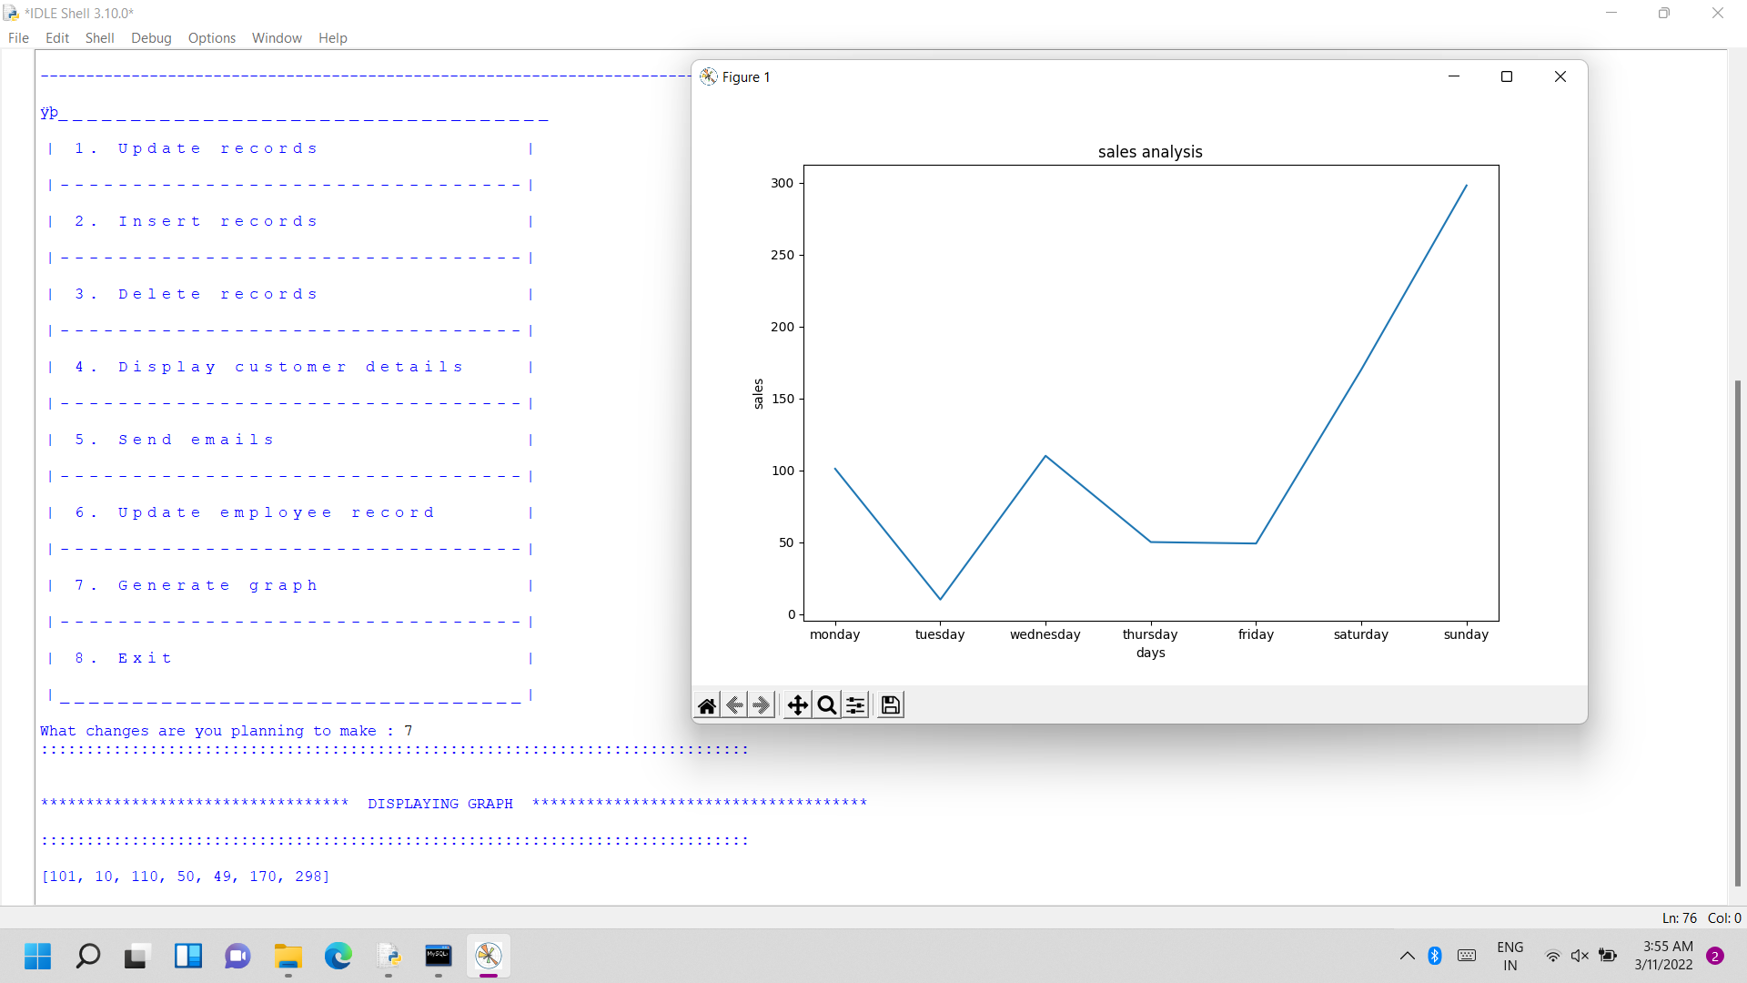

1. **EXITING:**

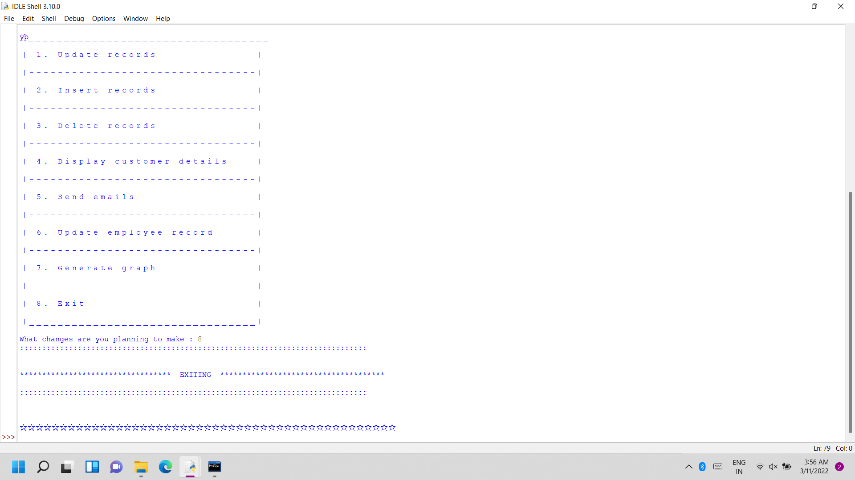

TXT FILES:

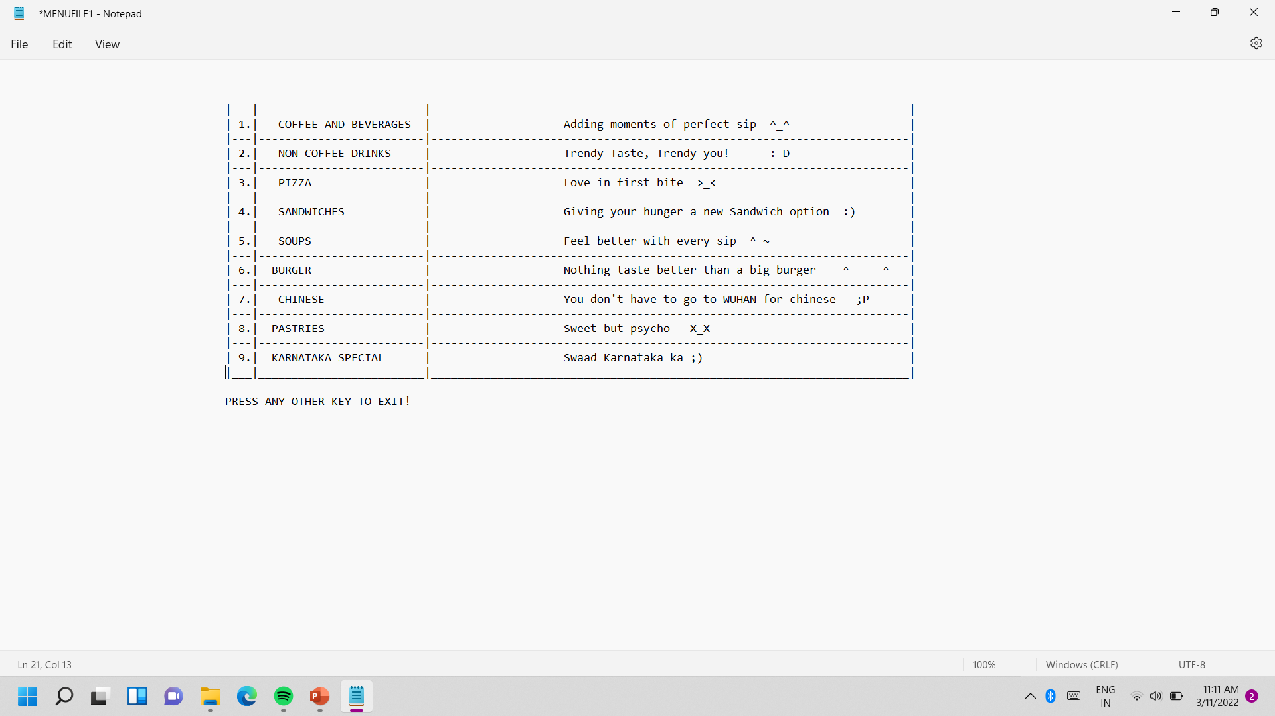

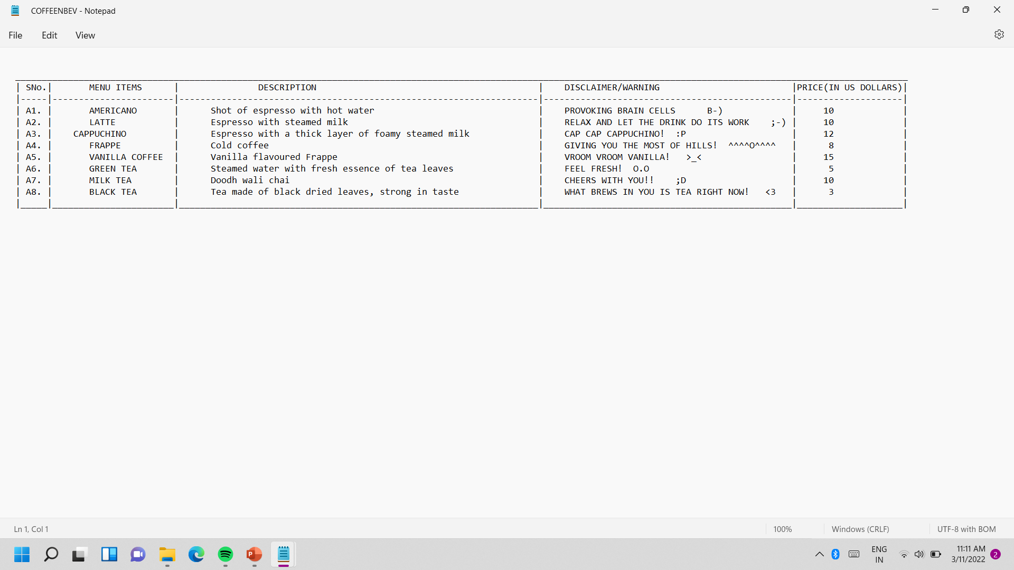

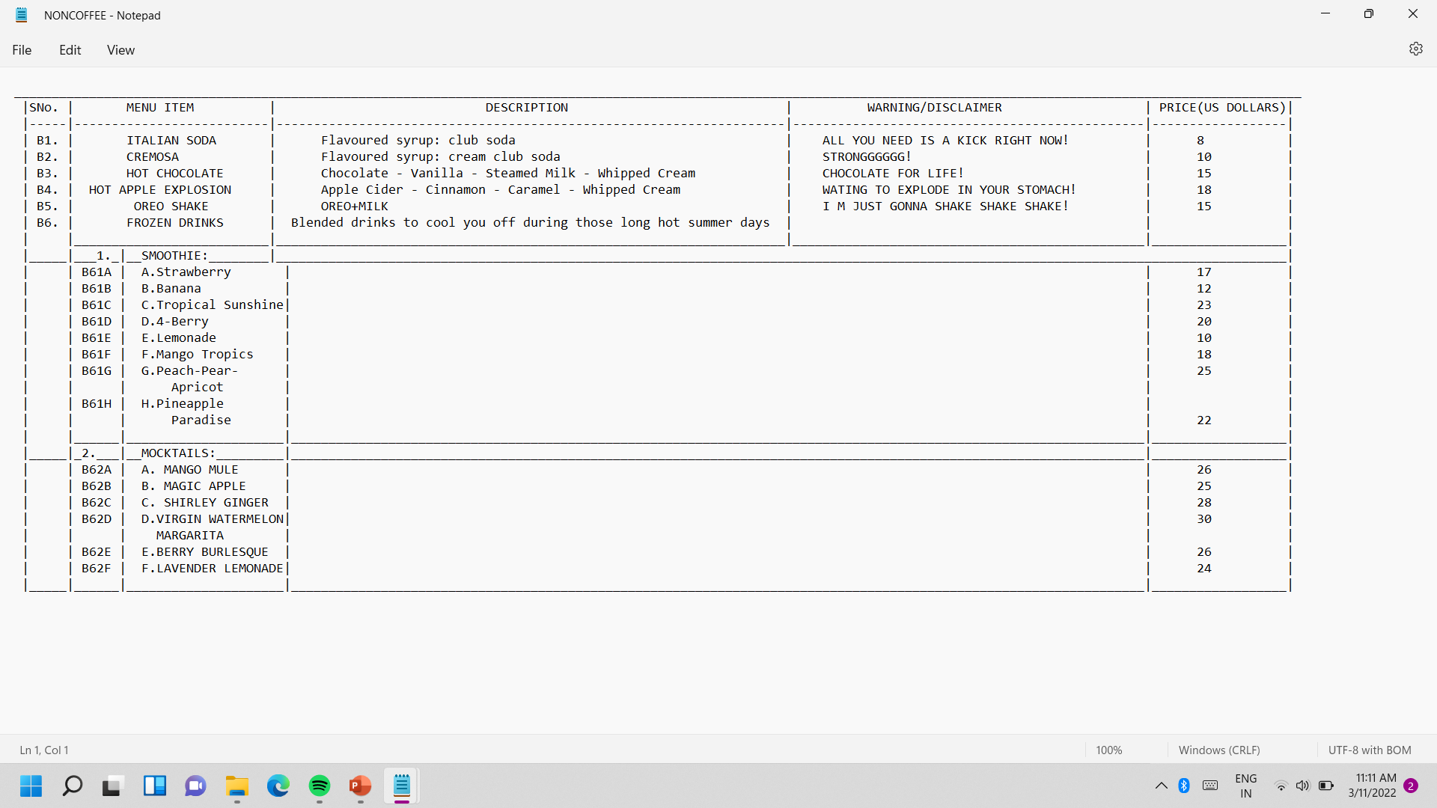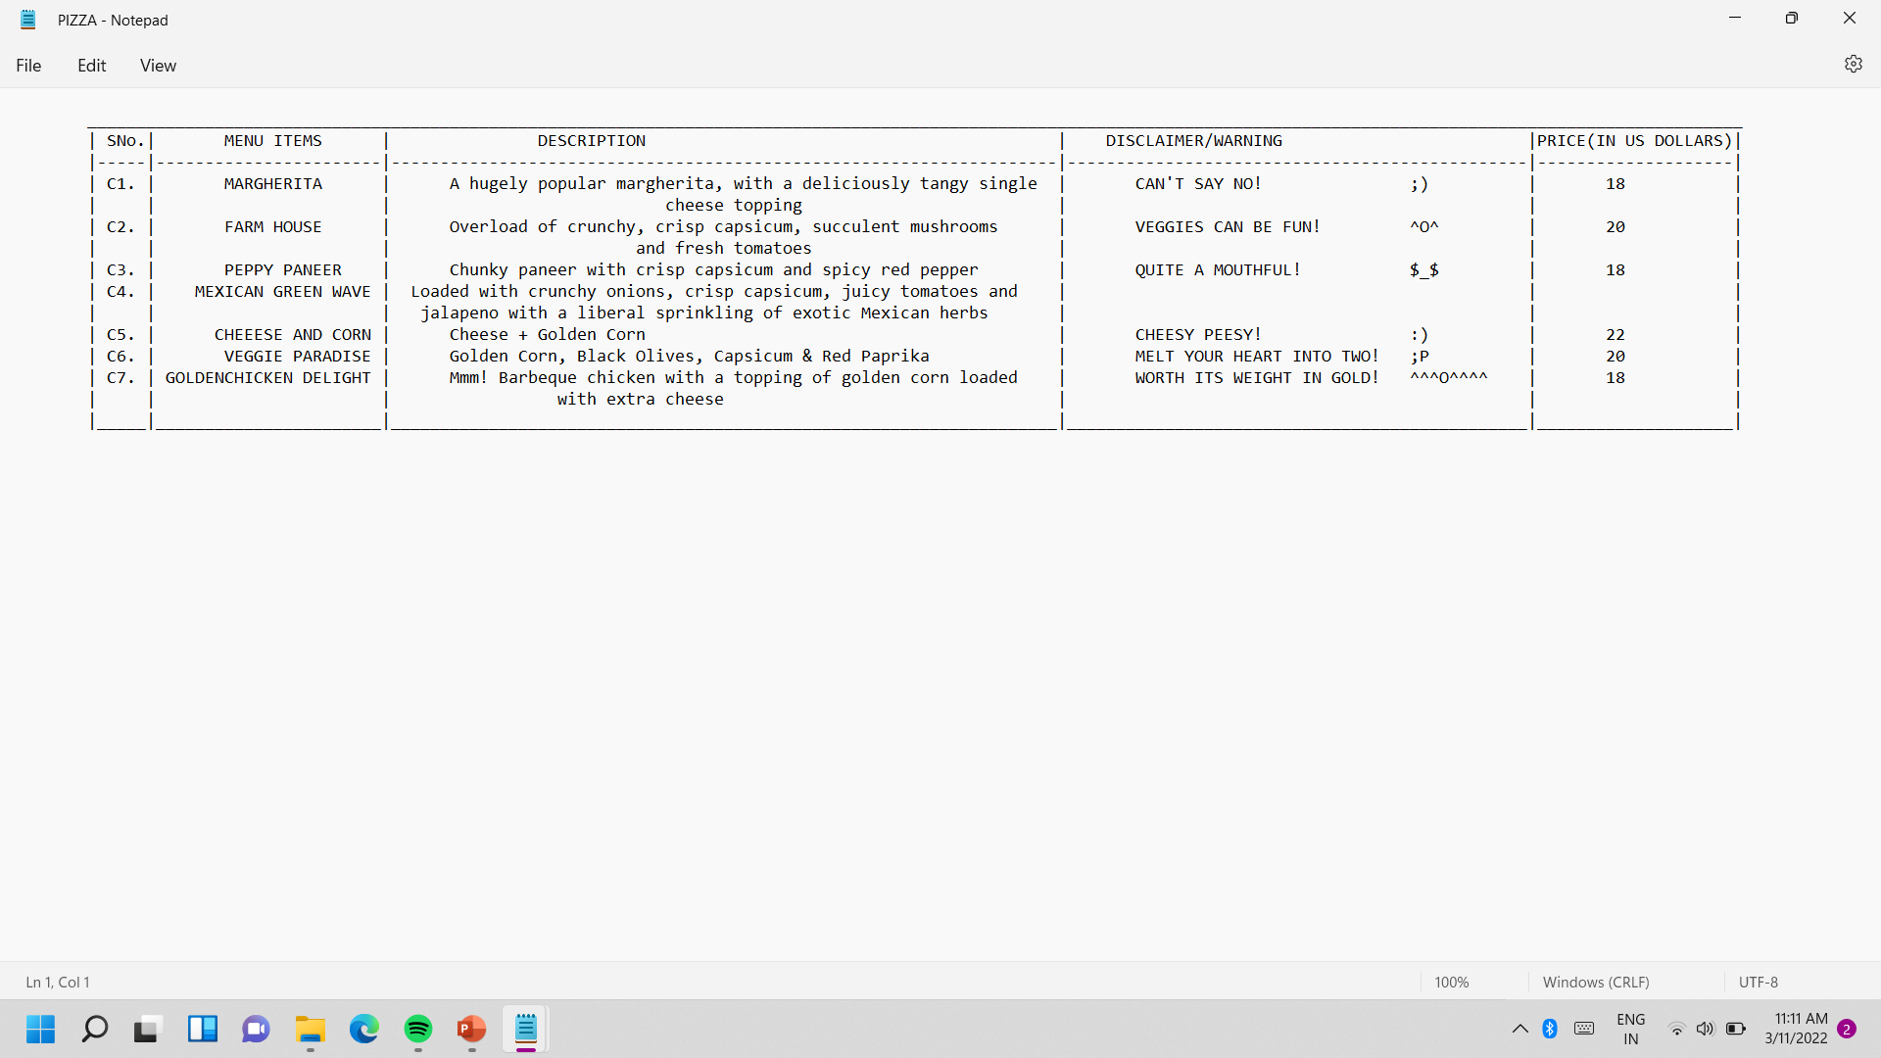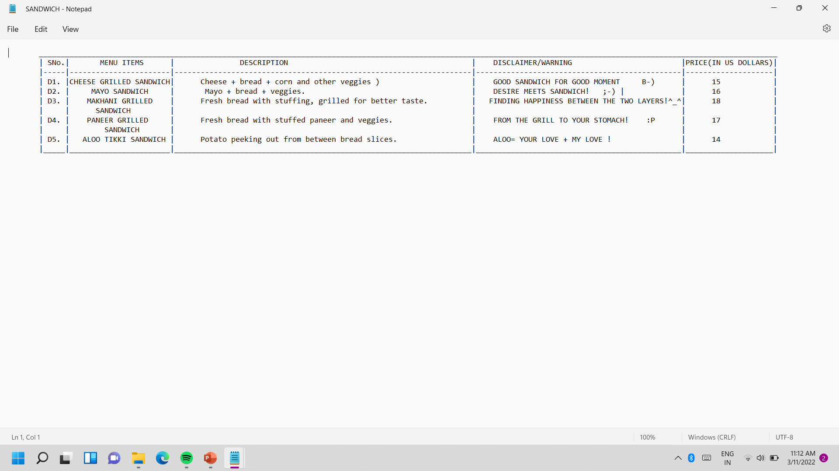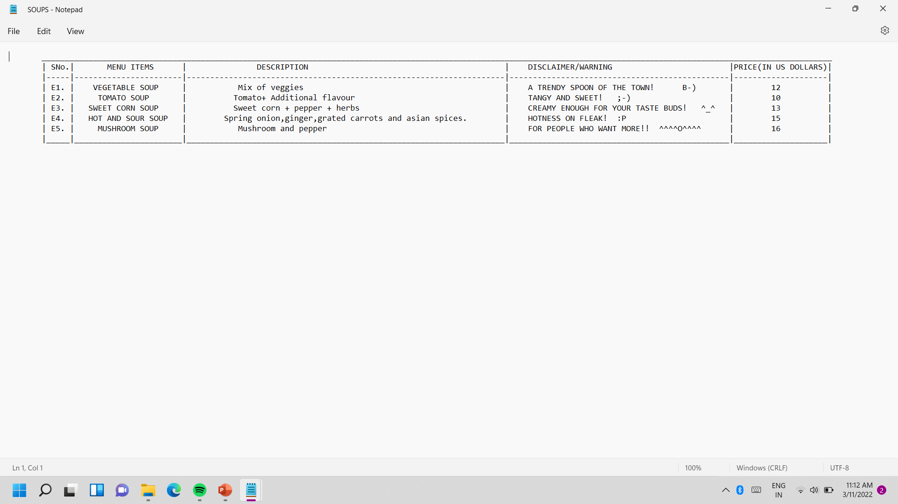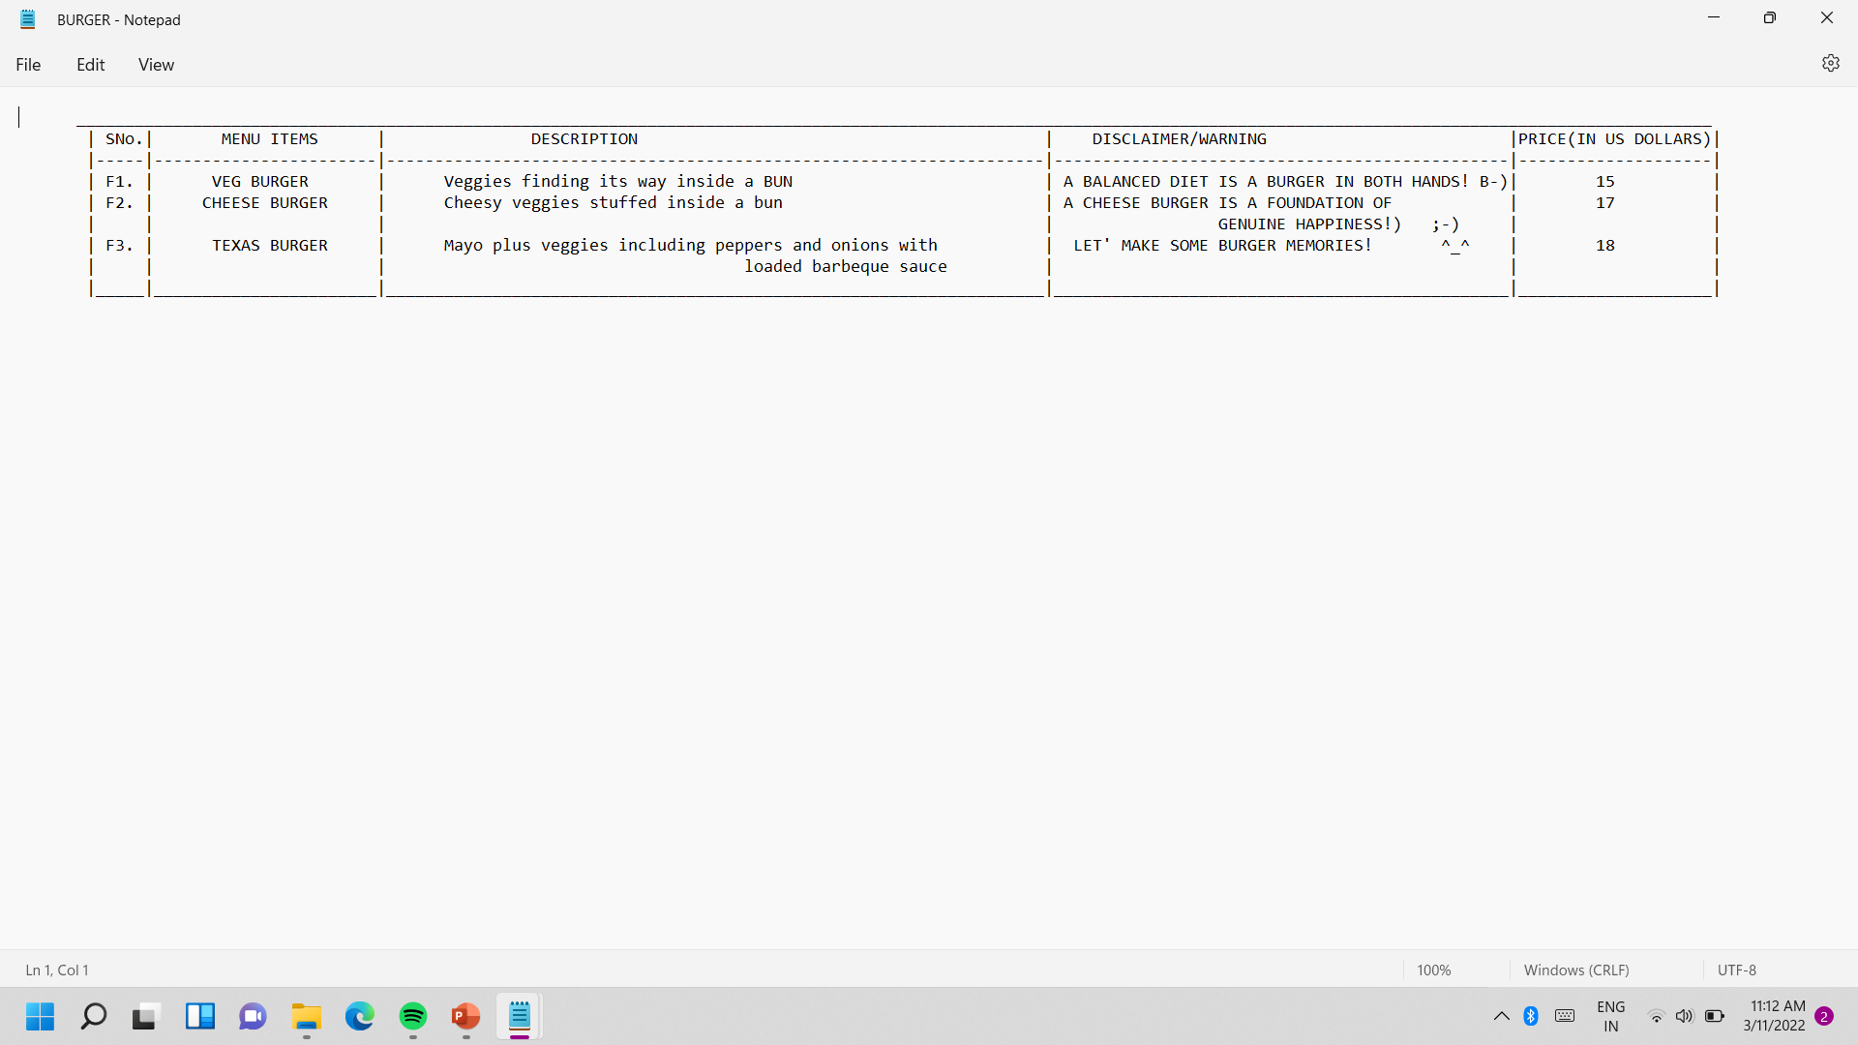

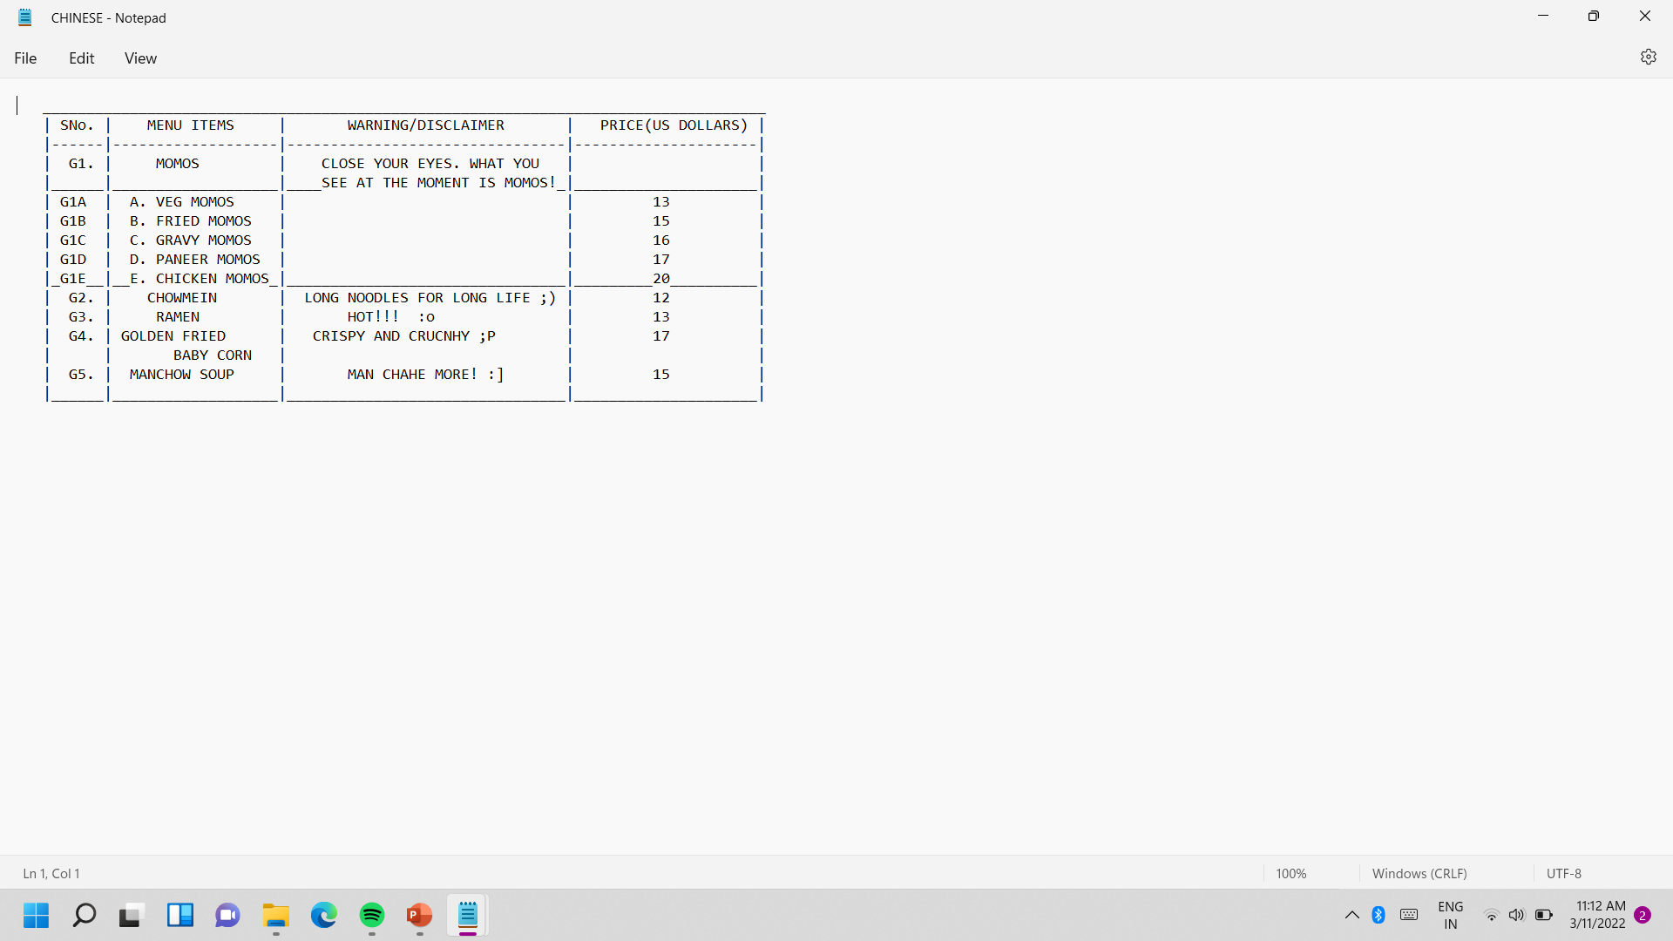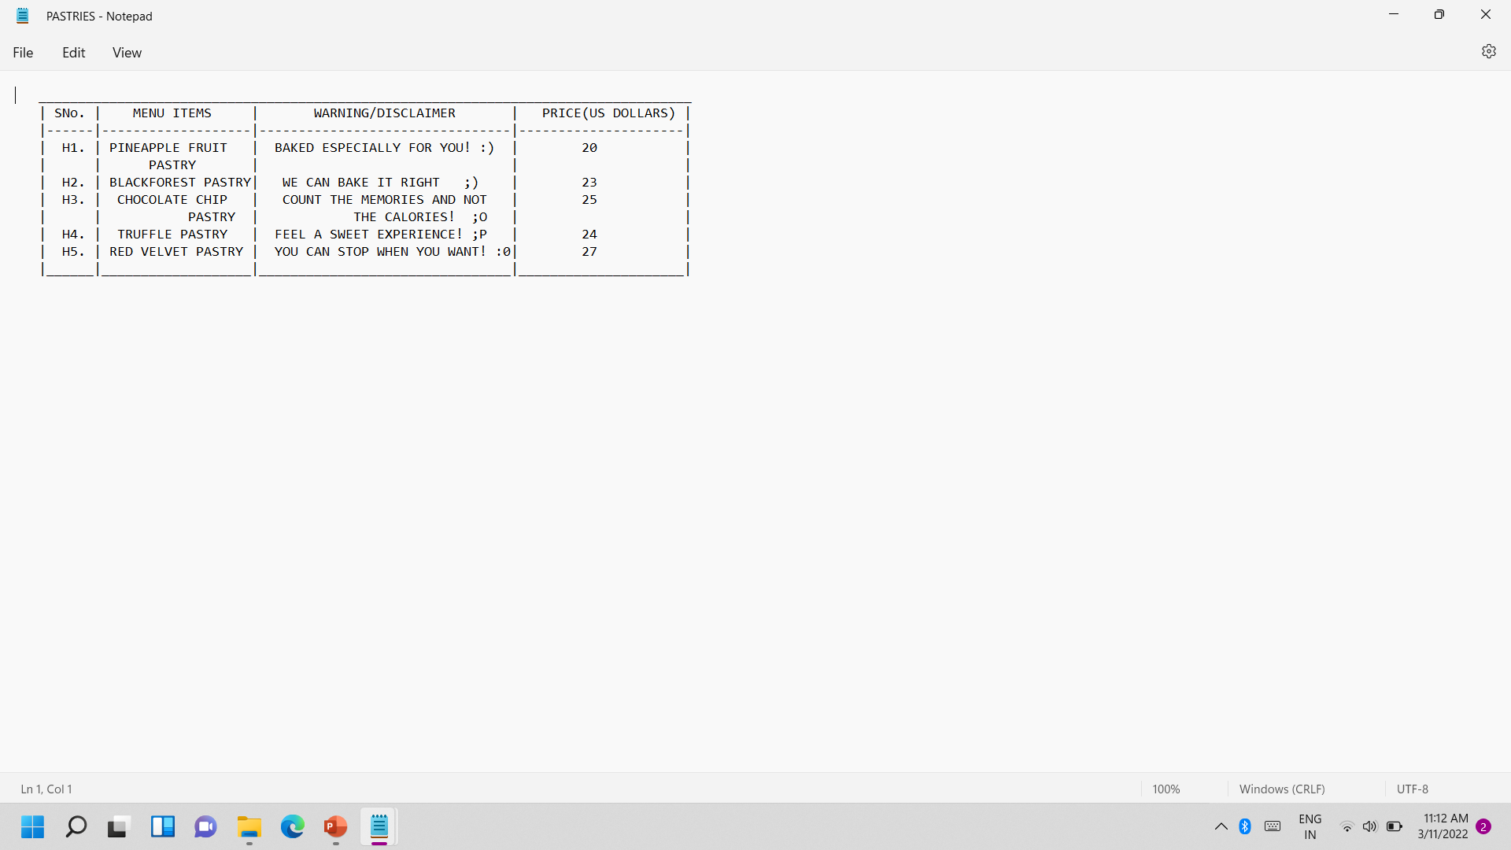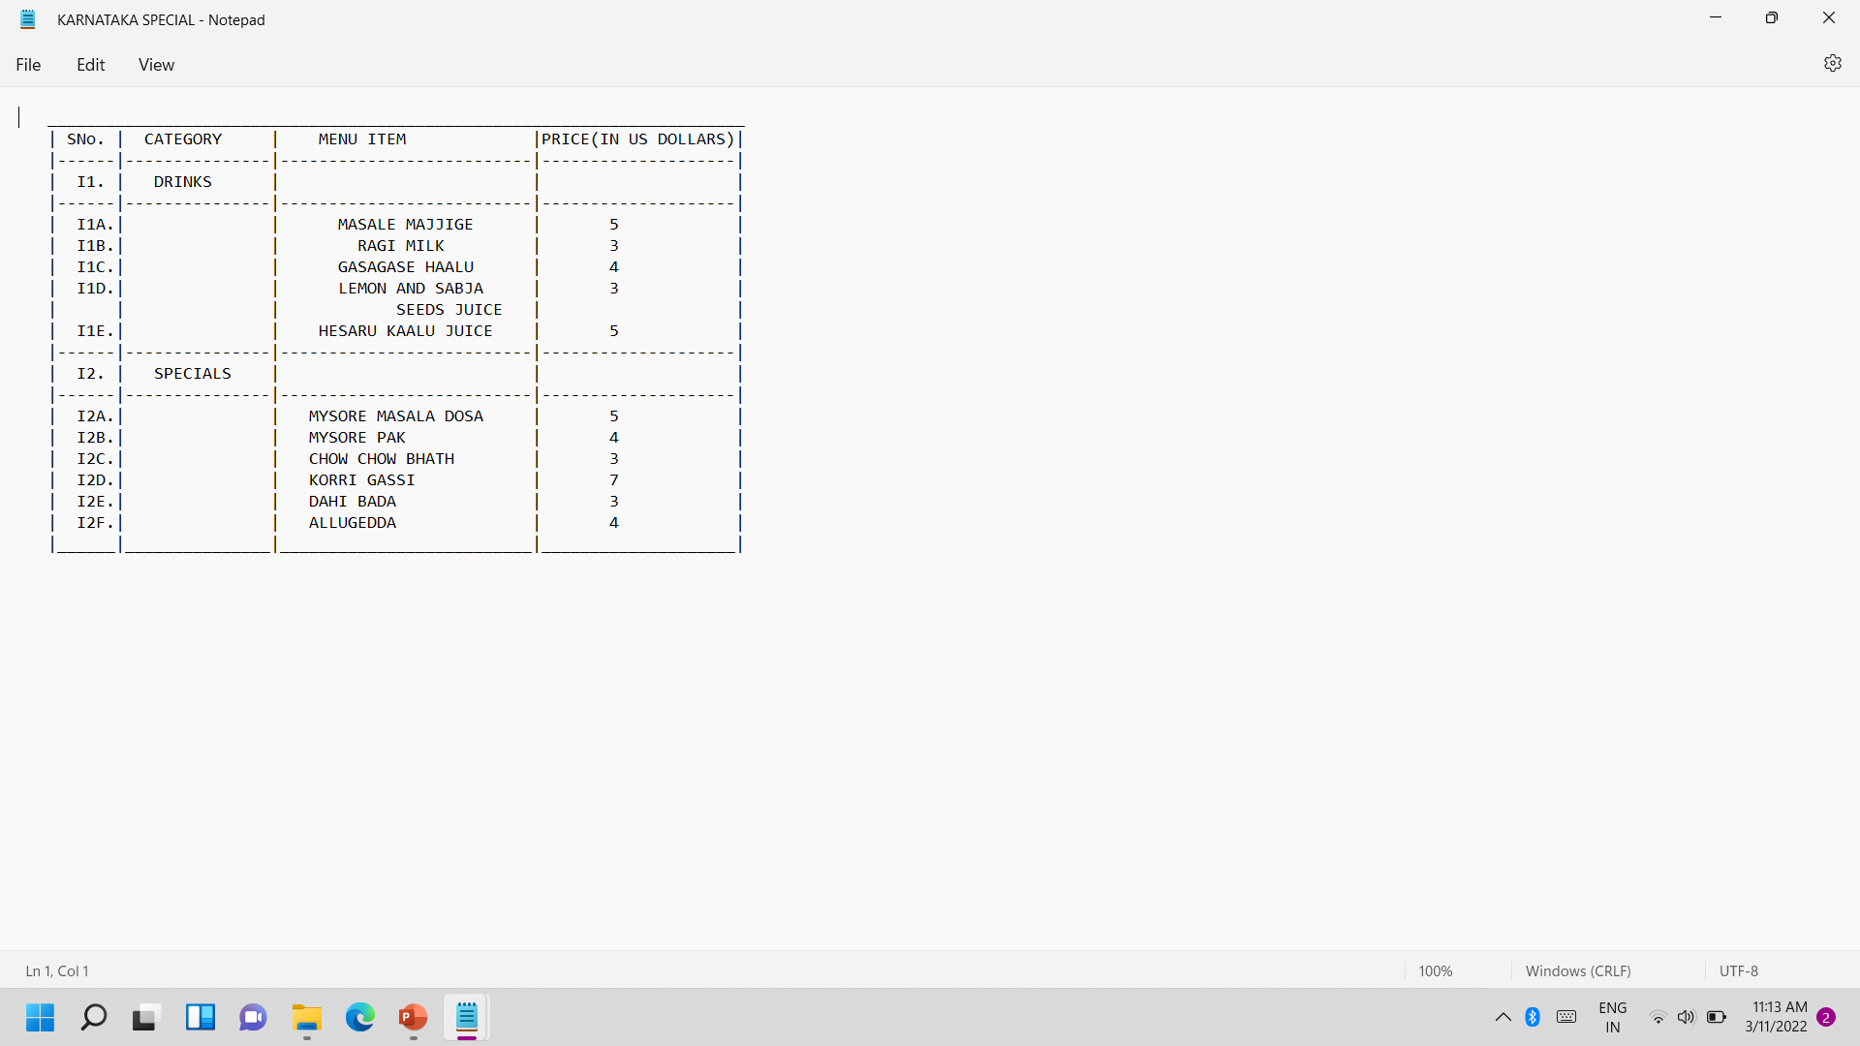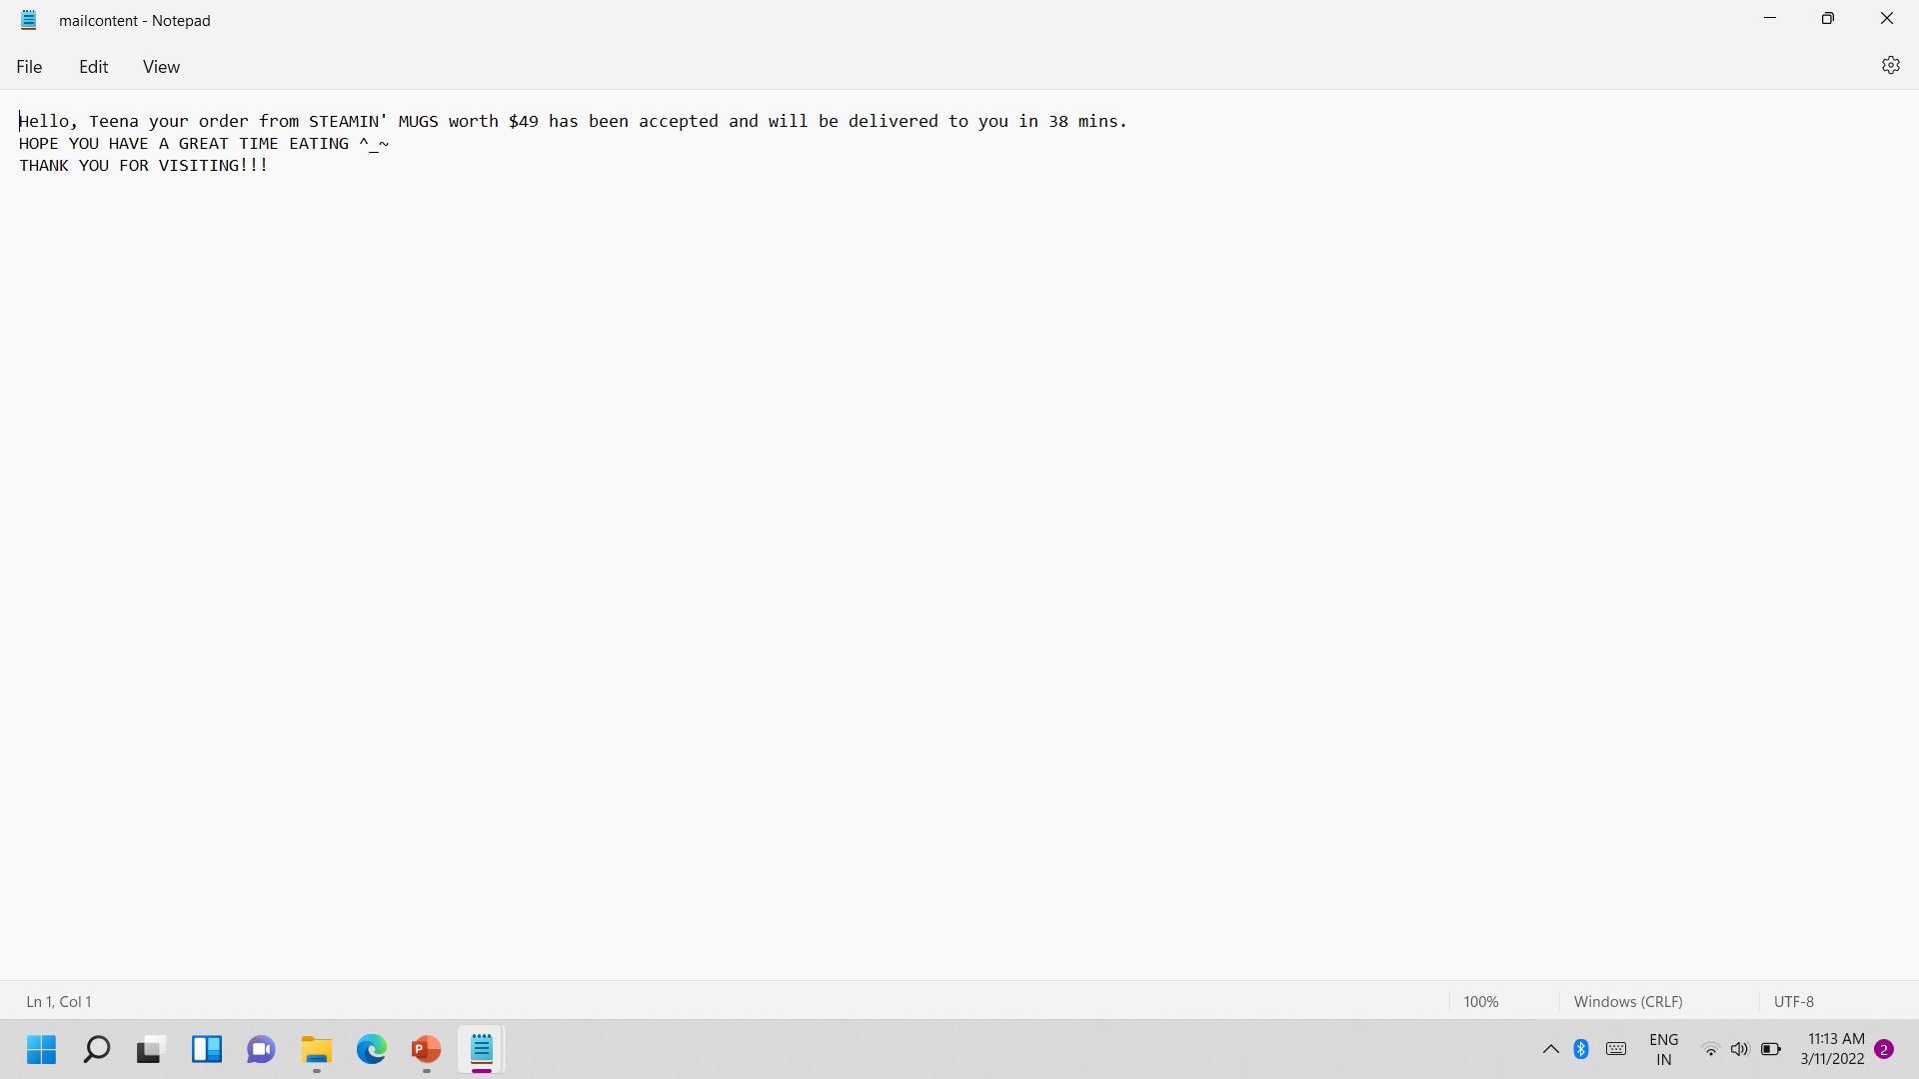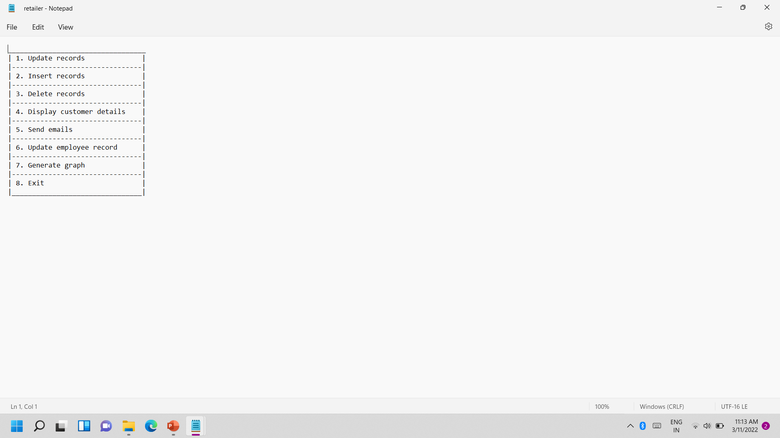

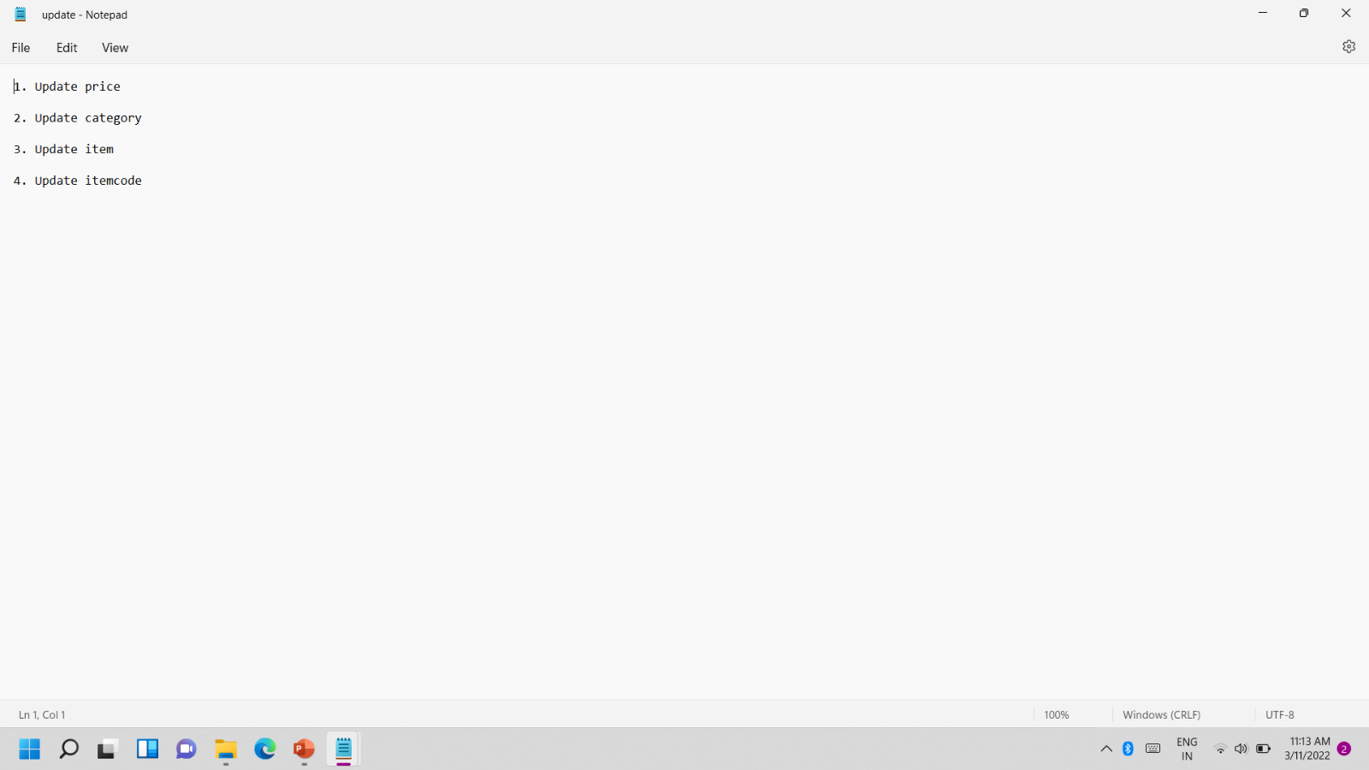

CSV FILES:

